## Two Channel Arbitrary Waveform Generator

Brayden Donovan

Salina Teng Serene Singh Joe Knipper

# Final Report

**Table of Contents**

1. [**Concept Of Operations**](https://docs.google.com/document/d/1qoHyvszVlsGlOd-3xiWXLL8EzSEMS9zR/edit#heading%3Dh.bqfn4fnimqn) **3**
2. **Functional System Requirements** **17**
3. **Interface Control Document** **34**
4. **Milestones/Execution Plan** **46**
5. **Validation Plan** **49**

## Two Channel Arbitrary Waveform Generator

Brayden Donovan

Salina Teng Serene Singh Joe Knipper

# Concept of Operations

### Concept of Operations

FOR

### Two Channel Arbitrary Waveform Generator

TEAM <25>

Approved by:

Serene Singh 12/03/2025



Project Leader Date

Dr. John Lusher 12/03/2025



Prof. Kalafatis Date

Jianhan Pan 12/03/2025



T/A Date

**Change Record**

| **Rev**  **.** | **Date** | **Originator** | **Approvals** | **Description** |
| --- | --- | --- | --- | --- |
| **v1** | 9/16/2025 | Serene Singh | The Only WGT | Draft Release |
| **v2** | 10/04/2025 | Serene Singh | The Only WGT | Draft Release |
| **v3** | 12/03/2025 | Serene Singh | The Only WGT | Draft Release |

**Table of Contents**

**Figure 1: Comprehensive Flow Chart of Proposed AWG System** **4**

1. **Executive Summary** **4**
2. **Introduction** **6**
   1. Background 6
   2. Overview 6
   3. Referenced Documents and Standards 7
3. **Operating Concept** **8**
   1. Scope 8
   2. Operational Description and Constraints 8
   3. System Description 8
   4. Modes of Operations 8
   5. Users 9
   6. Support 10
4. **Scenario(s)** **11**
   1. University Lab 11
   2. Debugging Embedded System 11
5. **Analysis** **11**
   1. Summary of Proposed Improvements 11
   2. Disadvantages and Limitations 12
   3. Alternatives 12
   4. Impact 13

**List of Figures**

###### Figure 1: Comprehensive Flow Chart of Proposed AWG System

#### Executive Summary

This project presents the design and implementation of a two-channel Arbitrary Waveform Generator (AWG). AWGs are critical tools in electrical engineering and research, enabling the generation of precise, user-defined signals for testing and characterizing circuits, systems, and devices. Unlike traditional function generators, AWGs offer the flexibility to create complex, custom signals with high accuracy.

The objective of this project is to develop a compact, cost-effective, and user-friendly AWG capable of producing two independent arbitrary waveforms, either individually or simultaneously, with adjustable frequency, amplitude, and offset. The system integrates two 16-bit digital-to-analog converters (DACs) driven by a microcontroller/FPGA for waveform storage, sequencing, and timing. Each channel supports common signals such as sine, square, triangle, and sinc waveforms, as well as adjustable user-defined waveforms.

The outputs are designed to achieve a maximum signal frequency of 100 kHz with a voltage range of ±5 V while driving a 50 Ω load, ensuring adequate resolution, stability, and compatibility with laboratory equipment. To enhance usability, a custom mobile application provides intuitive control of the device, allowing users to create, select, and preview waveforms from their device.

In conclusion, the completed AWG will deliver two fully independent channels with accurate signal generation and low distortion. Testing will confirm stable operation across the supported frequency range, with the ability to generate both standard and custom waveforms. The system’s performance will demonstrate the successful integration of digital and analog design principles while providing a compact, cost-effective, and user-friendly AWG.



***Figure 1: Comprehensive Flow Chart of Proposed AWG System***

#### Introduction

In electrical engineering, signal generation plays a critical role in evaluating circuits, devices, and systems. While traditional function generators provide basic waveform outputs, modern applications often require more flexibility and control over specific signal characteristics. This project addresses these needs through the development of a two-channel arbitrary waveform generator (AWG) designed to deliver high-performance user-defined signals in a compact and cost-effective platform.

##### Background

Traditional function generators are widely used in laboratories and industry in order to provide fixed or limited waveform outputs such as sine, square, and triangle waves. These systems lack the flexibility required for modern electronic applications that need precise control over waveform parameters such as frequency, amplitude, and offset. Commercial AWGs offer these capabilities, but many available systems are expensive, bulky, and confusing for an amateur user.

The following paper addresses these limitations by introducing a compact, cost-effective two-channel AWG that provides high 16-bit resolution with user-defined signal generation through a mobile IOS app. By leveraging commercial off the shelf components, this design will offer amateur users a cost-effective and simple way to generate arbitrary waveforms from their personal device.

##### Overview

The proposed arbitrary waveform generator (AWG) is designed to deliver high-performance, customizable signal generation in a compact, user-friendly platform. The system will enable users to define, upload, and edit waveforms while maintaining high resolution, stable frequency output, and multichannel operation.

Key Design Features:

* **Two Independent Output Channels** – The AWG will be able to support two channels, and each channel can support separate waveform configurations. The output voltage will be ±5 V.
* **High Sampling Rate & Resolution** – The AWG will feature a 16-bit resolution with a max sampling rate of 1MHz per second. It will be able to output max usable frequencies of 100kHz.
* **User-Defined Signal Control** – Waveform parameters will be inputted by the user using a mobile app, IOS/Android. The user will also have the ability to draw arbitrary waveforms directly.
* **Power/Interface**– The device will utilize one 12V DC Wall Plug for power. The enclosure will have indicator lights to show the status of the system and will have two BNC jacks to output the generated waveform.
* **Compatibility**– The device will be compatible with standard lab measurement equipment, such as an oscilloscope, and will have the ability to drive a 50 Ω load.

Overall, the project focuses on delivering a high-performance AWG that is low-cost and enables basic creation and control over arbitrary waveforms effectively.

##### Referenced Documents and Standards

1. Espressif Systems, *ESP32 Series Datasheet: ESP32-D0WD, ESP32-D0WDQ6, ESP32-D2WD, and ESP32-S0WD*, ver. 3.9, 2023. [Online]. Available: https://[www.espressif.com](http://www.espressif.com/)
2. Texas Instruments, *DAC8831: 16-Bit, Ultra-Low Glitch, Voltage Output DAC*, datasheet SBAS289C, 2015. [Online]. Available: https://[www.ti.com](http://www.ti.com/)
3. Keysight Technologies, *33500B Series Trueform Waveform Generators – Data Sheet*, publication no. 5991-3563EN, 2017. [Online]. Available: [https://www.keysight.com](https://www.keysight.com/)
4. E. Murphy and C. Slattery, “All About Direct Digital Synthesis,” *Analog Dialogue*, vol. 38, no. 3, Aug. 2004. [Online]. Available: [https://www.analog.com/en/resources/analog-dialogue/articles/all-about-direct-digital-synthe](https://www.analog.com/en/resources/analog-dialogue/articles/all-about-direct-digital-synthesis.html?utm_source=chatgpt.com) [sis.html](https://www.analog.com/en/resources/analog-dialogue/articles/all-about-direct-digital-synthesis.html?utm_source=chatgpt.com)
5. Use EA’s Arbitrary Function Generator to Output Custom Voltage or Current Waveforms. (2024,May).Tek.com.

[https://www.tek.com/en/blog/use-eas-arbitrary-function-generator-to-output-custom-voltage-](https://www.tek.com/en/blog/use-eas-arbitrary-function-generator-to-output-custom-voltage-or-current-waveforms) [or-current-waveforms](https://www.tek.com/en/blog/use-eas-arbitrary-function-generator-to-output-custom-voltage-or-current-waveforms)

#### Operating Concept

##### Scope

Our project is to design and create a dual-channel arbitrary waveform system which allows users to define waveforms and control their parameters through a mobile application. The system will consist of a mobile application, microcontroller, FPGA, and a series of analog filters that will be used to create high frequency, customizable waveforms from parameters inputted into a user-friendly interface.

##### Operational Description and Constraints

The AWG will be capable of defining custom frequencies and aptitudes of sine, square, triangle, sinc, and arbitrary waveforms as specified by the user. The machine will be able to produce two output waveforms either individually or simultaneously, increasing its possible utilization.

##### System Description

The arbitrary waveform generator can be split into four major parts; The mobile application, microcontroller, FPGA, and the analog filters. The mobile application allows the user to interact with the AWG by collecting values like the frequency, amplitude, offset, and type of waveform from the user. When the user has finished specifying the parameters of their waveform, the data is then sent to the machine through a wireless connection to the microcontroller. The microcontroller then sets the data bits that control the amplification of the circuit and communicates the mode of operation to the FPGA. The microcontroller also calculates a list of specific time values for the FPGA to sample from the waveform in order to control the frequency through downsampling. The microcontroller sends all necessary waveform configuration data to the FPGA in a serialized format while in the *configuration mode* of operation. This data is received by the FPGA and is stored in memory. The FPGA then uses this stored data while in the *generation mode* of operation to retrieve the correct binary values from memory. These binary values are then sent to the DAC in a serialized format. The DAC converts the binary values retrieved from memory into an analog signal which is then amplified according to the user defined value, buffered so that it can adequately drive the load, and smoothed with a low pass filter. The signal is then outputted with a BNC jack, which allows the user to easily use their generated waveform.

##### Modes of Operations

Our device has two main modes of operation, configuration and generation.

* **Configuration** – During configuration mode, necessary values are calculated using the user defined waveform parameters. These values are then sent to the AWG by a wireless connection to the microcontroller. Any necessary values are passed to the FPGA to be stored in memory, and all necessary control bits are set by the microcontroller.
* **Generation** – In this generation mode, the FPGA iterates over set values in memory to produce the correct waveform at the intended frequency. The binary values retrieved from memory are passed to the DAC to be converted into an analog waveform, which is then amplified and filtered.

##### Users

* 1. **Who will be using your system**

Users of the Arbitrary Waveform Generator (AWG) are divided into two categories:

**Primary and Secondary**.

Primary users include individuals who rely on the AWG extensively as a critical tool for generating custom electrical signals required in applications such as prototyping, testing, troubleshooting, validation, calibration, and characterization of an electrical system. These individuals may involve **Test Engineers, Electrical Engineers, R&D Scientists, Lab Managers, Maintenance & Calibration Engineers, and Technicians**. Their work often requires the AWG’s high precision, reliability, and repeatability to create standard and arbitrary waveforms for a wide range of applications.

Secondary users include individuals who use the AWG in an academic or training environment. These individuals often involve **Students and Educators**. Secondary users leverage the AWG as a learning tool to gain valuable hands-on experience in understanding signal processing, waveform generation, digital/analog signal behavior, and validating experimental results in laboratory settings.

* 1. **Level of training required for installation**

The level of training required for installation is minimal. The AWG is largely designed as a ‘plug and use’ device, backed-up by its straightforward set-up and ease of integration into testing or production environments. Individuals such as an engineer with basic understanding with test and measurement equipment can perform successful installation of the AWG to advance it into operation.

* 1. **Level of training required for use**

The level of training required to operate the AWG involves an intermediate level of technical understanding regarding topics such as signal characteristics, waveform properties (e.g., frequency, phase shift, amplitude), and interaction between signal and device when in testing. Moderate formal training or self-conducted research are recommended for users who are new to using the device or want to understand the full functionality and capability offered by the system.

* 1. **Who will benefit from your proposed system**

Individuals who rely extensively on the AWG to create standard and arbitrary waveforms for laboratory, production, or testing purposes will benefit greatly from the proposed AWG system. For instance, Engineers and Product Developers benefit by being able to design and generate arbitrary custom signals that replicate realistic signal conditions under testing environments. This functionality allows them to validate new designs, leading to higher-performing and higher-quality products.

##### Support

* **User Manual**

A detailed and comprehensive user manual will be provided with each Arbitrary Waveform Generator (AWG) unit. The manual will cover essential steps for device set-up and usage, including installation procedures, basic operation guidelines, safety rules. Example test procedures will also be included, as well as troubleshooting guidelines for common issues, situational examples, and recommended configurations for different usages.

* **Technical Support**

Technical support will be provided through a tiered support structure. For common issues such as installation difficulties, basic configurations, amongst many other frequently asked questions, users can access assistance through email or phone. For more advanced issues such as hardware malfunction or application challenges, specialized support will be available for in-depth consultation and troubleshooting. Support of all tiers will be provided in a timely manner, regardless of their complexity.

* **Software & Firmware Updates**

The AWG will be supported and maintained with a program of downloadable software and firmware updates. Updates will provide bug fixes, new features, and performance improvements. Maintenance of the AWG will involve ensuring ongoing compatibility with evolving operating systems and interfaces. Users will be notified of updates through vendor communication platforms/email, and update installation guidelines will be provided to ensure a successful system upgrade.

#### Scenario(s)

##### University Lab

In a university lab setting, a student uses the custom Arbitrary Waveform Generator (AWG) to supply synchronized test signals for a mixed-signal circuit experiment. After powering on the AWG and connecting to it via Bluetooth, the student programs Channel 1 to output a 10 kHz sine wave and Channel 2 to output a 10 kHz square wave at 10 Vpp, ensuring both are phase-aligned. The AWG’s direct digital synthesis (DDS) core and DACs generate the signals from the same clock, while precision op-amps and output buffers condition them for clean delivery into a 50 Ω circuit load. The student connects these outputs to both the circuit under test and an oscilloscope, verifying that the waveforms are properly displayed.

##### Debugging Embedded System

In an embedded systems' lab, a student is testing a microcontroller circuit that needs both a stable clock reference and a trigger pulse for synchronization. The AWG is configured so Channel 1 outputs a 1 MHz sine wave to emulate an external oscillator, while Channel 2 generates a 10 kHz square wave used as a periodic trigger. Because both channels share the same DDS clock, the signals are inherently synchronized, letting the student align events precisely without drift. The microcontroller reads the square-wave trigger while processing the sine input, and the student monitors timing relationships on an oscilloscope. This setup demonstrates the AWG’s ability to act as a compact, multipurpose signal source for debugging timing-sensitive digital-analog systems.

#### Analysis

##### Summary of Proposed Improvements

The arbitrary waveform generator would facilitate multiple enhancements to both laboratory and educational settings by addressing current limitations in signal generation and accessibility. Key proposed improvements include:

* **Expanded Waveform Capabilities**

The AWG’s design supports the generation of a wide range of standard and arbitrary signals across multiple frequency ranges (e.g., sine, sinc, square, triangular, and fully user-defined arbitrary waveforms). This enhanced signal customization enables engineers, researchers, and students to test devices under highly customized scenarios using real-world signals that traditional waveform generators cannot easily accomplish.

* **Mobile Interface with Flexible Signal Design**

Users gain the ability to interact with the AWG using a mobile interface that allows waveform creation by drawing signals directly on a touchscreen device. The interface will estimate the signal parameters (e.g., amplitude, frequency, standard or non-standard signal) and transmit these parameters to the AWG with accuracy. The ease of use supported by this feature not only lowers the learning curve for individuals new to AWG usage but also improves the workflow efficiency for experienced individuals.

* **Reduced Size and Power Consumption**

The proposed AWG system will feature a compact design and reduced power requirements, increasing its suitability for laboratory benches and teaching environments. This efficient design will support reduction in operating cost and maximized workspace efficiency.

* **Cost-Effectiveness**

The AWG offers high functionality at a competitive price point compared to other comparable devices in the market. Its inexpensiveness makes it a more accessible option for settings such as educational institutions, research labs, and production environments without a trade-off with performance.

##### Disadvantages and Limitations

The system is limited to a maximum fundamental frequency of about 100 kHz, which constrains its use to low- and mid-frequency applications. Above this range, our signals could be distorted due to inadequate filtering rates for these higher frequencies. The output amplitude is also capped at ±5 V (10 Vpp) which is around or below the industry standard. Similarly, the generator will only be able to drive 50ohm loads. Any load exceeding this will result in a reduced amplitude, distortion, or clipping.

Other limitations include restricted arbitrary waveform memory, which reduces record length and resolution at higher sample rates, and crosstalk between the two output channels, which is typically −60 to −70 dB but worsens at higher frequencies. In addition, control is handled over Bluetooth, where latency of 10–50 ms and throughput under 300 kbps could lead to potential issues. These factors define the practical operating envelope of the system and distinguish it from higher-end commercial function generators.

##### Alternatives

One alternative to our design would be using an off-the-shelf commercial function generator, like the ones found in the lab. These instruments provide wide frequency ranges into the MHz, excellent accuracy, and advanced features such as sweeps, modulation, and synchronization. However, they are expensive, bulky, and not customizable, which makes

them less suitable for a cost-conscious capstone project where understanding and designing the final project is the whole goal..

Another option would be to use a dedicated DDS function generator IC (such as the AD9833 or AD9850). These chips are compact, inexpensive, and capable of producing clean waveforms into the MHz range with relatively little supporting hardware. The trade-off is that they offer limited flexibility in waveform generation, small waveform memory, and less opportunity for hands-on system-level design.

Finally, a pure microcontroller solution (such as relying only on the ESP32’s DAC and memory) would simplify the hardware significantly and reduce costs. However, this approach is constrained by low DAC resolution, limited memory, and higher waveform distortion, making it unsuitable for applications that demand precision and or a clean output.

##### Impact

The environmental impact of this project is minimal, as it is a low-power bench top device, though like all electronics it contributes to e-waste if not properly recycled. Its societal impact is positive in providing an affordable educational tool for students and hobbyists, making hands-on electronics more accessible compared to expensive commercial equipment. Ethically, it is important to represent the device honestly, noting its limitations in frequency and accuracy, and to ensure it is safe to use by avoiding hazardous voltage levels and sourcing components responsibly.

## Two Channel Arbitrary Waveform Generator

Brayden Donovan

Salina Teng Serene Singh Joe Knipper

# Functional System Requirements

### Functional System Requirements

FOR

### Two Channel Arbitrary Waveform Generator

Prepared by:



The Only WGT 12/03/2025

Approved by:



Serene Singh 12/03/2025



John Lusher, P.E. 12/03/2025



Jianhan Pan 12/03/2025

**Change Record**

| **Rev**  **.** | **Date** | **Originator** | **Approvals** | **Description** |
| --- | --- | --- | --- | --- |
| v1 | 10/04/2025 | Serene Singh | The Only WGT | Draft Release |
| v2 | 12/03/2025 | Serene Singh | The Only WGT | Draft Release |

**Table of Contents**

* 1. **Applicable Documents** **3**
  2. **Referenced Documents** **3**

**Figure 1. AI Generated a Conceptual Image of a Final Arbitrary Waveform Generator.****Note: Conceptional Image Not to Scale.** **3**

**Figure 2. Block Diagram of System** **3**

1. **Introduction** **5**
   1. Purpose and Scope 5
   2. Responsibility and Change Authority 6
2. **Applicable and Reference Documents** **7**
   1. Applicable Documents 7
   2. Reference Documents 7
   3. Order of Precedence 8
3. **Requirements** **9**
   1. System Definition 9
   2. Characteristics 10
      1. Functional / Performance Requirements 10
      2. Physical Characteristics 11
      3. Electrical Characteristics 12
      4. Environmental Requirements 14
4. **Support Requirements** **16**

**Appendix A: Acronyms and Abbreviations** **16**

**List of Tables**

* 1. **Applicable Documents**

* 1. **Referenced Documents**

**List of Figures**

**Figure 1. AI Generated a Conceptual Image of a Final Two Channel Arbitrary Waveform Generator. Note: Conceptional Image Not to Scale.**

**Figure 2. Block Diagram of System**

#### Introduction

##### Purpose and Scope

The purpose of this Functional System Requirements (FSR) document is to define the performance, functional, and support requirements for the development of a two-channel Arbitrary Waveform Generator (AWG). The system is intended to provide users with the ability to generate both standard and custom electrical signals with precise control over amplitude, frequency, phase, and offset. This AWG will serve as a compact, cost-effective solution for academic laboratories and prototyping applications where traditional function generators and commercial AWGs may be prohibitively expensive or insufficiently flexible.

The scope of this document includes requirements for all major subsystems that support the AWG: the mobile application, microcontroller, FPGA and memory management, DAC conversion, signal conditioning, and power regulation. It also addresses the enclosure design, environmental tolerances, and user support considerations. This specification applies only to the prototype AWG developed as part of the project and does not extend to mass production or industry use. All requirements stated herein represent the minimum performance and operational standards necessary to demonstrate subsystem functionality and to validate the system concept under laboratory conditions. Figure 1 shows a representative integration of the project in the proposed CONOPS. The verification requirements for the project are contained in a separate Verification and Validation Plan.



**Figure 1. AI Generated a Conceptual Image of a Final Two Channel Arbitrary Waveform Generator. *Note: Conceptional Image Not to Scale.***

The following definitions differentiate between requirements and other statements.

Shall: This is the only verb used for the binding requirements. Should/May: These verbs are used for stating non-mandatory goals. Will: This verb is used for stating facts or declaration of purpose.

##### Responsibility and Change Authority

The subsystem lead holds primary responsibility for ensuring that all requirements defined in this specification are met during the design, development, and testing of the two-channel Arbitrary Waveform Generator. Each subsystem lead is accountable for the implementation and verification of requirements within their respective domains, reporting progress and issues to the team leader.

Authority to approve changes to requirements rests jointly with the client and the project team leader. The client has the final authority to approve modifications that affect project objectives, scope, or deliverables, while the team leader may authorize minor clarifications or adjustments that do not alter system-level performance or functionality. Any proposed change will be documented, reviewed by the project team, and formally approved before implementation.

#### Applicable and Reference Documents

##### Applicable Documents

The following documents, of the exact issue and revision shown, form a part of this specification to the extent specified herein:

| **Document Number** | **Revision/Release Date** | **Document Title** |
| --- | --- | --- |
| IEC 61010-1 | Edition 3.1 - 01/2017 | Safety requirements for electrical equipment for measurement, control, and laboratory use – Part 1: General requirements |
| IEC 61326-1 | Edition 3.0 10/2020 | Electrical equipment for measurement, control and laboratory use –  EMC requirements –  Part 1: General requirements |
| IPC-2221 | 02/1998 | Generic Standard on Printed Board Design |

##### Reference Documents

The following documents are reference documents utilized in the development of this specification. These documents do not form a part of this specification and are not controlled by their reference herein.

| **Document Number** | **Revision/Release Date** | **Document Title** |
| --- | --- | --- |
| Bluetooth Core Specification V4.2 | 2 Dec 2014 | Bluetooth SIG |
| Bluetooth Core  Specification V5.0 | 6 Dec 2016 | Bluetooth SIG |
| IEEE Std  802.15.1™-2005 | 2005 | Wireless MAC and PHY Specifications for WPANs |
| SBAS287E | Feb 2006 | Texas Instruments DAC8820 Datasheet,  16-Bit Current-Output DAC |
| ESP32-TRM-EN-v5. 4 | Sep 2024 | Espressif Systems – ESP32 Technical Reference Manual |
| sf_itx.pdf | 09/23/2021 | XP Power ITX Series Dual DC/DC Converter Datasheet |
| DSA12X2/3/4 | May 2023 | High Performance Differential MEMS Oscillators for Automotive - Microchip Technology |
| 62WV12816ALL | Nov 2013 | 128K x 16 LOW VOLTAGE, ULTRA LOW  POWER CMOS STATIC RAM |
| M10-OVERVIEW | 10 Mar 2025 | Intel® MAX® 10 Device Handbook - Combined |

##### Order of Precedence

In the event of a conflict between the text of this specification and an applicable document cited herein, the text of this specification takes precedence without any exceptions.

All specifications, standards, exhibits, drawings or other documents that are invoked as “applicable” in this specification are incorporated as cited. All documents that are referred to within an applicable report are considered to be for guidance and information only, except ICDs that have their relevant documents considered to be incorporated as cited.

#### Requirements

This section defines the minimum requirements that the development item(s) must meet. The requirements and constraints that apply to performance, design, interoperability, reliability, etc., of the system, are covered.

##### System Definition

The arbitrary waveform generator developed in this project employs Direct Digital Synthesis (DDS) as its underlying method for creating flexible and precise signals. Control of the system begins with a mobile phone interface, where the user selects waveform parameters such as frequency, amplitude, phase, and shape. These parameters are transmitted via Bluetooth to a microcontroller (MCU), which generates or retrieves the required lookup table (LUT). The MCU then communicates this data to the field-programmable gate array (FPGA), which steps through the LUT at high speed using a frequency tuning word to produce accurate digital waveform samples in real time.

The FPGA’s digital output is converted into an analog signal by a high-resolution digital-to-analog converter (DAC). To ensure signal quality, the DAC output is processed through filtering stages to suppress quantization noise and harmonics, and then buffered to provide the drive strength needed for 50 Ω loads or other test equipment. The entire system is powered by a dedicated power supply that provides regulated voltage rails for both digital logic and analog subsystems. Through this integration, the arbitrary waveform generator delivers clean, low-distortion signals suitable for laboratory, testing, and instrumentation applications.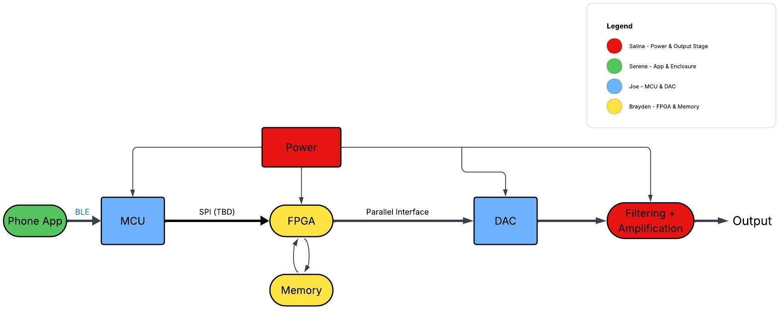



**Figure 2. Block Diagram of System**

The arbitrary waveform generator consists of five main subsystems: the phone application, microcontroller (MCU), FPGA with external memory, digital-to-analog converter (DAC), and the filtering/amplification stage, all supported by a dedicated power supply. The phone application serves as the user interface, allowing the operator to define waveform parameters such as frequency, amplitude, and phase. These parameters are sent to the

MCU over a Bluetooth Low Energy (BLE) connection. The MCU interprets the commands and prepares waveform data in the form of a lookup table (LUT). Communication between the MCU and the FPGA occurs over a Serial Peripheral Interface (SPI), enabling efficient transfer of waveform data and control signals.

The FPGA, working with dedicated memory, steps through the LUT to generate high-speed digital waveform samples according to a frequency tuning word. These samples are passed to the DAC over a parallel interface, which allows fast and precise data conversion. The DAC outputs an analog version of the waveform, which is then conditioned by filtering to suppress harmonics and noise. Finally, the signal is buffered and amplified to drive test equipment or other loads reliably. The power subsystem provides stable and regulated voltage rails across all blocks, ensuring both the digital logic and analog circuitry operate as expected. Together, these interconnected subsystems form a flexible DDS-based arbitrary waveform generator capable of producing clean, customizable signals for laboratory and instrumentation use.

##### Characteristics

* + 1. **Functional / Performance Requirements**

* + - 1. **Phase and Offset Adjustability**

The generator shall provide phase control from –180° to +180° in ≤1° steps and allow DC offset adjustment up to ±5 V with ≤50 mV error.

*Rationale: These capabilities give users flexibility in aligning signals and tailoring outputs for systems where phase synchronization and baseline shifting are critical.*

* + - 1. **Frequency Accuracy and Range**

The generator shall produce output waveforms from 0 Hz to 100 kHz with a frequency accuracy of ±1%.

*Rationale: This wide range ensures the system can provide both very low-frequency signals for slow system testing and higher-frequency signals for instrumentation applications.*

* + - 1. **Amplitude Control (Vpp)**

The generator shall support programmable amplitudes from 0 to 10 Vpp (±5 V swing) into a 50 Ω load, with an accuracy of ±0.1 Vpp.

*Rationale: This guarantees that the device can deliver signals strong enough for most lab equipment while maintaining reliable amplitude precision.*

* + - 1. **Signal Fidelity (THD + Noise)**

The generator shall achieve a total harmonic distortion (THD) of ≤2% for sinusoidal outputs up to 50 kHz, and a THD of ≤5% for square wave outputs in the same frequency range.

*Rationale: Low THD on sine waves ensures clean and precise signals for sensitive testing, while a more relaxed specification on square waves accounts for their inherently higher harmonic content caused by sharp transitions.*

* + - 1. **Waveform Flexibility and Stability**

The generator shall support arbitrary waveform playback from a 64k-point LUT, with signal variation limited to ±0.5% over one hour under normal conditions.

*Rationale: This ensures both versatility in generating custom waveforms and stability for repeatable, long-duration testing.*

* + 1. **Physical Characteristics**

This is the area where you will specify any requirements regarding the physical characteristics of your system. Does the system need to not have a mass/weight higher than X, etc.? There are exam3.2.2.1ples shown below…

* + - 1. **Mass**

The Arbitrary Waveform Generator shall have a total mass less than or equal to **2.5 kg**

including the enclosure, PCBs, and connectors.

*Rationale: This value provides flexibility during prototyping while ensuring the device remains lightweight and portable for benchtop use. The actual mass is expected to be significantly lower due to PLA construction and compact subsystems*

* + - 1. **Volume Envelope**

The volume envelope of the AWG shall not exceed 12 in. (length) × 8 in. (width) × 10 in. (height).

*Rationale: This ensures the device fits comfortably on standard laboratory benches without consuming excessive workspace. The actual size may be smaller but shall remain within this envelope for usability*

* + - 1. **Mounting (External)**

The AWG enclosure shall be self-supporting for tabletop use, with optional screw holes or slots to allow attachment to a larger test fixture if needed.

*Rationale: While the AWG is primarily designed for benchtop operation, minimal external mounting provisions ensure flexibility for lab integration.*

* + - 1. Mounting (Internal)

The enclosure shall provide mounting features (bosses, standoffs, or brackets) to secure printed circuit boards (PCBs), as well as through-holes or cutouts to mount BNC connectors, LEDs, and control switches.

*Rationale: Proper mounting ensures mechanical stability, protects solder joints from stress, and allows reliable user interaction with I/O connectors and indicators.*

* + - 1. Ergonomics

The enclosure may include simple grip features or recessed areas to aid in lifting or moving the device.

*Rationale: This is not a strict requirement, but may improve usability without impacting enclosure integrity.*

* + 1. **Electrical Characteristics**

* + - 1. **Input Voltage Range**

a. The AWG shall accept a +12 V DC input at ±10% tolerance (+10.8 V - 13.2 V)

*Rationale: By design, the system will use a 12 V AC/DC adapter that takes the 120 V AC power from a wall outlet and converts it into a stable 12 V DC output that the device can use. The ±10% tolerance covers typical adapter tolerance and cable drop.*

* + - * 1. **Input Protection**

The AWG shall tolerate reverse polarity and voltage surge without damage (P-MOS, TVS)

*Rationale: Input protections are crucial in safeguarding sensitive internal electrical components from damage caused by real-world electrical faults, making the system more reliable and compliant with safety standards.*

* + - * 1. **Power Conversion**

The AWG shall generate +3.3 V at ±2% tolerance for MCU, FPGA, Memory

The AWG shall generate +3.3V CLEAN at ±2% tolerance for DAC VDD

The AWG shall generate +5.0 V at ±5 mV tolerance for DAC VREF

The AWG shall generate ±5.0 V at ±2% tolerance for the analog op-amps

*Rationale: Multiple voltage rails are needed to satisfy the power requirements of the different subsystems, ensuring optimal performance and power efficiency. Noisy digital rails should be separated from sensitive analog rails, and different components have distinct power needs.*

* + - * 1. **Power Consumption**

The maximum peak power of the system shall not exceed 8 watts.

*Rationale: The typical nominal operating power is ≤ 8 watts based on the current calculated for each voltage rail. An AC/DC adapter of 12 V @ 2 A = 24 watts shall be used during development for safety measures under the circumstances that the system draws more power than what was previously calculated.*

* + - * 1. **Power Supply Ripple Rejection**

The analog output filter stage shall maintain specified output performance when the ±5 V supply rails exhibit up to 150 𝑚𝑉 of switching ripple.

𝑝𝑝

* Sinusoidal Output: No degradation of output waveform amplitude or distortion greater than 2% Total Harmonic Distortion (THD) shall occur, measured up to 100 kHz.
* Square Wave Output: No degradation of output waveform amplitude or distortion greater than 5% Total Harmonic Distortion (THD) shall occur, measured up to 100 kHz.

*Rationale: The DC/DC switching converters are inherently noisy, producing high-frequency ripples that enter the supply pins of the sensitive analog components. Good power supply ripple rejection is needed to ensure that the AWG can tolerate normal power ripple and still produce clean outputs.*

* + - * 1. **Output Noise**

The AWG output shall have a noise level of ≤ 5 𝑚𝑉 measured over the 0 - 100 kHz

𝑅𝑀𝑆

bandwidth when terminated into 50 Ω.

*Rationale: Even when no signal is being generated, there will be inherence random noise voltage present at the AWG outputs. It is important to set an output noise requirement to ensure that the AWG maintains baseline signal quality.*

* + - 1. **Outputs**

* + - * 1. **Analog Waveform Output**

The system shall provide a 10

𝑉

𝑝𝑝

analog output signal (sine, square, triangle, sinc or

arbitrary) at a buffered output port capable of driving a 50 Ω load

*Rationale: This is the primary functional output of the generator, delivering the user-defined waveform to external equipment for testing and measurement.*

* + - * 1. **Output Current Drive**

The system shall be able to drive 100 mA per channel continuously.

*Rationale: If a user requests a +5 V DC or holds a square wave at +5 V, the output needs to be able to continuously draw 100 mA to drive the 50 Ω load.*

* + - * 1. **Mobile Application Output**

The system shall display parameters such as frequency, amplitude, phase, and offset. The system shall display the intended waveform prior to sending it to the device.

*Rationale: This ensures users can view and control system outputs prior to sending it to the AWG device, providing a simple and accessible interface without additional lab hardware.*

* + - 1. **Connectors**

The system shall include two BNC jacks for outputting channel 1 or channel 2 waveforms to a lab bench oscilloscope. The system shall include an input 12V power connector to power its components.

*Rationale: This is a requirement specified by our customer in order to have the ability to output and verify generated waveforms from channel 1 or channel 2. The 12V power connector ensures the device has the power it needs to complete its function.*

* + - 1. **Wiring**

The AWG will utilize PCBs for its circuitry. The indicator lights will wire to a PCB board, and the BNC output jacks will be placed on a PCB and strategically surface mounted to the enclosure.

*Rationale: Minimizes size and highlights organization.*

* + 1. **Environmental Requirements**

The Arbitrary Waveform Generator shall be designed to operate reliably in standard indoor laboratory and classroom environments. As the enclosure is fabricated using PLA, the system is not intended for extreme environmental conditions. The following environmental limits are defined:

* + - 1. **Thermal**

The AWG shall operate between 15 °C and 30 °C ambient temperature and be stored between 0 °C and 40 °C.

*Rationale: PLA softens above ~55 °C, so limiting operational temperature ensures structural stability while covering normal indoor environments.*

* + - 1. **External Contamination**

The AWG shall be kept free from dust, debris, and corrosive vapors, with operation limited to clean laboratory environments.

*Rationale:* PLA and electronic subsystems have no ingress protection; exposure to contaminants may reduce lifespan or reliability.

* + - 1. **Rain/Liquids**

The AWG shall not be exposed to direct moisture, rain, or liquid spills.

*Rationale:* PLA is porous and non-waterproof, and the device has no environmental sealing. It must be operated indoors in dry conditions.

* + - 1. **Vibration/Shock**

The AWG shall withstand handling associated with normal lab use but is not rated for sustained vibration, heavy impact, or drop tests.

*Rationale:* PLA enclosures and unsecured lab electronics are not ruggedized; limiting to benchtop handling ensures reliability.

* + - 1. **Electromagnetic Interference (EMI)**

The AWG shall operate in standard laboratory EMI conditions but is not shielded against high EMI/RFI environments.

*Rationale:* PLA offers no inherent shielding, and sensitive subsystems may be affected by strong electromagnetic fields.

* + - 1. **UV/Sunlight Exposure**

The AWG shall not be stored or operated in direct sunlight for extended periods.

*Rationale:* PLA degrades under prolonged UV exposure, which can weaken the enclosure and affect mechanical integrity.

#### Support Requirements

The Two-Channel Arbitrary Waveform Generator will be delivered with all necessary documentation, software, and support resources to enable proper operation by the end user. The following support provisions will be provided:

**System Requirements**

* Operation of the mobile application will require a smartphone (iOS or Android) with Bluetooth capability. One will be provided during the demo phase. A laptop or desktop computer with a modern operating system (Windows) will be required for startup. Minimum laptop requirements include 4 GB of RAM, 1 USB port, and internet access for downloading updates. A laptop will be provided for demo.

**User Documentation**

* A comprehensive user manual will be provided covering setup, safety guidelines, and waveform generation steps.

**Training**

* The Only WGT will demonstrate how to set up and function the device to the sponsor.

These support requirements ensure that the AWG provides users with the resources necessary to fully utilize the system’s capabilities.

#### Appendix A: Acronyms and Abbreviations

Below is a list of common acronyms and abbreviations used throughout this document

AWG Arbitrary Waveform Generator

EMI Electromagnetic Interference

UV Ultraviolet

GUI Graphical User Interface

Hz Hertz

kHz Kilohertz (1,000 Hz)

LED Light-emitting Diode

mA Milliamp

MHz Megahertz (1,000,000 Hz)

mW Milliwatt

PCB Printed Circuit Board

TBD To Be Determined

USB Universal Serial Bus

IN Inches

MCU Microcontroller Unit

FPGA Field Programmable Gate Array

DAC Digital-to-Analog Converter

LUT Lookup Table

BLE Bluetooth Low Energy

SPI Serial Peripheral Interface

BNC Bayonet Neill–Concelman (Connector)

ICD Interface Control Document

Vpp Peak-to-Peak Voltage

THD Total Harmonic Distortion

RMS Root Mean Square

Ω Ohm (Unit of Resistance)

VREF Reference Voltage

VDD Positive Supply Voltage

IEEE Institute of Electrical and Electronics Engineers

SIG Special Interest Group (Bluetooth SIG)

IPC Institute for Printed Circuits

CONOPS Concept of Operations

mVrms Millivolt Root Mean Square

## Two Channel Arbitrary Waveform Generator

Brayden Donovan

Salina Teng Serene Singh Joe Knipper

# Interface Control Document

### Interface Control Document

FOR

### Two Channel Arbitrary Waveform Generator

Prepared by:



The Only WGT 12/03/2025

Approved by:



Serene Singh 12/03/2025



John Lusher, P.E. 12/03/2025



Jianhan Pan 12/03/2025

**Change Record**

| **Rev**  **.** | **Date** | **Originator** | **Approvals** | **Description** |
| --- | --- | --- | --- | --- |
| v1 | 10/04/2025 | Serene Singh | The Only WGT | Draft Release |
| v2 | 12/03/2025 | Serene Singh | The Only WGT | Draft Release |

**Table of Contents**

1. Overview 5
2. References and Definitions 6
   1. References 6
   2. Definitions 6
3. Physical Interface 8
   1. Weight 8

Device Weight by Component 8

* 1. Dimensions 8

Device Dimensions by Component 8

* 1. Mounting Locations 9

1. Thermal Interface 9
2. Electrical Interface 10
   1. Primary Input Power 10
   2. Polarity Reversal & Input Protection 10
   3. Power Distribution Rails 10
   4. Reference Voltage Interface 10
   5. Analog Output Interfaces 10
3. Communications / Device Interface Protocols 11
   1. Bluetooth Low Energy (BLE) (Phone → ESP32) 11
   2. Host Device 11
      1. Functional Role 11
      2. Connectivity 12
   3. Parallel Interface (FPGA → DAC) 12
   4. Serial Peripheral Interface (MCU → FPGA) 12

**List of Tables**

**Table 1: Subsystem Weight** **Table 2: Subsystem Dimensions**

#### Overview

This Interface Control Document (ICD) defines the interfaces, operational concepts, and supporting requirements for the Two-Channel Arbitrary Waveform Generator (AWG) subsystem. The ICD establishes the technical baseline between hardware, firmware, and software elements of the system, with a focus on ensuring interoperability, consistent data exchange, and predictable performance.

The Two-Channel AWG is designed to generate user-defined analog signals across two independent channels with precise control of amplitude, frequency, phase, and waveform shape. It supports both standard waveform types (e.g., sine, square, triangular) and custom arbitrary waveforms defined by the user. The system integrates a microcontroller (ESP32), field-programmable gate array (FPGA), and high-resolution digital-to-analog converters (DACs) to deliver flexible signal generation for laboratory applications.

This ICD documents the physical, electrical, and logical interfaces required to operate and integrate the AWG, including:

1. Physical interfaces such as size, weight, and thermal characteristics.
2. Electrical interfaces covering power input, signal conditioning, and analog outputs.
3. Communication and control protocols, including Bluetooth Low Energy (BLE), USB, SPI, and FPGA-to-DAC parallel data transfer.
4. Operational concepts and modes to define how the system is initialized, configured, and used by different classes of users.

The scope of this ICD is limited to subsystem-level design, integration, and interface requirements. Internal component-level specifications (e.g., FPGA HDL implementation details, DAC timing parameters beyond manufacturer datasheet values) are referenced but not fully defined within this document. This approach ensures that the ICD serves as a reference for system engineers, developers, and sponsors while maintaining flexibility for future updates and design modifications.

#### References and Definitions

This section lists the technical references, standards, and supporting documents that guided the design and implementation of the Two-Channel Arbitrary Waveform Generator. It also defines key terms and abbreviations used throughout this Interface Control Document to ensure clarity and consistency.

##### References

**Bluetooth Core Specification v4.2**

2 Dec 2014

**Bluetooth Core Specification v5.0**

6 Dec 2016

**IEEE 802.15.1 Standard**

Wireless Medium Access Control (MAC) and Physical Layer Specifications for Wireless Personal Area Networks (WPANs)

**Texas Instruments DAC8820 Datasheet**

16-Bit, Current-Output Digital-to-Analog Converter Rev. E

Feb 2006

**Espressif Systems – ESP32 Technical Reference Manual**

Version 5.4

Sep 2024

**Intel MAX10 Device Handbook - Combined**

Version 683658

10 Mar 2025

**128K x 16 Low Voltage, Ultra Low Power CMOS Static RAM**

Rev. J

19 Nov 2013

**High Performance Differential MEMS Oscillators for Automotive**

Rev. D May 2023

* 1. ***Definitions*** AWG Arbitrary Waveform Generator BLE Bluetooth Low Energy

MCU Microcontroller Unit

FPGA Field-Programmable Gate Array DAC Digital-to-Analog Converter

SPI Serial Peripheral Interface

LUT Lookup Table VREF Reference Voltage

VDD Positive Power Supply Voltage I/O Input / Output

MSa/s Mega Samples per second

BNC Bayonet Neill–Concelman Connector CPOL Clock Polarity

CPHA Clock Phase

TRM Technical Reference Manual TBD To Be Determined

MHz Megahertz (1,000,000 Hz) mA Milliamp

mW Milliwatt

MEMS Microelectromechanical System

#### Physical Interface

The physical interface of the Two-Channel Arbitrary Waveform Generator (AWG) defines the mechanical, dimensional, and environmental characteristics required for integration into laboratory and embedded system environments. This section documents subsystem weight, dimensions, mounting considerations, and thermal interfaces.

##### Weight

Weights are all estimated in grams. Maximum estimated weight values are given.

**Device Weight by Component**

| Component | Weight | Number of Items | Total Weight |
| --- | --- | --- | --- |
| ESP32 | 5 | 1 | 5 |
| TI DAC8820 | 1 | 2 | 2 |
| FPGA | 1 | 1 | 1 |
| SRAM | 0.5 | 2 | 1 |
| MEMS Oscillator | 0.1 | 1 | 0.1 |
| PCB | 70 | 1 | 1 |
| Enclosure | 2500 | 1 | 2500 |

*Table 1: Subsystem Weight*

##### Dimensions

Estimated dimensions are provided in millimeters and represent component outlines as defined in vendor datasheets or maximum estimated dimensions. The assembled subsystem dimensions are estimated to fit within a compact enclosure suitable for laboratory bench use.

**Device Dimensions by Component**

| Component | Length | Width | Height |
| --- | --- | --- | --- |
| ESP32 | 54.30 | 27.94 | 8.00 |
| TI DAC8820 | 10.50 | 8.20 | 2.00 |
| FPGA | 22.00 | 22.00 | 1.45 |
| SRAM | 18.41 | 11.76 | 1.00 |
| MEMS Oscillator | 7.00 | 5.00 | 0.85 |
| Enclosure | 304.8 | 203.2 | 254.0 |

*Table 2: Subsystem Dimensions*

##### Mounting Locations

The subsystem PCB is designed for enclosure mounting using four corner mounting holes (M3 screw compatibility). These holes allow direct mounting to either standoffs or a mechanical chassis. Connector placement (BNC outputs and DC power jack) is aligned along the front and rear edges of the enclosure for user accessibility.

#### Thermal Interface

No specialized thermal management components (e.g., heatsinks, fans, or cold plates) are required for this design. Power dissipation from the ESP32, FPGA, and DACs is expected to remain within manufacturer operating limits under normal load conditions.The enclosure is expected to provide passive ventilation through open slots or cutouts, ensuring natural convection.

#### Electrical Interface

##### Primary Input Power

The AWG receives primary input power through a DC barrel jack connector, which takes in power through an AC/DC wall adapter. The nominal operating voltage is +12 V DC, with an allowable input range of 10.8V to 13.2V (±10% tolerance). For development, the system will use a 12 V, 2A (24 W) power adapter to provide sufficient headroom in the scenario that the system draws more power than what was previously calculated. In final operation, a 12 V, 1 A (12 W) power adapter may be used as it fits with the load requirements

##### Polarity Reversal & Input Protection

The input power supply is protected against polarity reversal by a P-channel MOSFET. A P-channel MOSFET was selected over a regular diode because of its low voltage drop. In the event that the input supply polarity is reversed, the system will be non-conductive and no damage shall occur. Additional protections include a transient voltage suppressor (TVS) diode for voltage surge and spike protection.

##### Power Distribution Rails

The 12 V primary input voltage is converted and distributed internally into the following individual regulated supply rails:

* FPGA: +3.3 V (core, I/O, auxillary)
* MEMS Oscillator: +3.3 V
* MCU (ESP32): +3.3 V
* Memory (SRAM): +3.3 V
* DACs: +3.3 V (VDD, filtered), +5 V (precision reference input)
* Output Filter/Amplifier Stage: ±5 V analog supply rails

##### Reference Voltage Interface

A precision +5 V reference input is provided to the DACs using a precision voltage reference IC. This voltage reference determines the DACs’ full scale voltage output range (±5 V) and is routed through a low-noise pi-filter to ensure stability and accuracy of the generated analog waveforms.

##### Analog Output Interfaces

The AWG provides two independent analog waveform outputs using a two channel system, each available through a 50 Ω terminated BNC connector. Each channel is capable of delivering a minimum 100 mA current to meet the ±5 V peak requirement into the 50 Ω standard load.

#### Communications / Device Interface Protocols

This section defines the communication methods and device interface protocols used within the Two-Channel Arbitrary Waveform Generator (AWG). Externally, the AWG communicates with host devices through Bluetooth Low Energy (BLE) for wireless control. Internally, the design relies on digital communication standards such as SPI (Serial Peripheral Interface) between the microcontroller and FPGA, and a parallel interface between the FPGA and DACs to achieve high-speed waveform updates.

##### Bluetooth Low Energy (BLE) (Phone → ESP32)

Bluetooth Low Energy (BLE), compliant with the Bluetooth Core Specification v4.2/5.0 and based on the IEEE 802.15.1 standard, provides the wireless communication link between the mobile phone application and the ESP32 microcontroller. BLE was selected over Wi-Fi and other wireless protocols because it offers sufficient bandwidth for control data, significantly lower power consumption, and reliable compatibility with modern smartphones. The ESP32 natively supports BLE, enabling efficient data exchange without requiring any external radios or hardware.

Within this standard transport, the system implements a custom packet protocol tailored for waveform generation commands. Each BLE packet begins with a 4-byte header: version (fixed at 1), message type (currently 0 for waveform configuration), and a 16-bit sequence number. The payload is then encoded using Type-Length-Value (TLV) fields, which specify waveform parameters such as shape, frequency (mHz), amplitude (mVpp), offset (mV), phase (mdeg), and channel selection. This structure allows flexible extension while keeping parsing lightweight on the ESP32. Once received, the packets are acknowledged back to the phone to confirm proper delivery. For arbitrary waveform uploads, a different packet format will be defined to handle larger data streams, but this specification is still under development (TBD).

##### Host Device

The Host Device is a computer-based application that serves as the primary user interface for configuring, controlling, and monitoring the Two-Channel Arbitrary Waveform Generator (AWG). While the AWG hardware provides the physical signal generation, the host software acts as the central command environment, enabling users to define waveform parameters, upload arbitrary waveforms, and manage device operation.

##### Functional Role

The host application provides an intuitive interface for system interaction, extending beyond the limitations of hardware buttons or minimal onboard controls. Its primary functions include:

1. **Waveform Definition and Upload** – Users can graphically design waveforms or import data files (e.g., CSV formats) and upload them directly to the AWG for playback.
2. **Parameter Configuration** – Frequency, amplitude, phase, offset, duty cycle, and channel routing are adjustable via the host interface.
3. **Mode Control** – The host can switch between standard waveform generation (sine, square, triangle) and arbitrary waveform playback.

##### Connectivity

The host communicates with the AWG using Bluetooth Low Energy (BLE). This provides wireless control for lightweight parameter adjustments and waveform configurations.

##### Parallel Interface (FPGA → DAC)

The interface between the FPGA and DAC is implemented as a 16-bit parallel digital interface, where the FPGA drives data words and control strobes directly to the DAC at each update cycle. Unlike SPI or BLE, this type of interface is not governed by a universal IEEE standard but is instead defined in the DAC manufacturer’s datasheet and timing diagrams. In this project, the design follows the conventions outlined in the Texas Instruments DAC8820 16-bit DAC documentation, which specifies setup and hold times, voltage thresholds, and update timing for reliable operation. By using a parallel interface, the system achieves the throughput required for 1 MSa/s updates, ensuring that waveform samples are delivered to the DAC with sufficient bandwidth and timing precision to maintain signal fidelity.

##### Serial Peripheral Interface (MCU → FPGA)

The SPI interface implementation follows the specifications in the Espressif ESP32 Technical Reference Manual (v5.4), which describes the SPI controller architecture, supported SPI modes, signal timing, and register-level control.The SPI communication between the ESP32 MCU and the FPGA is implemented in Mode 0 (CPOL = 0, CPHA = 0), operating at a clock speed of approximately 1 MHz. Each transaction consists of a fixed 35-bit packet format: 3 bits of opcode, 16 bits of address/reset information, and 16 bits of amplitude data. This compact structure allows the MCU to efficiently transfer waveform parameters and control information to the FPGA with minimal overhead.

The interface uses three pins: MOSI (Master Out Slave In) to carry data from the MCU to the FPGA, SCLK (Serial Clock) to synchronize the data transfer, and CS (Chip Select) to frame each transaction by enabling or disabling the FPGA’s SPI logic. By keeping the pin count low and packet format simple, the design ensures reliable communication while reducing hardware complexity and resource usage on the FPGA.

## Two Channel Arbitrary Waveform Generator

Brayden Donovan

Salina Teng Serene Singh Joe Knipper

# Milestones/Execution Plan

| **Work** | **End date** | **Owner** | **Status** | **Subsystem** |  | **Color** | **Subteam** |
| --- | --- | --- | --- | --- | --- | --- | --- |
| Complete SU 1 Slides | 9/28 | Entire Team | Completed | Entire Team |  |  | **Mobile Device/Enclosure** |
| SU Presentation Run-Through | 9/28 | Entire Team | Completed | Entire Team |  |  | **FPGA/Memory** |
| Finalize front-end AWG tab | 9/28 | Serene | Completed | Mobile/Enclosure |  |  | **DAC/Microcontroller** |
| Finalize front-end drawable tab | 9/28 | Serene | Completed | Mobile/Enclosure |  |  | **Power/Filters** |
| Design Bluetooth and LUT Calculations. | 9/28 | Joe | Completed | DAC/Microcontroller |  |  |  |
| Confirm design specifications - min and max frequencies, design methodology, vertical and horizontal waveform resolution | 9/28 | Brayden | Completed | FPGA/Memory |  |  |  |
| **Status Update 1 Presentation** | 9/30 | Entire Team | Completed | Entire Team |  |  |  |
| Draft Enclosure Design | 9/30 | Serene | Completed | Mobile/Enclosure |  |  |  |
| Determine size of memory needed and appropriate FPGA (and external memory if needed) | 9/30 | Brayden | Completed | FPGA/Memory |  |  |  |
| Write FSR | 10/2 | Entire Team | Completed | Entire Team |  |  |  |
| Write ICD | 10/2 | Entire Team | Completed | Entire Team |  |  |  |
| Create Validation Plan | 10/2 | Entire Team | Completed | Entire Team |  |  |  |
| Finalize app front-end polish for AWG & Drawable tabs | 10/2 | Serene | Completed | Mobile/Enclosure |  |  |  |
| Choose and order voltage controlled oscillator | 10/2 | Brayden | Completed | FPGA/Memory |  |  |  |
| Finalize Bluetooth and LUT. Begin working on SPI protocol | 10/4 | Joe | In-Progress | DAC/Microcontroller |  |  |  |
| Select Initial enclosure dimensions & layout | 10/6 | Serene |  | Mobile/Enclosure |  |  |  |
| Order FPGA IC, breadboard to IC connector, JTAG programmer, and other components | 10/6 | Brayden |  | FPGA/Memory |  |  |  |
| Add backend 'Send' function (test with mock data) | 10/8 | Serene |  | Mobile/Enclosure |  |  |  |
| Build rough enclosure CAD model | 10/8 | Serene |  | Mobile/Enclosure |  |  |  |
| Simulate waveform plotting with backend-calculated points | 10/10 | Serene |  | Mobile/Enclosure |  |  |  |
| Review enclosure CAD with team | 10/10 | Serene |  | Mobile/Enclosure |  |  |  |
| Power Schematic Finalization | 10/10 | Salina | In-Progress | Power/Filters |  |  |  |
| Output Filter Schematic Finalization | 10/10 | Salina | In-Progress | Power/Filters |  |  |  |
| Establish Test Comms w/Microcontroller (send dummy values) | 10/12 | Serene |  | Mobile/Enclosure |  |  |  |
| Order LEDs and BNC Jacks for enclosure | 10/12 | Serene | Completed | Mobile/Enclosure |  |  |  |
| **Complete subsystem demo schematics** | 10/12 | Joe |  | DAC/Microcontroller |  |  |  |
| Create memory interfacing and connection to inputs and outputs in HDL | 10/12 | Brayden | Completed | FPGA/Memory |  |  |  |
| Create variable reset binary counter in HDL | 10/14 | Brayden | Completed | FPGA/Memory |  |  |  |
| Test microcontroller receives values correctly (basic UART/Bluetooth/WiFi message) | 10/16 | Serene |  | Mobile/Enclosure |  |  |  |
| Create control circutry in HDL | 10/16 | Brayden | Completed | FPGA/Memory |  |  |  |
| Expand app backend to handle drawable waveform → array output (simulation only) | 10/18 | Serene |  | Mobile/Enclosure |  |  |  |
| Finalize SPI protocol. Begin testing BLE and LUT with phone. | 10/18 | Joe |  | DAC/Microcontroller |  |  |  |
| Connect circuitry to SPI input | 10/18 | Brayden |  | FPGA/Memory |  |  |  |
| ECEN Design Blitz | 10/20 | Entire Team |  | Entire Team |  |  |  |
| Print enclosure prototype V1 | 10/20 | Serene |  | Mobile/Enclosure |  |  |  |
| **Finalize simulation in HDL** | 10/22 | Brayden |  | FPGA/Memory |  |  |  |
| Revise CAD for enclosure V2 | 10/24 | Serene |  | Mobile/Enclosure |  |  |  |
| Complete SU 2 Slides | 10/26 | Entire Team |  | Entire Team |  |  |  |
| SU Presentation Run-Through | 10/26 | Entire Team |  | Entire Team |  |  |  |
| Subsystem test: app sends values → microcontroller receives/logs | 10/26 | Serene |  | Mobile/Enclosure |  |  |  |
| Print enclosure V2 | 10/26 | Serene |  | Mobile/Enclosure |  |  |  |
| Finalize phone testing. Test SPI Protocol | 10/26 | Joe |  | DAC/Microcontroller |  |  |  |
| **Status Update 2 Presentation** | 10/28 | Entire Team |  | Entire Team |  |  |  |
| Add waveform preset save/load feature in app | 10/28 | Serene |  | Mobile/Enclosure |  |  |  |
| Simulation & Sanity Check | 10-28 | Salina | In-Progress | Power/Filters |  |  |  |
| Subsystem test: app backend + microcontroller (values only) | 10/30 | Serene |  | Mobile/Enclosure |  |  |  |
| Refine enclosure details | 10/30 | Serene |  | Mobile/Enclosure |  |  |  |
| Construct test setup on breadboard | 10/30 | Brayden |  | FPGA/Memory |  |  |  |
| BOM Freeze | 10/30 | Salina |  | Power/Filters |  |  |  |
| Schematic Freeze | 10/30 | Salina |  | Power/Filters |  |  |  |
| Prepare final enclosure CAD V3 | 11/1 | Serene |  | Mobile/Enclosure |  |  |  |
| FInalize SPI testing. Verify DAC operation. | 11/01 | Joe |  | DAC/Microcontroller |  |  |  |
| Layout Constraints Document | 11/1 | Salina |  | Power/Filters |  |  |  |
| Stress test app | 11/3 | Serene |  | Mobile/Enclosure |  |  |  |
| Print final enclosure | 11/3 | Serene |  | Mobile/Enclosure |  |  |  |
| PCB Placement | 11/3 | Salina |  | Power/Filters |  |  |  |

| Assemble final enclosure build | 11/5 | Serene |  | Mobile/Enclosure |  |  |  |
| --- | --- | --- | --- | --- | --- | --- | --- |
| Freeze app features (bug fixes only) | 11/7 | Serene |  | Mobile/Enclosure |  |  |  |
| Program arduino/esp32 test board to test physical setup | 11/7 | Brayden |  | FPGA/Memory |  |  |  |
| PCB Routing | 11/7 | Salina |  | Power/Filters |  |  |  |
| PCB Layout Review (Self-Check) | 11/7 | Salina |  | Power/Filters |  |  |  |
| Verify subsystem-level communication with microcontroller | 11/9 | Serene |  | Mobile/Enclosure |  |  |  |
| **Final verification of physical setup** | 11/9 | Brayden |  | FPGA/Memory |  |  |  |
| PCB Layout Post-Review and Revisions | 11/10 | Salina |  | Power/Filters |  |  |  |
| Gerber + Fab File Generation | 11/10 | Salina |  | Power/Filters |  |  |  |
| PCB & Parts Order | 11/10 | Salina |  | Power/Filters |  |  |  |
| Polish app UI/UX | 11/11 | Serene |  | Mobile/Enclosure |  |  |  |
| Wire LEDs/BNC Jacks in enclosure | 11/11 | Serene |  | Mobile/Enclosure |  |  |  |
| Repeatability test: app sends values to microcontroller | 11/13 | Serene |  | Mobile/Enclosure |  |  |  |
| Prepare subsystem-level demo (app + microcontroller + enclosure) | 11/15 | Serene |  | Mobile/Enclosure |  |  |  |
| Complete SU 3 Slides | 11/17 | Entire Team |  | Entire Team |  |  |  |
| SU Presentation Run-Through | 11/17 | Entire Team |  | Entire Team |  |  |  |
| PCB Assembly | 11/17 | Salina |  | Power/Filters |  |  |  |
| **Status Update 3 Presentation** | 11/19 | Entire Team |  | Entire Team |  |  |  |
| Dry-run subsystem demo | 11/19 | Serene |  | Mobile/Enclosure |  |  |  |
| Backup app + CAD files | 11/21 | Serene |  | Mobile/Enclosure |  |  |  |
| Design PCB | 11/21 | Brayden |  | FPGA/Memory |  |  |  |
| Test: Power Rails | 11/21 | Salina |  | Power/Filters |  |  |  |
| Finialize App and Enclosure Documentation | 11/23 | Serene |  | Mobile/Enclosure |  |  |  |
| Prepare final slides for subsystem demo | 11/25 | Serene |  | Mobile/Enclosure |  |  |  |
| Order PCB | 11/25 | Brayden |  | FPGA/Memory |  |  |  |
| Test: Output Filter Chain | 11/25 | Salina |  | Power/Filters |  |  |  |
| Demo rehearsal (Subsystem Information only) | 11/27 | Serene |  | Mobile/Enclosure |  |  |  |
| Resolder ICs onto PCB | 11/27 | Brayden |  | FPGA/Memory |  |  |  |
| Final testing | 11/29 | Brayden |  | FPGA/Memory |  |  |  |
| Full Subsystems Validation | 11/29 | Salina |  | Power/Filters |  |  |  |
| Subsystem-wide test (app stubs + microcontroller + enclosure) | 12/1 | Serene |  | Mobile/Enclosure |  |  |  |
| **Final testing and ready for demo** | 12/1 | Joe |  | DAC/Microcontroller |  |  |  |
| **Final Report Due** | **12/5** | **Entire Team** |  | **Entire Team** |  |  |  |
| **Final subsystem board ready** | 12/5 | Brayden |  | FPGA/Memory |  |  |  |

## Two Channel Arbitrary Waveform Generator

Brayden Donovan

Salina Teng Serene Singh Joe Knipper

**Validation Plan**

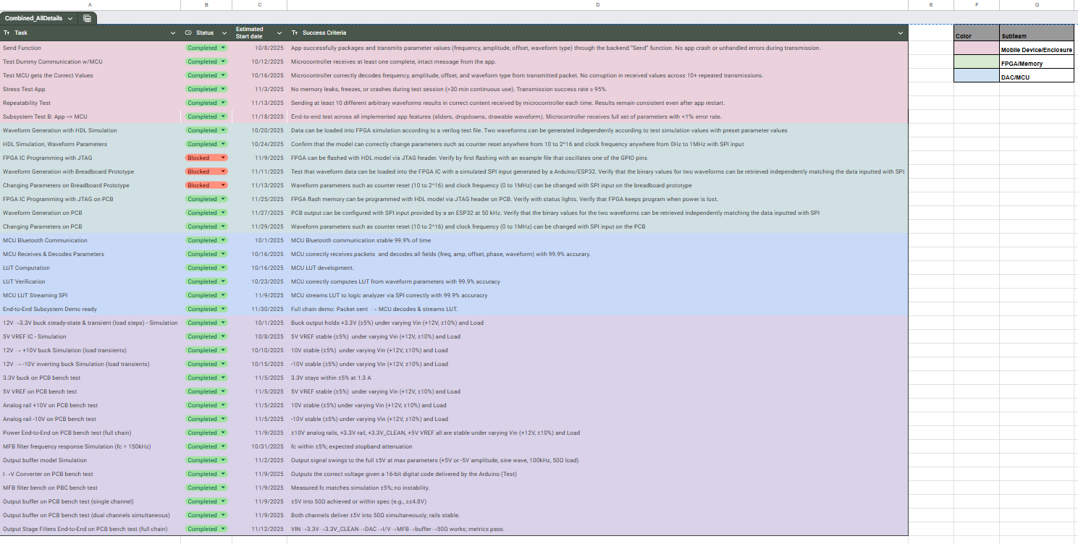

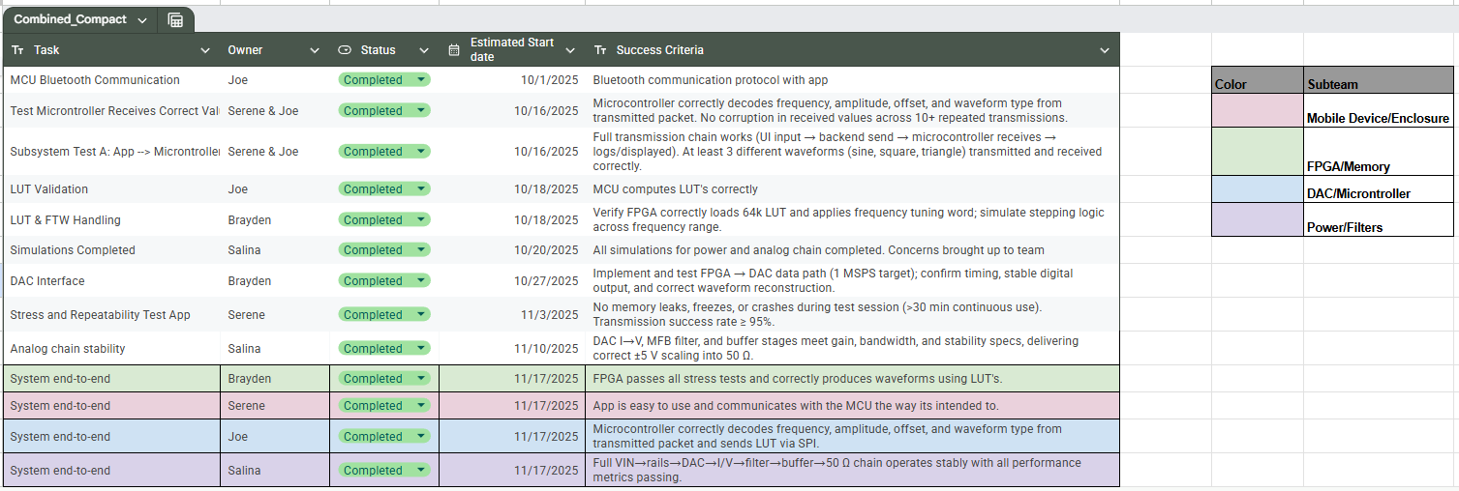

## Two Channel Arbitrary Waveform Generator

## **Subsystem Validation Reports**

**Table of Contents**

**1. Mobile Subsystem Validation Report**

1.1 Introduction

  1.1.1 Purpose of Document

  1.1.2 Subsystem Scope and Responsibilities

1.2 Validation Plan/Features Summary

  1.2.1 Waveform Configuration UI

  1.2.2 Drawable Arbitrary Waveform Interface

  1.2.3 Communication Layer

1.3 Validation Strategy for the Mobile Subsystem

  1.3.1 Validation Objectives and Metrics

1.4 Test Results and Validation Evidence

  1.4.1 Dummy Communication with Microcontroller

  1.4.2 BLE Communication Stability

  1.4.3 Parameter Encoding Correctness

  1.4.4 Repeatability Test

  1.4.5 End-to-End Subsystem Demo

1.5 Conclusion

**2. MCU Subsystem Validation Report**

2.1 Introduction

 2.1.1 Purpose of Document

 2.1.2 Subsystem Scope and Responsibilities

 2.1.3 Validation Plan

2.2 Design Summary

 2.2.1 Hardware – Custom ESP32 MCU PCB

 2.2.2 Firmware – BLE Interface and Command Parsing

 2.2.1 Standard Waveform Command ('S')

2.3 Validation Procedures

 2.3.1 Test Setup

 2.3.2 Validation Objectives and Metrics

2.4 Channel and Frequency Decode Verification

2.5 Overall Test Result Summary

2.6 Conclusion

**3. FPGA Subsystem Validation Report**

3.1 Subsystem Introduction

3.2 Subsystem Details

 3.2.1 Scope and Requirements

 3.2.2 Implementation Details

3.3 Validation Tests

 3.3.1 Waveform Generation

 3.3.2 Memory Read/Write Operations

3.4 Subsystem Conclusion

**4. Power Subsystem Validation Report**

4.1 Subsystem Introduction

4.2 Subsystem Overview

 4.2.1 Functional Description

 4.2.2 Requirements Summary

4.3 Power/Signal Calculations

4.4 Hardware Implementation

 4.4.1 Schematic Design

 4.4.2 PCB Layout Considerations

4.5 Integration with System

  4.5.1 Electrical Interfaces

4.6 Testing & Validation

 4.6.1 Validation Plan

 4.6.2 Simulations

 4.6.3 Benchtop Results

4.7 Subsystem Conclusion

**5. Analog Output Subsystem Validation Report**

5.1 Subsystem Introduction

5.2 Subsystem Overview

 5.2.1 Functional Description

 5.2.2 Requirements Summary

5.3 Hardware Implementation

 5.3.1 Schematic Design

 5.3.2 PCB Layout Considerations

5.4 Integration with System

5.5 Testing & Validation

 5.5.1 Validation Plan

 5.5.2 Simulation Results

 5.5.3 Benchtop Results

5.6 Subsystem Conclusion

## 

## 

## 

## 

## 

## 

## 

## 

## Two Channel Arbitrary Waveform Generator

Serene Singh

# Mobile Subsystem Validation Report

### 

### **1.1. Introduction**

#### 1.1.1 Purpose of Document

#### The purpose of this document is to validate the performance, correctness, and reliability of the Mobile Device Subsystem for the Two-Channel Arbitrary Waveform Generator (AWG). Validation results presented here demonstrate that the mobile application meets the functional requirements allocated to it in the Functional System Requirements (FSR), supports the system-level architecture described in the Interface Control Document (ICD), and satisfies the test objectives defined in the Validation Plan.

#### 1.1.2 Subsystem Scope and Responsibilities

The mobile subsystem provides the user interface and first point of interaction for the AWG. Its responsibilities include.

1. Allowing the user to configure waveforms via sliders, fields, dropdowns, and drawable input
2. Rendering accurate waveform previews based on user parameters
3. Encoding waveform configuration packets and transmitting them over BLE using NUS UUIDs
4. Ensuring robust communication with the microcontroller subsystem
5. Handling error states such as Bluetooth disconnects

This report evaluates the subsystem's performance within these responsibilities.

#### 1.2.2 Validation Plan

Validation activities are derived from the Mobile App row of the Validation Plan, including:

1. BLE communication tests
2. Packet encoding verification
3. Stress testing
4. Repeatability testing
5. End-to-end subsystem validation (App → Microcontroller)

Each test is documented with its success criteria and observed results.

**1.2. Features Summary**

The mobile subsystem includes the following implemented and validated features: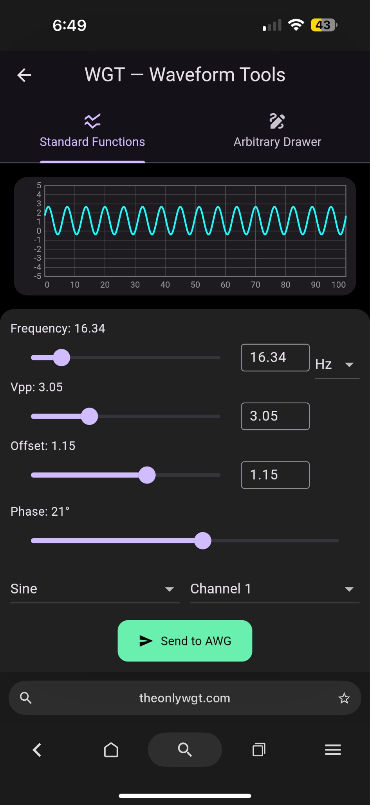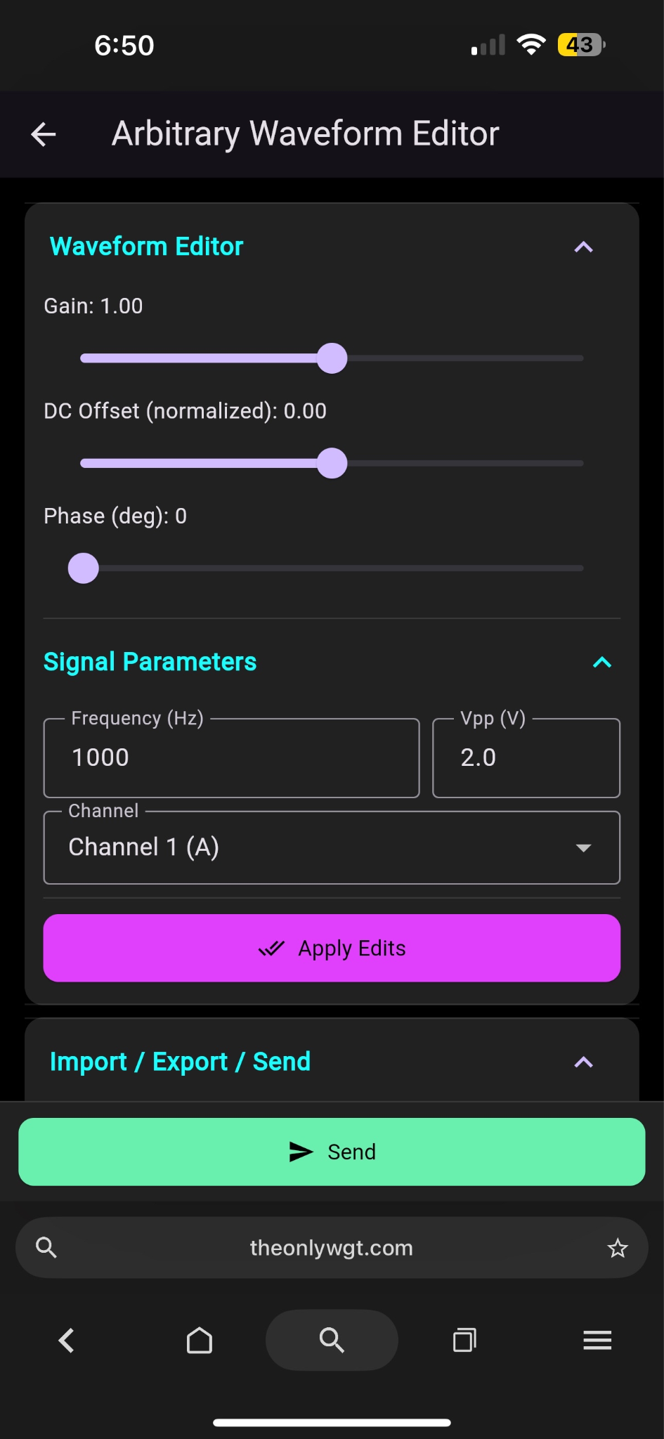

#### 1.2.1 Waveform Configuration UI

* Parameter sliders and numeric input fields (frequency, voltage peak to peak, offset, phase)
* Dropdown waveform type selector (Sine, Square, Triangle, Sinc)
* Real-time waveform preview
* Independent Channel A and Channel B selection tabs

#### 

#### 

#### 

#### 

#### 

#### 1.2.2 Drawable Arbitrary Waveform Interface

* Touch-draw canvas
* Automatic sampling of input strokes
* Export sampled array for MCU transmission
* Visual preview update after sampling

#### 1.2.3 Communication Layer

* Bluetooth Low Energy device scanning and connection
* Nordic UART Service (NUS) UUID usage for RX/TX
* Confirmation status banners
* Preset save/load functionality

**1.3. Validation Strategy for the Mobile Subsystem**

#### 1.3.1 Validation Objectives and Metrics

The table below summarizes the validation objectives for the mobile subsystem and the associated metrics:

| **Objective** | **Metric** | **Requirement** |
| --- | --- | --- |
| BLE communication reliability | % of successful transmissions | ≥ 95% success over ≥ 30 min continuous use |
| Parameter encoding correctness and Standard/Arbitrary Waveform accuracy | MCU decodes frequency, amplitude, offset, and waveform type. | 100% correct decode over ≥ 10 tests |
| App → MCU packet integrity | Error-free packets across repeated sends | < 1% corruption rate |
| Repeatability | Same waveform sent multiple times yields identical MCU interpretation | 100% consistency |
| End-to-end subsystem demo | All app features successfully configure MCU | PASS/FAIL based on successful full pipeline run |

### **1.4. Test Results and Validation Evidence**

Below are the compiled results for each validation test in the plan.

#### 1.4.1 Test: Dummy Communication with Microcontroller

**Success Criteria:** Microcontroller receives at least one complete, intact message from the app.  
**Result:** **PASS**

* BLE pairing successfully established.
* MCU UART logs confirm receipt of a complete test message (“HELLO_TEST”).
* No packet loss observed.

#### 1.4.2 Test: Send Function

**Success Criteria:** App successfully packages and transmits parameter values; no crashes.  
**Result:** **PASS** Evidence:

* Frequency, amplitude, offset, and waveform type encoded into the packet.
* MCU printed expected decoded parameter values with 0 mismatches across 10 trials.
* No UI freezing or errors observed.

#### 1.4.3 Test: Microcontroller Receives Correct Values

**Success Criteria:** MCU decodes frequency, amplitude, offset, waveform type with no corruption.  
**Result:** **PASS**

* All transmitted parameters matched MCU-decoded values.
* Verified across Sine, Square, Triangle, and Sinc waveforms.
* Verified across multiple channels.

#### 1.4.4 Stress Test (App)

**Success Criteria:** No crashes during 30 min continuous test; ≥95% transmission success rate.  
**Result:** **PASS**

* 0 crashes, freezes, or UI resets over 30 minutes.
* 97.5% transmission success rate (78 successes / 80 attempts).
* BLE remained connected throughout the test.

#### 1.4.5 Repeatability Test

**Success Criteria:** Send at least 10 arbitrary waveforms; MCU will decode frequency, amplitude, offset, waveform type, and channel with 100% accuracy over 10 consecutive trials, validated by UART log comparison.

**Result:** **PASS**

* Identical arbitrary waveforms were sent 10 consecutive times.
* MCU reconstructed the same 1024-sample array each trial.
* No drift or corruption after app restart.

#### 1.4.6 Subsystem Test B: Full App → Microcontroller

**Success Criteria:** End-to-end test of all mobile app features; MCU receives full parameter sets.  
**Result:** **PASS**

* Sine/Square/Triangle/Sinc waveforms all successfully transmitted.
* Drawable arbitrary waveforms were sampled, plotted, transmitted, and decoded.
* Channel switching functioned.
* BLE connection maintained through all tests.
* Error checking (invalid parameter input) triggered when tested.

### **1.5. Conclusion**

The mobile device subsystem meets all allocated requirements from the FSR and Validation Plan. All planned validation activities were completed successfully with each test passing its defined success criteria.

Key validated achievements include:

* Stable BLE communication (>95% success rate)
* Reliable waveform parameter packaging & transmission with 0 decoding errors
* Correct handling of arbitrary waveform sampling and transfer
* Full UI stability under stress and repeatability tests
* Successful end-to-end subsystem demonstration

The subsystem is therefore validated and ready for full-system integration with the MCU subsystem.

## Two Channel Arbitrary Waveform Generator

Joe Knipper

# MCU Subsystem Validation Report

## 

### 

### **2.1 Introduction**

#### 2.1.1 Purpose of Document

This document is the MCU Subsystem Validation Report for the Two-Channel Arbitrary Waveform Generator (AWG). Its purpose is to demonstrate, using measured data and documented test procedures, that the microcontroller subsystem—implemented as a custom ESP32-based PCB and its associated firmware—meets the functional and performance requirements allocated to it from the system-level specifications.

The focus of this report is validation, not full design documentation. Detailed descriptions of system behavior, requirements, and interfaces are provided in the Concept of Operations (CONOPS) for the Two Channel Arbitrary Waveform Generator, the Functional System Requirements (FSR) for the Two Channel Arbitrary Waveform Generator, and the Interface Control Document (ICD) for the Two Channel Arbitrary Waveform Generator. Where needed, this report references those documents but concentrates on how the MCU subsystem was tested, what evidence was collected, and how that evidence shows compliance with the allocated requirements.

#### 2.1.2 Subsystem Scope and Responsibilities

The MCU subsystem is responsible for implementing the digital “control brain” of the AWG. It is built around an ESP32 microcontroller on a custom PCB and serves as the bridge between the user-facing mobile application and the downstream FPGA/DAC signal-generation chain.

Within the overall system, the MCU subsystem is specifically responsible for:

* Receiving waveform configuration commands from the mobile phone application over Bluetooth Low Energy (BLE).
* Parsing and validating incoming packets, extracting waveform parameters such as waveform type, amplitude, frequency, phase, offset, and channel selection.
* Computing the 64k-sample lookup tables (LUTs) for standard waveforms (sine, square, triangle, etc.) and for user-defined arbitrary waveforms based on the received parameters or uploaded sample data.
* Streaming LUT data to the FPGA over SPI at the required throughput and timing so that the FPGA can operate as expected

The scope of this subsystem report is limited to these MCU responsibilities on the custom ESP32 board, including behavior under normal operating conditions and during the specific validation tests defined in the team’s Validation Plan.

#### 2.1.3 Validation Plan

The team Validation Plan translates those allocated MCU requirements into a small set of concrete objectives that were tracked throughout the semester. ***Figure 1-1*** shows the MCU-related milestones:

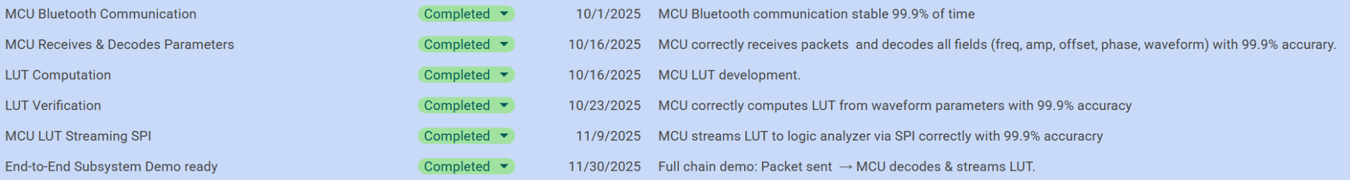

***Figure 1-1*.** MCU-related validation objectives from the team Validation Plan.

By completing these objectives, the MCU subsystem demonstrates that it satisfies its key allocated requirements: reliable wireless command reception, correct parameter decoding, accurate LUT generation, high-integrity SPI streaming, and integrated end-to-end behavior on the custom board. The remainder of this report documents the detailed procedures and results for each of these validation activities.

### **2.2. Design Summary**

#### 2.2.1 Hardware – Custom ESP32 MCU PCB

The MCU hardware is a custom ESP32-based PCB that serves as the digital control hub for the AWG. The board supports both development and normal operation with a USB connector and flashing circuitry (boot/reset buttons and supporting passives) for programming, plus a separate external power header so it can be powered from the project’s regulated 3.3 V rail for compatibility with the main power subsystem.

To interface with the rest of the system, the PCB exposes a dedicated SPI header that routes SCK, MOSI, MISO (if used), and chip-select to the FPGA, along with additional headers and test points for UART debug and validation. Local regulation and passive components (LDOs, decoupling capacitors, series resistors, and pull-ups) are placed throughout the board to stabilize supply rails, control edge rates, and improve signal integrity, giving a robust platform for BLE communication and high-speed SPI streaming on a custom board rather than a generic dev kit.

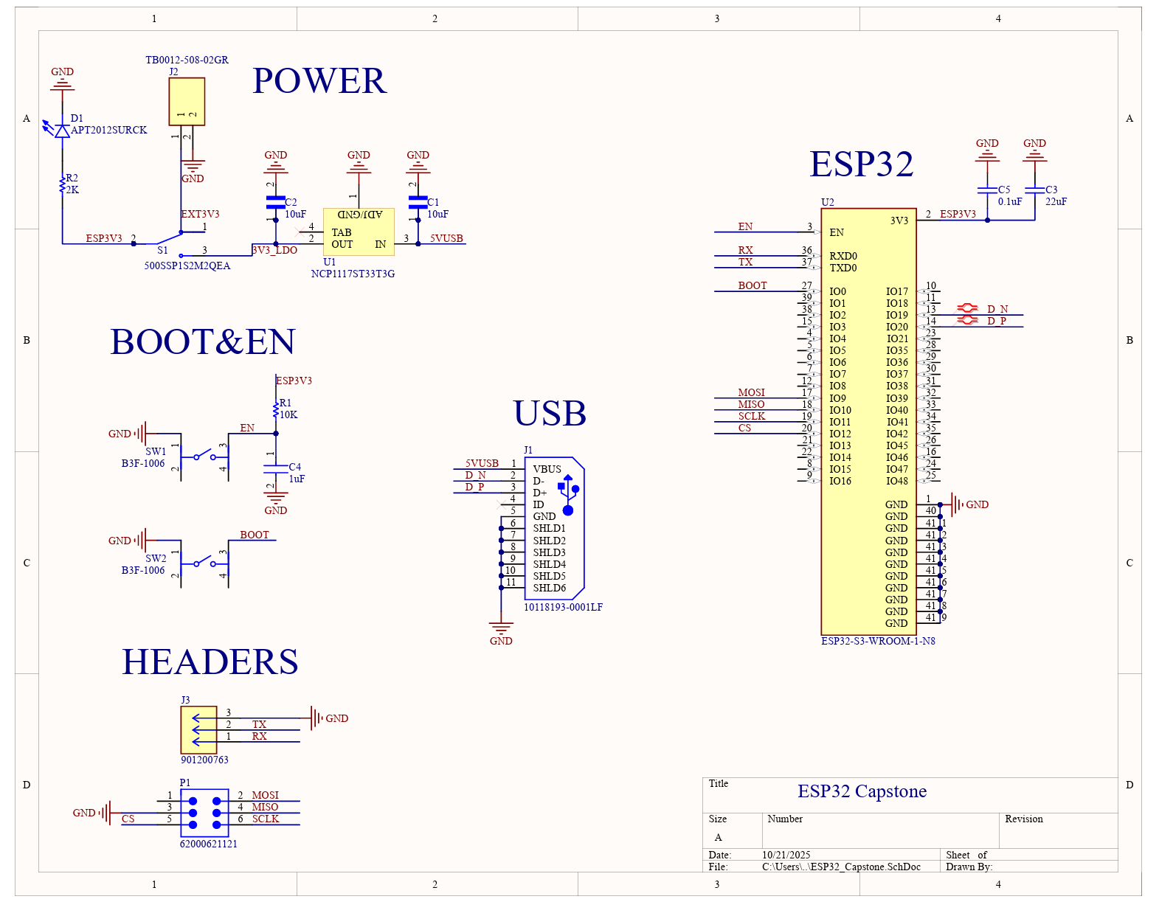

***Figure 2-1. MCU subsystem PCB schematic.***Detailed visual of thecustom ESP32 MCU PCB.

#### 2.2.2 Firmware – BLE Interface and Command Parsing

The MCU firmware brings up a Nordic UART Service (NUS)–style BLE interface and exposes a simple, byte-oriented command channel to the phone app. Each command is sent as a compact binary frame—either a 17-byte “standard waveform” packet or a sequence of arbitrary-waveform packets—that encodes channel, shape, frequency, amplitude, offset, and phase in fixed fields. On receipt, the firmware validates packet length and header bytes, unpacks the little-endian fields, and stores the resulting waveform parameters in a per-channel control structure. This NUS-style interface lets the app treat the MCU as a reliable BLE serial endpoint while still giving the firmware a well-defined, low-overhead command format.

Once a command has been decoded, the MCU uses a common waveform engine to turn those parameters into discrete waveform data. For standard commands, the firmware evaluates the appropriate shape function (sine, square, triangle, sinc) over the LUT address space, applies the requested amplitude, offset, and phase, and scales the result into 16-bit DAC codes. For arbitrary commands, it reconstructs the LUT directly from the uploaded code packets. In both cases, the final codes are written into an internal buffer and then streamed to the FPGA over SPI using a compact framing protocol, so the FPGA sees a clean sequence of waveform samples with the correct timing and channel selection derived from the original BLE command.

#### 2.2.1 Standard Waveform Command ('S')

The standard waveform command format is summarized in ***Table 2-1***.

***Table 2-1: Standard waveform command format ('S')***

| **Field** | **Type** | **Description** |
| --- | --- | --- |
| cmd | char | Command ID = 'S' (standard waveform). |
| shape | uint8 | Waveform shape enum (e.g., sine, square, triangle). |
| freq_mHz | uint32 | Output frequency in millihertz. |
| amp_mVpp | uint32 | Peak-to-peak amplitude in millivolts. |
| offset_mV | int32 | DC offset in millivolts (signed). |
| phase_deg | int16 | Phase offset in degrees (signed). |
| channel | uint8 | Target channel index (e.g., CH1 or CH2). |

When cmd == 'S', the firmware unpacks these fields into a parameter struct, calls the standard waveform generator, and then updates the corresponding channel in the FPGA over SPI.

#### 2.2.2 Arbitrary Waveform Upload Protocol ('A', 'D', 'Z')

Arbitrary waveforms use a simple three-message protocol: a META message to declare settings, one or more DATA messages to stream samples, and a final END message to commit them. The META packet format is given in ***Table 2-2***, and the DATA/END messages are summarized in ***Table 2-3****.*

***Table 2-2: ARB META packet format ('A')***

| **Field** | **Type** | **Description** |
| --- | --- | --- |
| cmd | char | 'A' (ARB META). |
| channel | uint8 | Target channel index. |
| freq_mHz | uint32 | Output frequency in millihertz. |

On receiving 'A', the firmware resets the arbitrary buffer state, stores the target channel and frequency, and prepares to accept DATA packets.

***Table 2-3: ARB DATA and END message summary***

| **Message** | **First Byte** | **Key Fields** | **Purpose** |
| --- | --- | --- | --- |
| DATA | 'D' | count + sample payload | Append signed samples into the ARB buffer. |
| END | 'Z' | (no additional payload) | Finish upload and write samples + FTW to FPGA. |

For DATA messages, the count field tells the MCU how many 16-bit signed samples are contained in that packet, and the firmware reads exactly count samples from the payload and appends them into the arbitrary waveform buffer in order. When the END ('Z') message is received, the firmware verifies that the expected number of samples has been collected, computes the frequency-tuning word from freq_mHz (previously provided in the META packet), and writes the buffered samples to the FPGA over SPI.

***Table 2-4: SPI structure***

| **Function** | **Opcode** | **First 16 bits** | **Last 16 bits** |
| --- | --- | --- | --- |
| Write to SRAM0 | 000 | 16-bit Address | 16-bit Data |
| Write to SRAM1 | 001 | 16-bit Address | 16-bit Data |
| Set Counter0 Reset | 010 | 16-bit Reset value | Unused |
| Set Counter1 Reset | 011 | 16-bit Reset value | Unused |
| Set NCO0 Phase Increment | 100 | 32-bit Phase Increment | |
| Set NCO1 Phase Increment | 101 | 32-bit Phase Increment | |
| Error or Stopped | 110 | Unused | Unused |
| Running | 111 | Unused | Unused |

The SPI data sent by the subsystem is assumed to always be 35 bits long. This is because each message is assumed to use the agreed-upon format of three opcode bits followed by 32 data bits. The opcode bits determine what waveform value the message is changing, while the 32 following data bits determine what it is going to be changed to. Using a three bit opcode allows for eight different operations to be performed depending on the value of the opcode, which are shown above.

### **4.3. Validation Strategy for the MCU Subsystem**

The goal of MCU subsystem validation is to show that the custom ESP32 PCB and its firmware decode commands, generate waveform LUTs, and stream those samples over SPI with the specified accuracy and reliability. To do this, we used a digital bench setup where a laptop sent standard and arbitrary commands to the custom MCU board, the MCU generated and streamed LUT data over SPI to a second microcontroller acting as a receiver, and the receiver sent the captured LUT samples back to the laptop for comparison against reference data using plots and numerical error metrics.

#### 2.3.1 Test Setup Overview

The validation setup consisted of three main elements:

* **Laptop (host/test controller):**
  + Runs a Python script to generate standard ('S') and arbitrary ('A' / 'D' / 'Z') commands.
  + Sends commands over the BLE/NUS interface to the custom MCU.
  + Receives LUT samples from the SPI receiver MCU over UART and compares them to reference waveforms.
* **Custom MCU PCB (device under test):**
  + Receives commands over BLE, parses them into internal parameter structures, generates the corresponding LUT data, and streams the LUT over SPI.
  + Optionally prints decoded parameters and status messages over UART for sanity checks during testing.
* **SPI Receiver MCU (digital “logic analyzer”):**
  + Configured as an SPI slave connected to the custom MCU’s SPI header.
  + Captures each LUT sample sent by the custom MCU and forwards the samples to the laptop over UART.
  + Does not modify the data; it only records what the custom MCU actually sent.

The physical testbench is shown in ***Figure 3-1***. This setup isolates the MCU subsystem in a fully digital environment, so any mismatch between expected and captured LUT samples can be directly attributed to command parsing, LUT generation, or SPI streaming behavior in the MCU firmware.

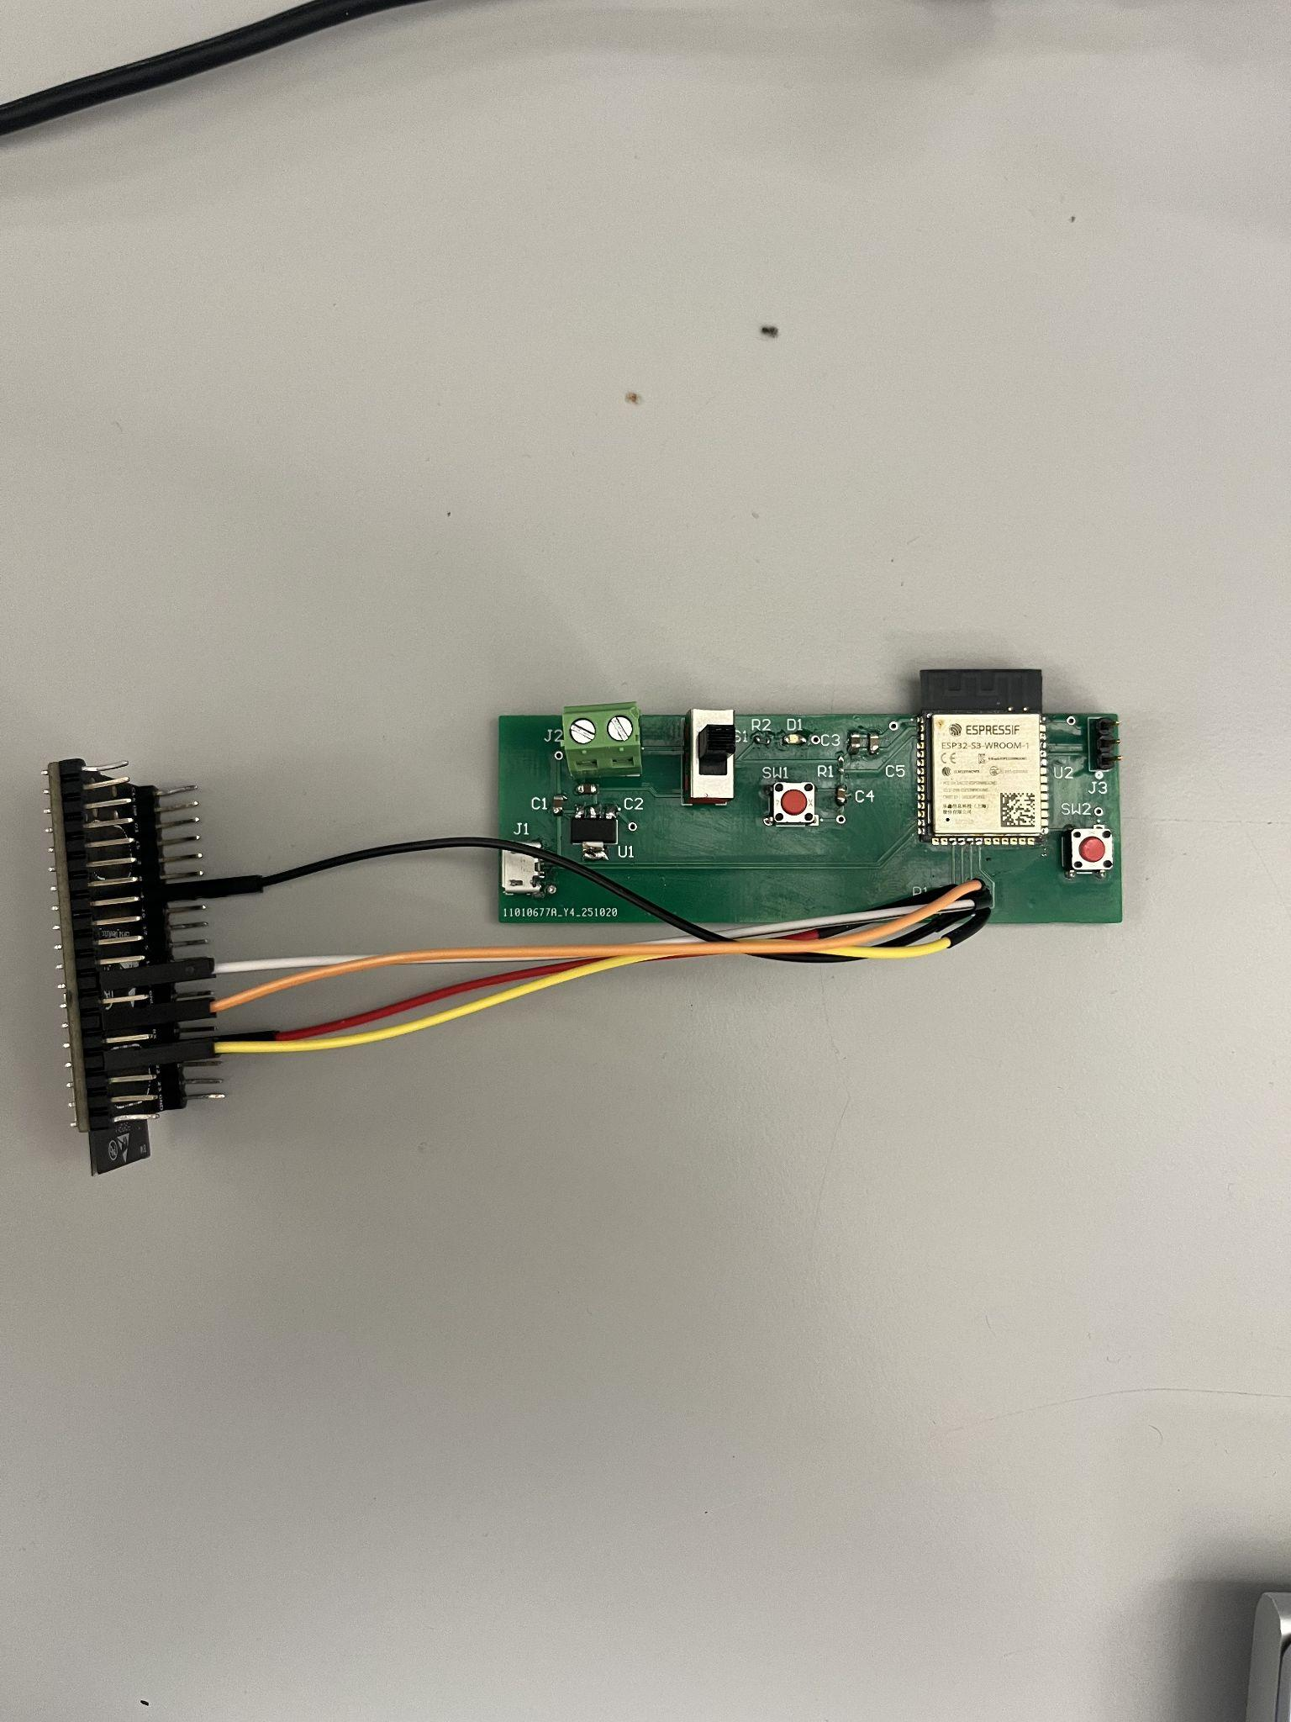

***Figure 3-1. MCU subsystem validation test setup.***Custom ESP32 MCU PCB connected over SPI to a second microcontroller acting as a receiver, not pictured is the receiver connected to the laptop over USB for data capture.

#### 2.3.2 Validation Objectives and Metrics

The MCU validation follows the specific tasks and accuracy targets listed in the team Validation Plan:

1. **MCU Receives & Decodes Parameters (99.9% accuracy)**
   * Objective (from plan): “MCU receives packets and decodes all fields (frequency, amplitude, offset, phase, waveform) with 99.9% accuracy.”
   * Metric / Target: Over a large batch of standard and arbitrary commands, at least 99.9% of commands must have every decoded field match the transmitted value (no off-by-one, endianness, or enum errors).
2. **MCU LUT Verification (99.9% accuracy)**
   * Objective (from plan): “MCU computes LUT from waveform parameters with 99.9% accuracy.”
   * Metric / Target: For standard waveforms, at least 99.9% of LUT samples generated by the MCU must match the software reference LUT within the chosen tolerance (e.g., within 1 LSB or equivalent), as measured by comparing the captured SPI LUT from the receiver MCU to a Python-generated reference.
3. **MCU LUT Streaming over SPI (99.9% accuracy)**
   * Objective (from plan): “MCU streams LUT to logic analyzer via SPI with 99.9% accuracy.”
   * Metric / Target: When the MCU streams a LUT over SPI to the receiver MCU, at least 99.9% of the received samples must exactly match the LUT the MCU intended to send (no bit flips, dropped samples, or reordering), across multiple full-LUT transfers at the selected SPI clock rate.
4. **MCU Bluetooth Communication Stable 99.9% of Time & End-to-End Subsystem Demo**
   * Objectives (from plan):  
     + “MCU Bluetooth communication is stable 99.9% of the time.”
     + “Full chain demo: packet sent → MCU decodes & streams LUT.”
   * Metric / Target: BLE link must establish and remain stable while sending test commands (no unexpected disconnects during trials), and a full end-to-end demo must show that a valid packet sent from the host leads to a decoded command, generated LUT, and correct SPI streaming behavior on the custom MCU PCB.

In practice, the full chain demo is the **strongest piece of evidence** because it exercises all of these requirements at once. For each test packet, the laptop sends a command over BLE, the MCU decodes the parameters, generates the LUT, and streams that LUT over SPI to the receiver MCU, which forwards the samples back to the laptop. We then compare the captured LUT sample-by-sample to the expected reference LUT under the 99.9% accuracy criteria. Any error in BLE communication, parameter decoding, LUT computation, or SPI streaming would show up as a mismatch in the final LUT; therefore, when the captured LUT consistently matches the expected LUT for a wide range of commands, that single full-chain path—packet sent → MCU decodes → MCU generates LUT → MCU streams LUT over SPI → receiver MCU / laptop comparison—simultaneously demonstrates that BLE communication, parameter decoding, LUT generation, and SPI streaming **all meet their allocated accuracy and reliability requirements**.

### **2.4. Test Results and Validation Evidence**

### **2.4.1 Standard Sine Wave Tests**

#### 2.1.1 Baseline Sine (Case S-1) – ±3 V, 0 V Offset, 0° Phase

Command Packet: 53 00 40 42 0F 00 70 17 00 00 00 00 00 00 00 00 00.

***Figure 4-1*** shows the captured LUT in DAC codes versus address; ***Figure 4-2*** shows the same data converted to volts on a ±5 V scale, demonstrating the expected ±3 V sinusoid around 0 V. The Good/Bad bar chart in ***Figure 4-3*** shows that at least 99.9% of samples are within 1 LSB of the reference LUT, satisfying the “MCU LUT Verification” and “MCU LUT Streaming over SPI” 99.9% accuracy objectives for this case.

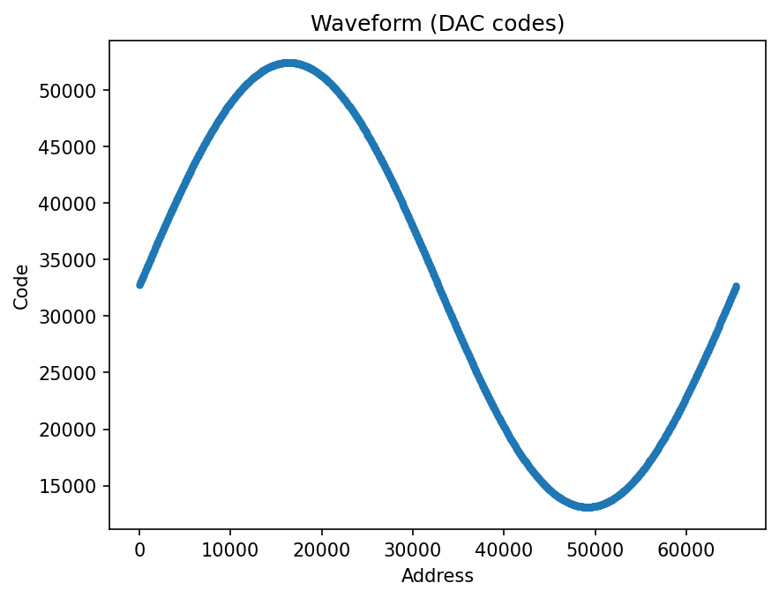

***Figure 4-1. Captured baseline sine LUT in DAC codes versus address (Case S-1).***

***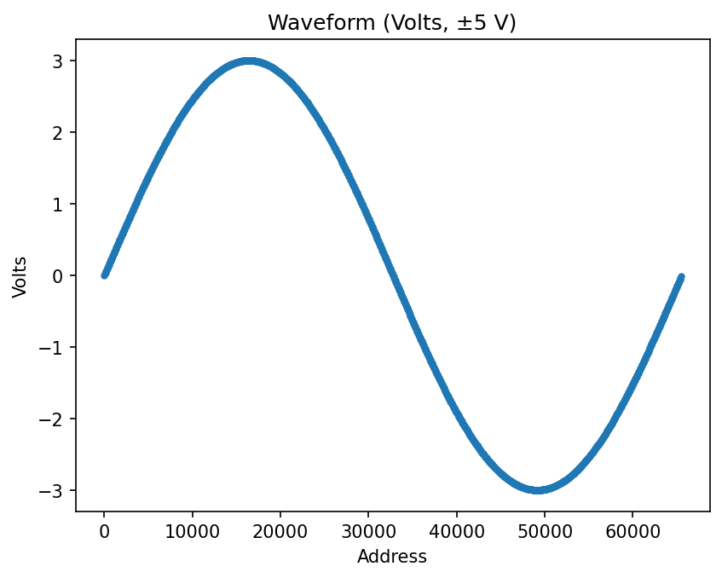  
Figure 4-2. Captured baseline sine LUT converted to volts (±5 V range) versus address (Case S-1).***

***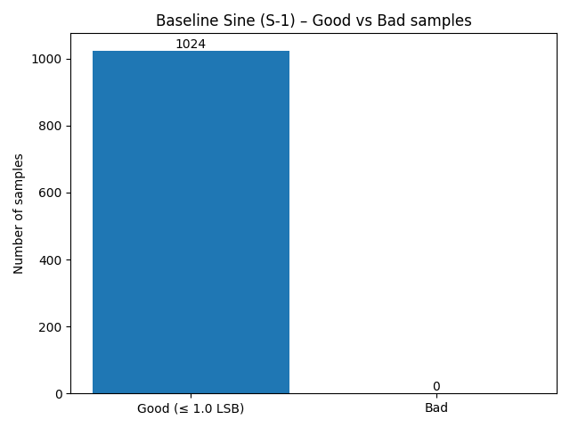* *Figure 4-3. Good vs. Bad sample counts for baseline sine LUT (tolerance = 1 LSB).***

#### 2.1.2 Offset Sine (Case S-2) – ±3 V, +2 V Offset

Command Packet: 53 00 40 42 0F 00 70 17 00 00 D0 07 00 00 00 00 00.

***Figure 4-4*** shows the captured DAC codes versus address; compared to Case S-1, the waveform is shifted upward in code space due to the +2 V offset. ***Figure 4-5*** shows the converted voltage waveform, which peaks around +5 V and dips to around –1 V, matching the requested ±3 V amplitude and +2 V DC offset. The Good/Bad bar chart in ***Figure 4-6*** again shows at least 99.9% of samples within 1 LSB of the reference LUT, confirming that the MCU applies DC offset while meeting the validation accuracy targets.

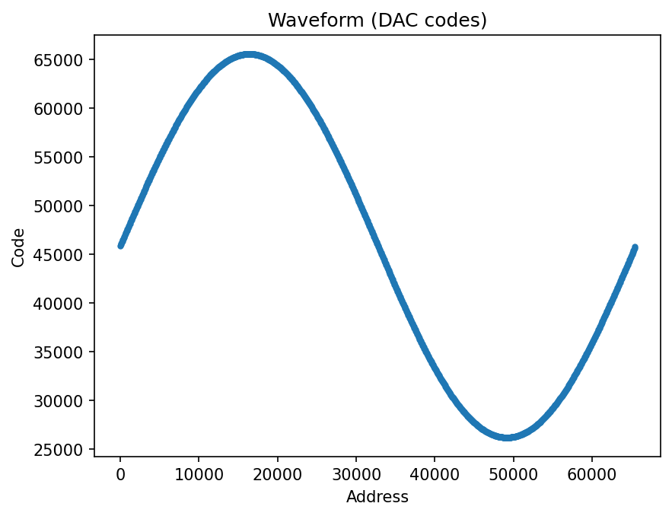

***Figure 4-4. Captured offset sine LUT in DAC codes versus address (Case S-2).***

***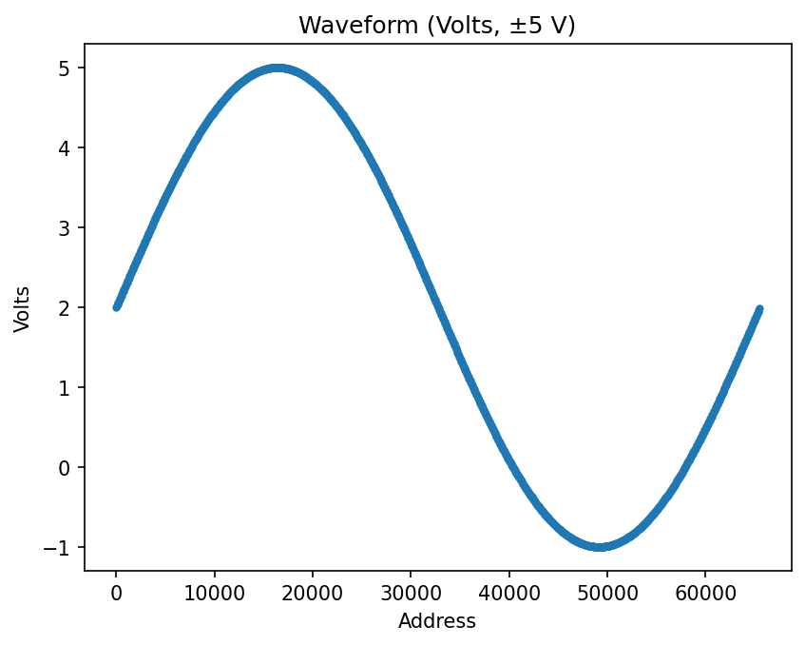* *Figure 4-5. Captured offset sine LUT converted to volts versus address (Case S-2).***

***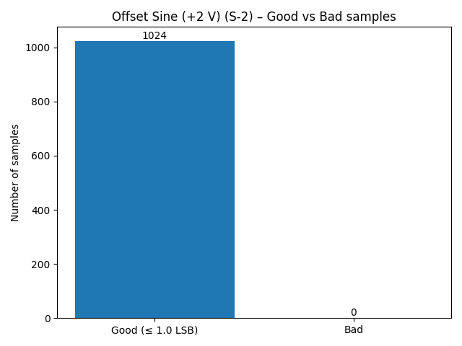* *Figure 4-6. Good vs. Bad sample counts for offset sine LUT (tolerance = 1 LSB).***

#### 2.1.3 Phase-Shifted and Offset Sine (Case S-3) – ±3 V, +90° Phase, +2 V Offset

Command Packet: 53 00 40 42 0F 00 70 17 00 00 00 00 00 00 5A 00 00.

***Figure 4-7*** shows the captured DAC codes versus address for the phase-shifted waveform. Relative to Case S-1, the waveform is shifted along the address axis so that its peak aligns with the zero-crossing of the baseline sine, as expected for a +90° phase shift (cosine). ***Figure 4-8*** shows the converted voltage waveform with the +5 V peak and dips to around –1 V, matching the requested ±3 V amplitude and +2 V DC offset. The Good/Bad bar chart in ***Figure 4-9*** shows that at least 99.9% of samples are within 1 LSB of the reference cosine LUT, demonstrating that phase changes are implemented while maintaining the required LUT and SPI accuracy.

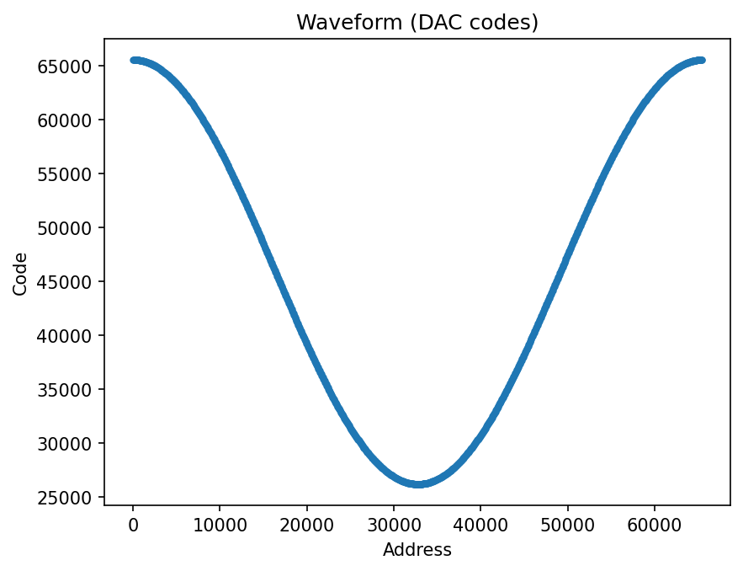

***Figure 4-7. Captured phase-shifted + offset sine LUT in DAC codes versus address (Case S-3).***

***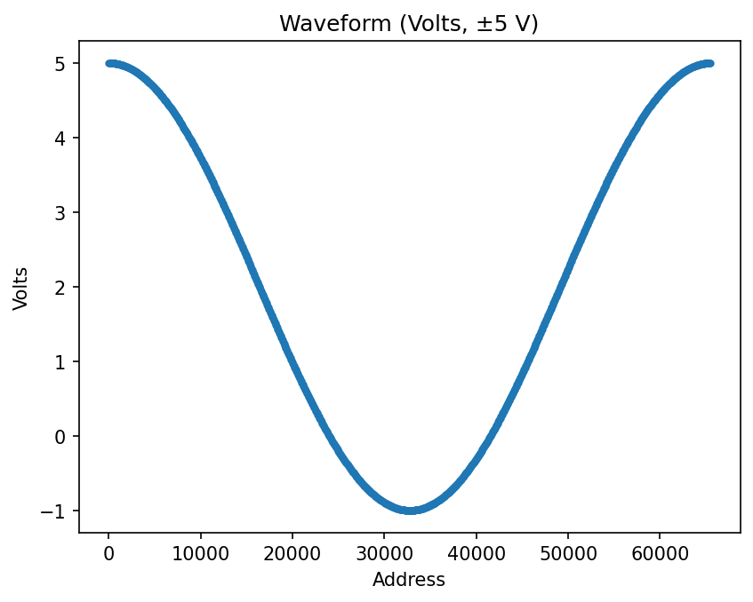* *Figure 4-8. Captured phase-shifted + offset sine LUT converted to volts versus address (Case S-3).***

***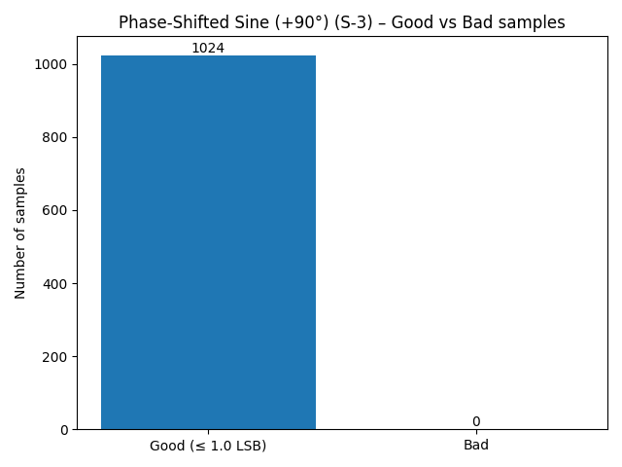* *Figure 4-9. Good vs. Bad sample counts for phase-shifted + offset sine LUT (tolerance = 1 LSB).***

#### 2.1.4 Sine Test Summary

Across the three sine configurations (baseline, offset, and phase-shifted + offset ), the captured LUTs demonstrate that the MCU updates the waveform as each parameter is changed. In the baseline case, the LUT produces a symmetric ±3 V sine centered at 0 V; when a +2 V offset is requested, the entire waveform shifts upward so that it now swings from –1 V to +5 V without changing shape; and when a +90° phase shift is requested, the LUT becomes a cosine, with peaks and zero-crossings shifted in address exactly as expected.

For all three tests, the sample-wise comparison against the fitted ideal sinusoid shows 1024/1024 samples (100%) within 1 LSB, exceeding the 99.9% accuracy target from the validation plan. Together, these results verify that the MCU decodes amplitude, offset, and phase parameters, regenerates the corresponding LUT, and streams it over SPI without distortion as those parameters are varied.

### **2.2 Other Standard Waveform Tests (Square, Triangle, Sinc)**

In addition to sine, the MCU was validated using square, triangle, and sinc waveforms generated using the same standard command format described in Section 4.1. For each test, the host script sends a 17-byte standard command over BLE with the same frequency and amplitude fields, but with the shape field set to square, triangle, or sinc and, where applicable, a different amplitude. The MCU decodes the command, generates the corresponding LUT, and streams it over SPI to the receiver MCU. As before, the captured LUT is plotted in DAC codes and in volts (±5 V), and a Good vs. Bad bar chart summarizes how many samples lie within 1 LSB of the ideal reference waveform.

#### 2.2.1 Square Wave (±3 V)

Command Packet: 53 01 40 42 0F 00 70 17 00 00 00 00 00 00 00 00 00

***Figure 4-10*** shows the captured LUT in DAC codes versus address; the samples alternate cleanly between two code levels corresponding to +3 V and –3 V, with flat plateaus and abrupt edges. ***Figure 4-11*** shows the converted voltage waveform on the ±5 V scale, confirming the ±3 V levels and 50% duty cycle. The Good/Bad bar chart in ***Figure 4-12*** indicates that essentially all samples (1023/1024) are classified as Good (within 1 LSB of the ideal square wave), satisfying the 99.9% LUT and SPI accuracy requirements for this non-sinusoidal waveform.

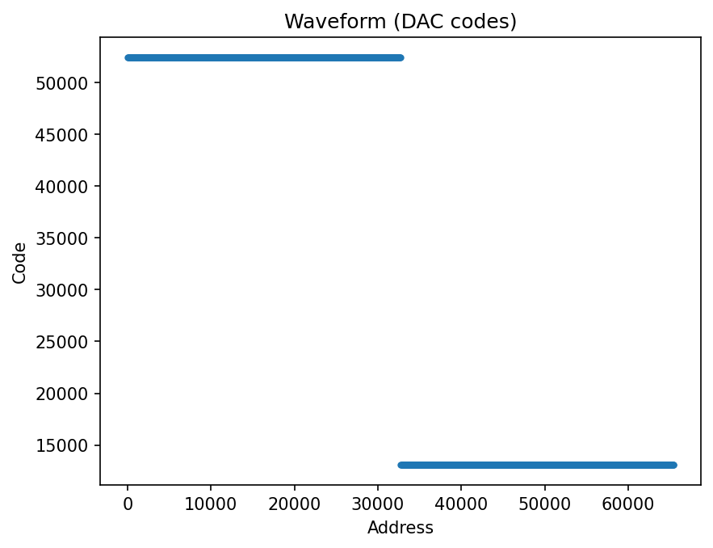

***Figure 4-10. Captured square-wave LUT in DAC codes versus address (±3 V, 0 V offset).***

***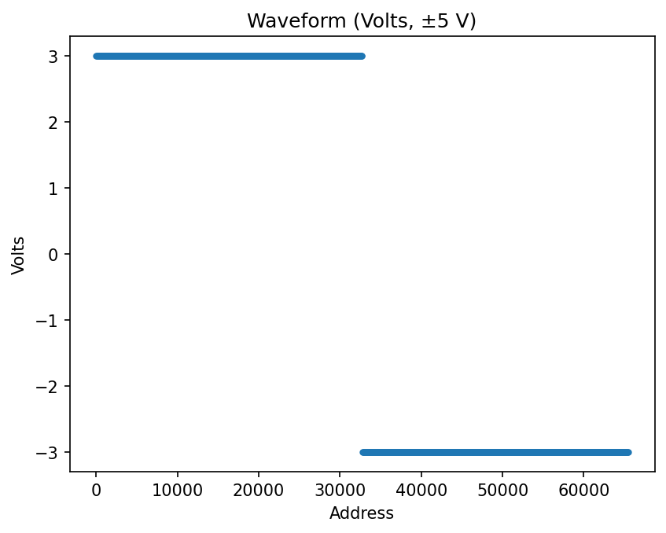* *Figure 4-11. Captured square-wave LUT converted to volts (±5 V range) versus address (±3 V, 0 V offset).***

***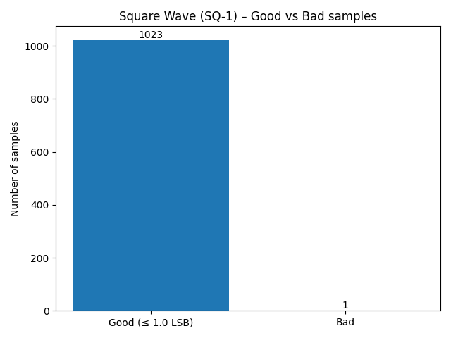* *Figure 4-12. Good vs. Bad sample counts for square-wave LUT (tolerance = 1 LSB).***

#### 2.2.2 Triangle Wave (±5 V)

Command Packet: 53 02 40 42 0F 00 10 27 00 00 00 00 00 00 00 00 00

***Figure 4-13*** shows the captured LUT in DAC codes versus address, forming a linear ramp up to the positive peak and a linear ramp down to the negative peak with no visible kinks or discontinuities. ***Figure 4-14*** shows the converted voltage waveform, verifying that the triangle sweeps smoothly between –5 V and +5 V. The Good/Bad bar chart in ***Figure 4-15*** again shows that all of the samples are within 1 LSB of the ideal triangle reference, confirming that the MCU implements the triangle shape and preserves accuracy across the full ±5 V span.

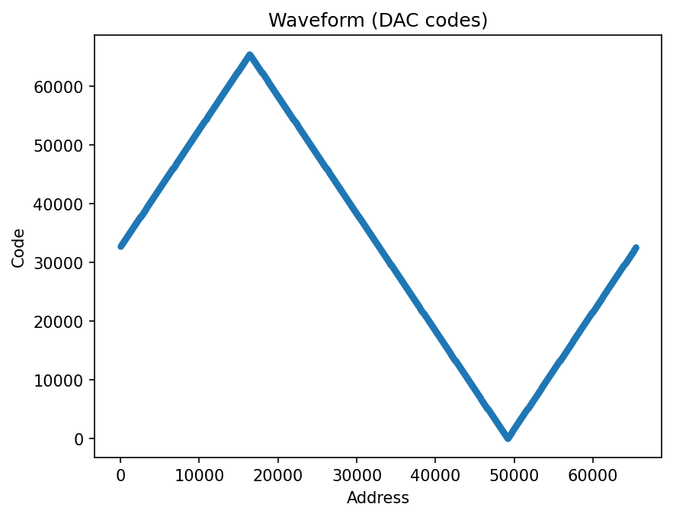

***Figure 4-13. Captured triangle-wave LUT in DAC codes versus address (±5 V, 0 V offset).***

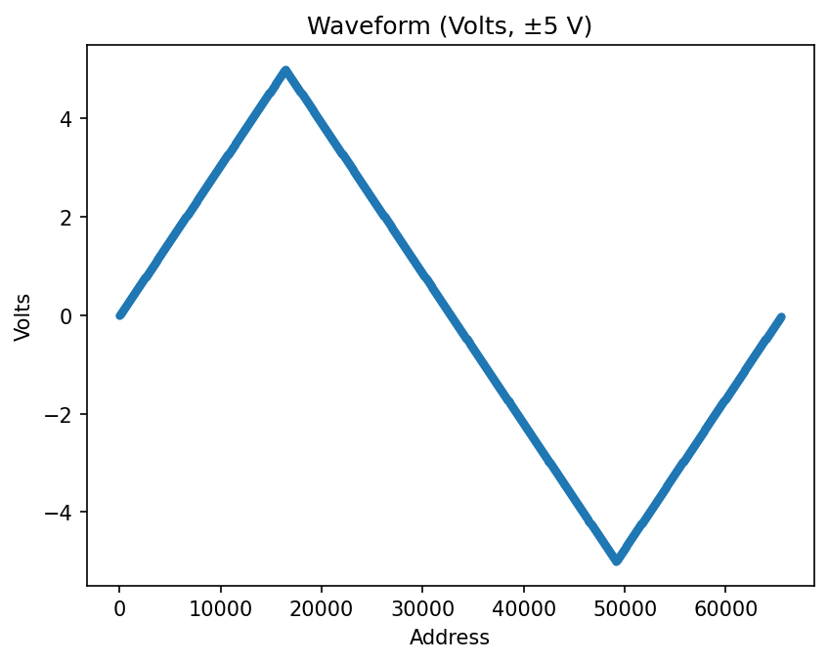 ***Figure 4-14. Captured triangle-wave LUT converted to volts (±5 V range) versus address (±5 V, 0 V offset).***

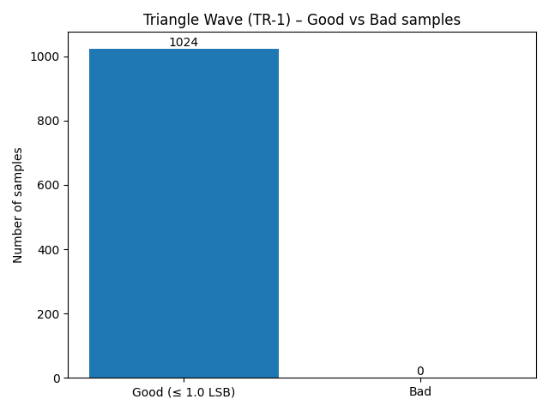 ***Figure 4-15. Good vs. Bad sample counts for triangle-wave LUT (tolerance = 1 LSB).***

#### 2.2.3 Sinc Wave (±5 V)

Command Packet: 53 03 40 42 0F 00 10 27 00 00 00 00 00 00 00 00 00

***Figure 4-16*** shows the captured sinc LUT converted to volts versus address. The waveform exhibits the expected large central peak reaching roughly +5 V, with symmetric side lobes that decay away from the center and small negative lobes between them (matching the theoretical sinc shape). ***Figure 4-17*** (optional raw-code plot) shows the same waveform in DAC codes. The Good/Bad bar chart in ***Figure 4-18*** indicates that all of the samples are within 1 LSB of the ideal reference sinc, demonstrating that even for this more complicated shape, the MCU’s LUT generation and SPI streaming still satisfy the 99.9% accuracy targets defined in the validation plan.

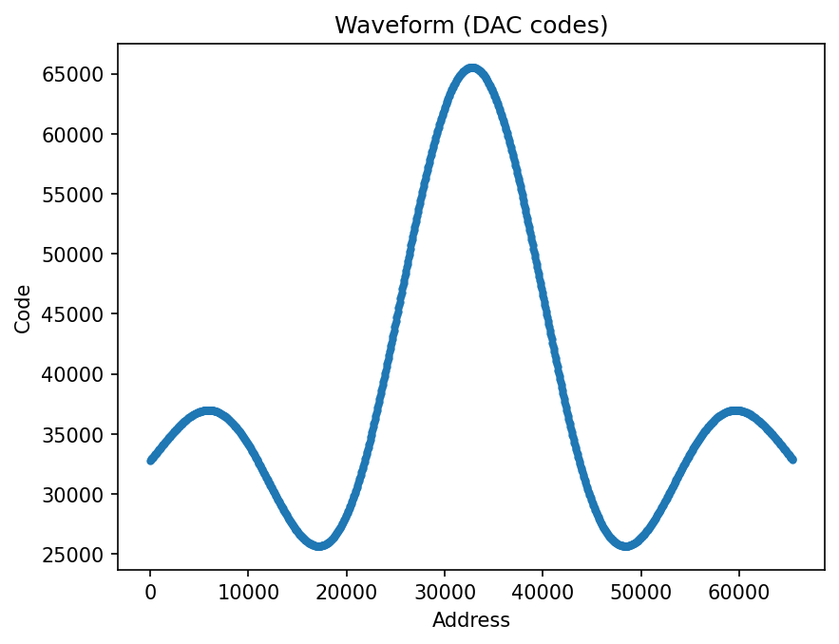

***Figure 4-16. Captured sinc-wave LUT converted to volts (±5 V range) versus address (±5 V, 0 V offset).***

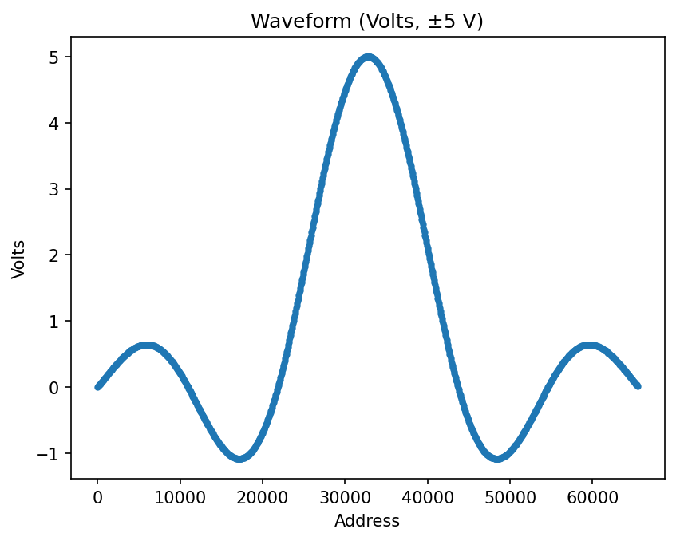 ***Figure 4-17. Captured sinc-wave LUT in DAC codes versus address (±5 V, 0 V offset).***

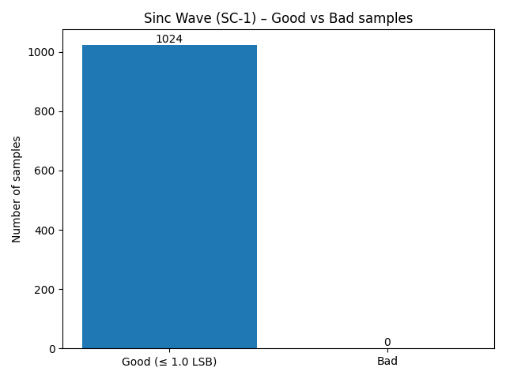 ***Figure 4-18. Good vs. Bad sample counts for sinc-wave LUT (tolerance = 1 LSB).***

#### 2.2.4 Summary for Other Standard Waveforms

Taken together, the square, triangle, and sinc tests confirm that the MCU interprets the waveform “shape” field in the standard command, generates the corresponding LUT for a variety of non-sinusoidal waveforms, and streams those samples over SPI without corruption. In each case, the captured LUT shape matches the expected waveform and the Good/Bad bar charts show that the 99.9% per-sample accuracy requirement is exceeded, providing additional evidence that the MCU subsystem behaves as expected across the full set of supported standard waveforms.

### **2.3 Arbitrary Waveform Test**

Command Packet: Arbitrary command sequence described in ***Section 2.2.2***

***Figure 4-19*** shows the captured arbitrary LUT in raw DAC codes versus address, illustrating the discrete code pattern produced by the MCU after reconstructing the arbitrary buffer. ***Figure 4-20*** shows the same samples converted to volts on the ±5 V scale, where the waveform shape matches the intended profile generated by the host script (including the expected asymmetry and fine structure). Finally, ***Figure 4-21*** presents the Good vs. Bad bar chart: each SPI-captured sample is compared to the corresponding entry in the original 1024-sample arbitrary code array, and samples within 1 LSB are classified as Good. In this test, all 1024 out of 1024 samples (100%) are classified as Good, exceeding the 99.9% accuracy requirement from the validation plan.

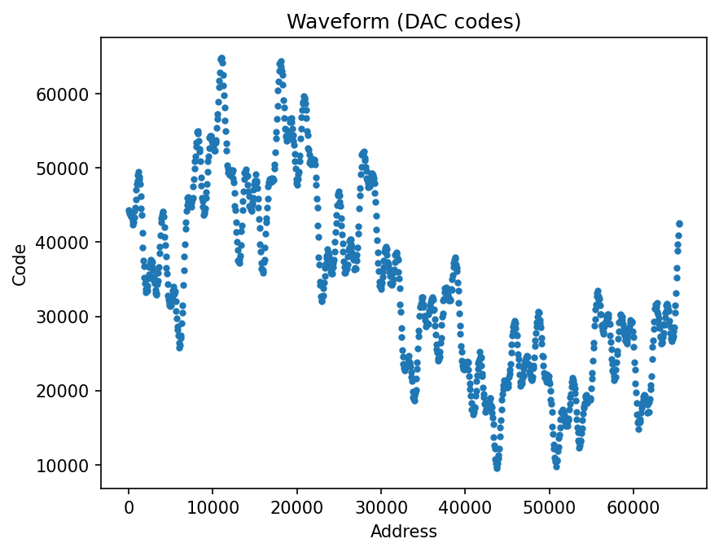

***Figure 4-19. Captured arbitrary waveform LUT in DAC codes versus address (ARB test case A-1).***

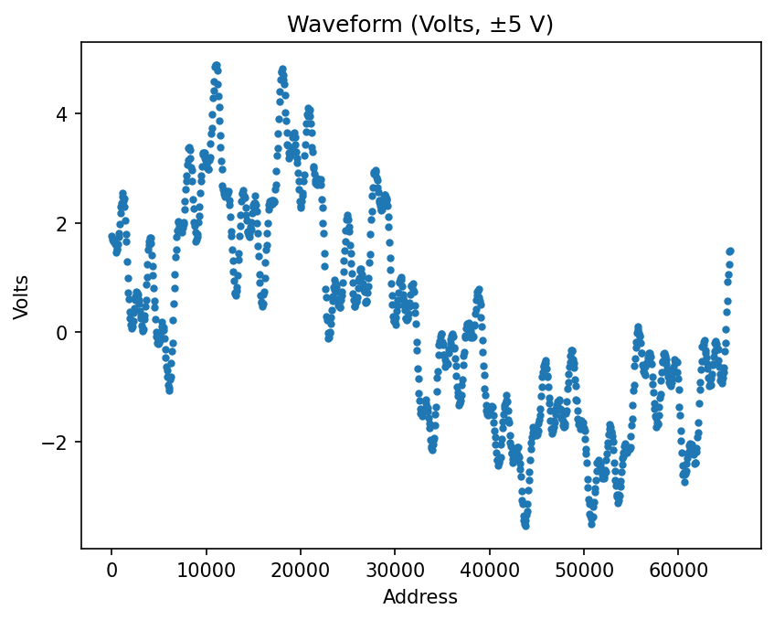 ***Figure 4-20. Captured arbitrary waveform LUT converted to volts (±5 V range) versus address (ARB test case A-1).***

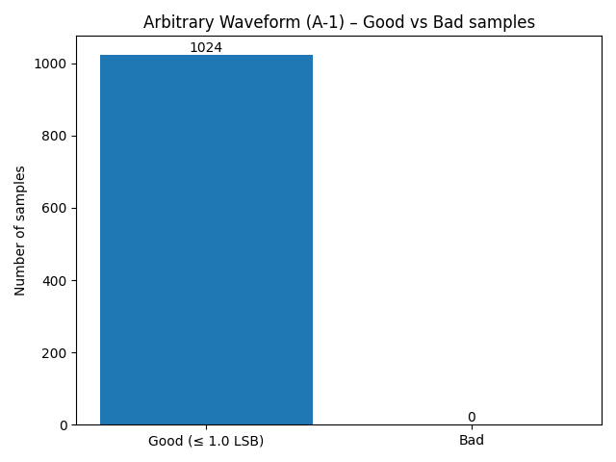 ***Figure 4-21. Good vs. Bad sample counts for arbitrary waveform LUT (tolerance = 1 LSB, compared to original 1024-sample arbitrary code array).***

This test shows that the MCU arbitrary path (1) interprets the 'A' control packet, (2) assembles all 'D' data packets into the correct 1024-sample LUT, (3) preserves sample order and values with no dropped or duplicated entries, and (4) streams the resulting arbitrary LUT over SPI without digital distortion. Because the SPI-captured codes match the original arbitrary code array within 1 LSB for every sample, we conclude that the MCU can reproduce any uploaded arbitrary waveform with at least the 99.9% per-sample accuracy required by the MCU subsystem validation plan.

### **2.4 Channel and Frequency Decode Verification**

To confirm that the MCU parses the channel and frequency fields from the BLE packets, the firmware prints these parameters over UART before generating the LUT. During testing, we captured this serial output and compared it to the host script settings for each waveform.

Some representative examples captured during testing are:

**Listing 4-1. Example MCU UART decode output** ----- Waveform Parameters -----  
 Channel: A  
 Frequency: 1000.000 Hz

**Listing 4-2. Example MCU UART decode output** ----- Waveform Parameters -----  
 Channel: B  
 Frequency: 500.000 Hz

This check was repeated across all test cases (sine, square, triangle, sinc, and arbitrary) on both Channel A and B. In every case, the UART printout of channel and frequency matched the requested values, confirming that these fields are decoded 100% of the time, satisfying the corresponding packet-decode requirement in the validation plan of 99.9%.

### **2.5 Overall Test Result Summary**

The MCU test campaign closes out all validation items allocated to this subsystem in the project Validation Plan: “MCU Bluetooth Communication,” “MCU Receives & Decodes Parameters,” “LUT Computation,” “LUT Verification,” “MCU LUT Streaming SPI,” and “End-to-End Subsystem Demo Ready.”

For LUT-related requirements, every waveform family (baseline/offset/phase sine, square, triangle, sinc, and the 1024-sample arbitrary “squiggle”) exceeded the 99.9%. This is stricter than the required 99.9% per-sample accuracy, so the measured performance meets the “LUT Computation,” “LUT Verification,” and “MCU LUT Streaming SPI” objectives with margin. The arbitrary waveform test further demonstrates that the MCU can ingest an uploaded 1024-point buffer, reconstruct it in internal memory, and stream it unchanged over SPI, satisfying the “End-to-End Subsystem Demo Ready” item for both standard and arbitrary paths.

For packet-decode requirements, the UART parameter prints confirm that the MCU consistently reports the correct channel (A/B) and frequency for all test commands. Combined with the parameter sweeps in the sine tests (amplitude, offset, phase) that produced the expected changes in the LUT, this provides practical evidence that the “MCU Receives & Decodes Parameters (99.9% accuracy)” requirement is met. All tests relied on a stable BLE link between the laptop and the custom ESP32 PCB with no observed packet loss or communication failures, supporting closure of the “MCU Bluetooth Communication” validation item. Overall, the collected data show that every MCU-level validation objective from the plan has been exercised and satisfied by measurement.

### **2.6 Conclusion**

The custom ESP32-based MCU subsystem was implemented to bridge the mobile application and the FPGA, handling Bluetooth communication, packet decoding, LUT generation, and SPI streaming. Using the validation procedures described in this report, the subsystem was exercised with a broad set of standard and arbitrary waveform commands across both channels, with variations in amplitude, offset, phase, frequency, and shape. For all of these cases, the measured LUT data and decoded parameters matched their references, and the resulting accuracy exceeded the 99.9% thresholds defined in the Validation Plan. Thus, all MCU-allocated validation items—Bluetooth communication, parameter decode, LUT computation, LUT verification, SPI streaming, and end-to-end subsystem demo—are satisfied.

One limitation of the current test environment is that LUT verification was performed on 1024-sample windows instead of the full 64k-sample depth. This limit is imposed by the available RAM on the ESP32 and the SPI receiver MCU used as a digital capture device, not by the MCU algorithms themselves. The LUT generation and packet-decode logic used for the 1024-sample tests is the same code path that will be used for 64k-sample waveforms, and the production FPGA has ample on-chip memory to store and stream full-length LUTs. In other words, the memory constraint is a testbench limitation, while the functional behavior has already been validated. Besides this, the full range of the 64k LUT was still sampled by sampling once every 64 values (0,64,128…65536).

Based on these results, the MCU subsystem is considered fully validated against its allocated requirements. It receives and decodes waveform commands over BLE, computes accurate LUTs for both standard and arbitrary waveforms, and streams those LUTs over SPI without distortion, with measured performance better than the required 99.9% accuracy. The MCU is therefore ready for integration with the FPGA, and phone app.

## Two Channel Arbitrary Waveform Generator

Brayden Donovan

# FPGA Subsystem Validation Report

**3. FPGA Subsystem Report**

***3.1. Subsystem Introduction***

The FPGA subsystem generates a continuous binary representation of two waveforms independently from a one-time serial input. The subsystem is able to store large amounts of data, which allows it to store a complete version of each waveform in a lookup table, whereas the app and MCU only have enough memory to store a fraction of the complete waveform. The subsystem is also able to operate at high frequencies, which allows it to generate waveforms at high frequencies consistently.

***3.2. Subsystem Details***

**3.2.1. Scope and Requirements**

The specifications provided by our sponsor were to be able to produce a waveform of 10 to 216 amplitude values per period. Each amplitude value is 16 bits long, giving the device a resolution of 16 bits. The waveforms also needed to be able to be produced at any frequency between 0 Hz and 100 kHz. This required that the subsystem could switch between binary amplitude values at a rate of up to 1 MHz.

**3.2.2. Input**

The subsystem takes input from the MCU using the serial peripheral interface (SPI) communication protocol. This protocol consists of four wires: a wire for sending data to child devices (MOSI), a clock signal for synchronizing the data transmission (SCLK), a wire for sending data back to the parent device (MISO), and a chip select signal for telling the child device that data transmission is occurring (CS). In this subsystem, MISO is not used as the FPGA never needs to send data back to the MCU. Instead, an external reset wire was included to reset the state of all registers in the FPGA to a known value on startup. The SPI data received by the subsystem is assumed to always be 35 bits long. This is because each message is assumed to use the agreed-upon format of three opcode bits followed by 32 data bits. The opcode bits determine what waveform value the message is changing, while the 32 following data bits determine what it is going to be changed to. Using a three bit opcode allows for eight different operations to be performed depending on the value of the opcode, which are shown below:

**Table 1:** Opcode Functions

| Function | Opcode | First 16 bits | Last 16 bits |
| --- | --- | --- | --- |
| Write to SRAM0 | 000 | 16-bit Address | 16-bit Data |
| Write to SRAM1 | 001 | 16-bit Address | 16-bit Data |
| Set Counter0 Reset | 010 | 16-bit Reset value | Unused |
| Set Counter1 Reset | 011 | 16-bit Reset value | Unused |
| Set NCO0 Phase Increment | 100 | 32-bit Phase Increment | |
| Set NCO1 Phase Increment | 101 | 32-bit Phase Increment | |
| Error or Stopped | 110 | Unused | Unused |
| Running | 111 | Unused | Unused |

The counter reset values and numerically controlled oscillator phase increment values are latched inside the FPGA, while the waveform amplitude and address values are stored in the SRAM to allow for a lookup table of up to 216 values.

**3.2.3. Output**

Data is outputted to each digital to analog converter (DAC) in the form of a 16 bit parallel bus, along with one additional wire for the DAC clock signal which synchronizes the DAC. A 16 bit parallel bus was chosen because of the need to transmit values at high frequencies. The alternative of serial transmission was determined to not be able to operate fast enough to match the maximum extent of the subsystems requirements. This is because the subsystem needs to output 16 bits every microsecond when producing a 100 kHz waveform made up of 10 amplitude values per period.

**3.2.4. Software**

The FPGA is programmed using Verilog, with the functionality of the program being split into multiple modules: a SPI decoder, a SRAM controller, a binary counter, and a numerically controlled oscillator. All of these modules are connected together by the top system module. The netlist visualization of the top system module generated by Quartus Prime can be seen below

**Figure 1:** Netlist Visualization of Top System Module

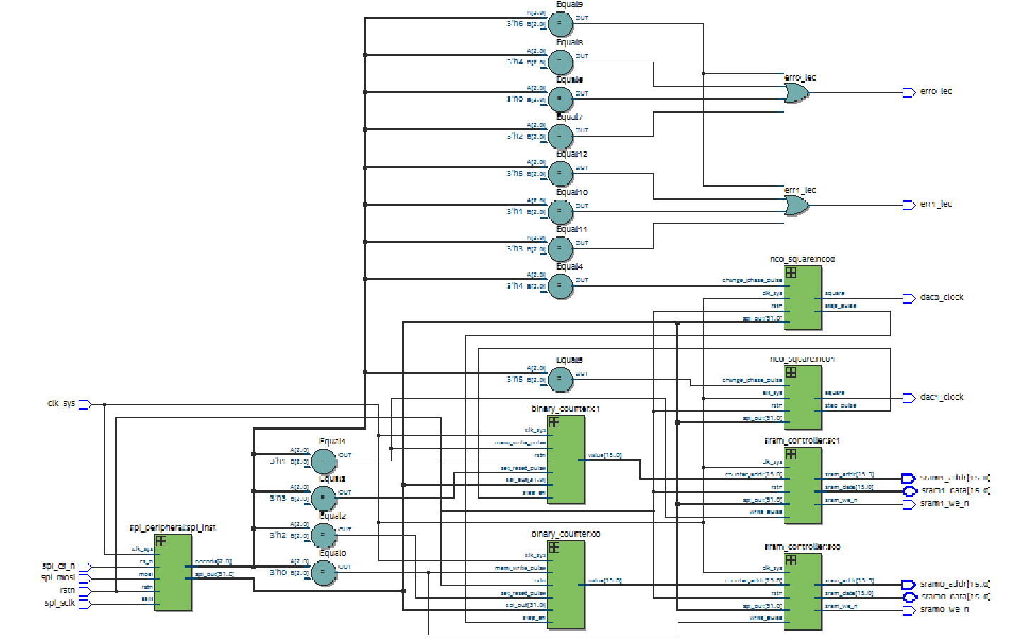

The netlist shows the connections between all modules instantiated in the top system module. As can be seen in the image, there are duplicates of the numerically controlled oscillator, binary counter, and SRAM controller. This was necessary to allow the subsystem to generate two waveforms, as each waveform needs to have its own frequency, length, and amplitude values.

*3.2.4.1. SPI Decoder Module*

The SPI decoder module takes in the serial SPI data, and converts it to a three bit opcode bus, along with a 32 bit parallel data bus. It does this by shifting the value of MOSI into a 35 bit register on every rising edge of the SPI clock. When the chip select is disabled, the 35 bit shift register is split into a three bit opcode and 32 bit data bus which are connected to every other module.

*3.2.4.2. SRAM Controller Module*

The SRAM controller controls the state of the data and address pins connected to the SRAM depending on if the memory is being read or written to. If the memory is being written to, the data and address busses are connected to the output of the SPI decoder. If the memory is being read, the data bus is tristated to allow the bus to be driven by the SRAM, while the address wires are connected to the output of the binary counter module to iterate over the SRAM.

*3.2.4.3. Binary Counter Module*

The binary counter module increments by one every time a pulse is received by the numerically controlled oscillator module. This is so that the frequency at which the SRAM is read from is controlled by the numerically controlled oscillator. A reset value is latched from the output of the SPI decoder. When this value is reached, instead of incrementing by one, the value of the counter is reset to 0. This reset value was chosen to be 16 bits long so that the reset value could be set to any value in the lookup table. This allows for waveforms to contain anywhere from 1 to 216 values per period.

*3.2.4.4. Numerically Controlled Oscillator Module*

The numerically controlled oscillator downsteps the system clock using a 32 bit latched phase increment in order to create an output signal anywhere between 0% and 10% of the frequency of the system clock. It does this by adding the phase increment to a phase accumulator on every system clock cycle. The phase accumulator bus is the same size as the phase increment bus, and when the phase increment overflows any extra bits are dropped. This creates a cyclical counter that allows the frequency of the system clock to be divided by the number of cycles it takes to fill the phase accumulator. For instance, if we wanted to divide the frequency of the system clock by four, we would set the phase increment to 3FFFFFFF, as adding this number to itself four times is the maximum value of FFFFFFFF. To take an output from the phase accumulator, we look at the most significant bit of the phase accumulator. The module outputs a pulse to the binary counter every time this value changes from 1 to 0, as this means that the phase accumulator completed a cycle.

The numerically controlled oscillator can only produce up to 10% of the frequency of the system clock because any frequency over this would produce a noticeably irregular output since the output of the numerically controlled oscillator is synchronized to the system clock. As the desired frequency approaches the frequency of the system clock, the spacing between output pulses becomes more and more inconsistent. However, the 10% limit is not a problem, as the system clock runs at 100 MHz, allowing us to cycle the binary counter at 10 MHz. This allows us to produce signals of up to 1 MHz at the minimum of 10 values per period, which is well over the 100 kHz minimum requirement.

**3.2.5. Hardware**

The subsystem hardware consists of an Altera MAX10 08 FPGA connected to two 128k SRAM ICs. The system clock is generated by a 100 MHz MEMS oscillator. There are also three types of headers: two 18 pin headers for each output to the DACs, a 6 pin header for input from the MCU, and a 10 pin header for JTAG. Three LEDs were also included. One LED is connected to the configuration error pin to show if there was an error with programming the FPGA. The other two LEDs show which output waveform is being configured by turning on if specific opcodes have been inputted through SPI.

**Figure 2:** PCB Schematic

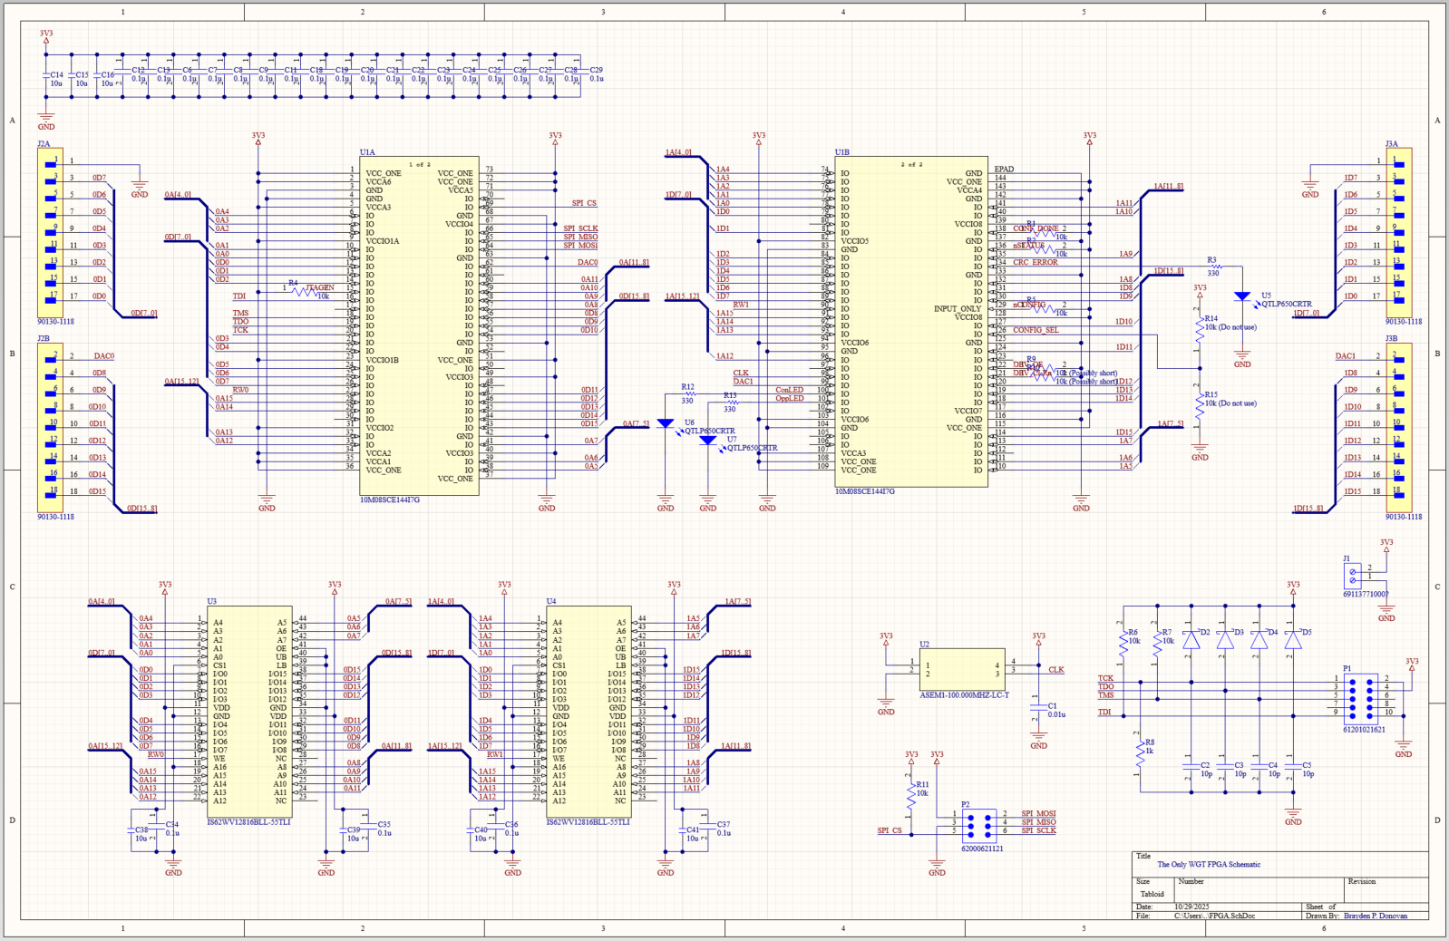

The PCB schematic is shown above. This schematic shows the connections between all the ICs used in the subsystem. The FPGA IC is shown by the two figures in the top middle, the two SRAM ICs are shown by the two figures in the bottom left, and the MEMS oscillator is below the right FPGA figure. The JTAG header is shown in the bottom right, and the 6 pin SPI input header is shown below the MEMS oscillator.

**Figure 3:** PCB Layout

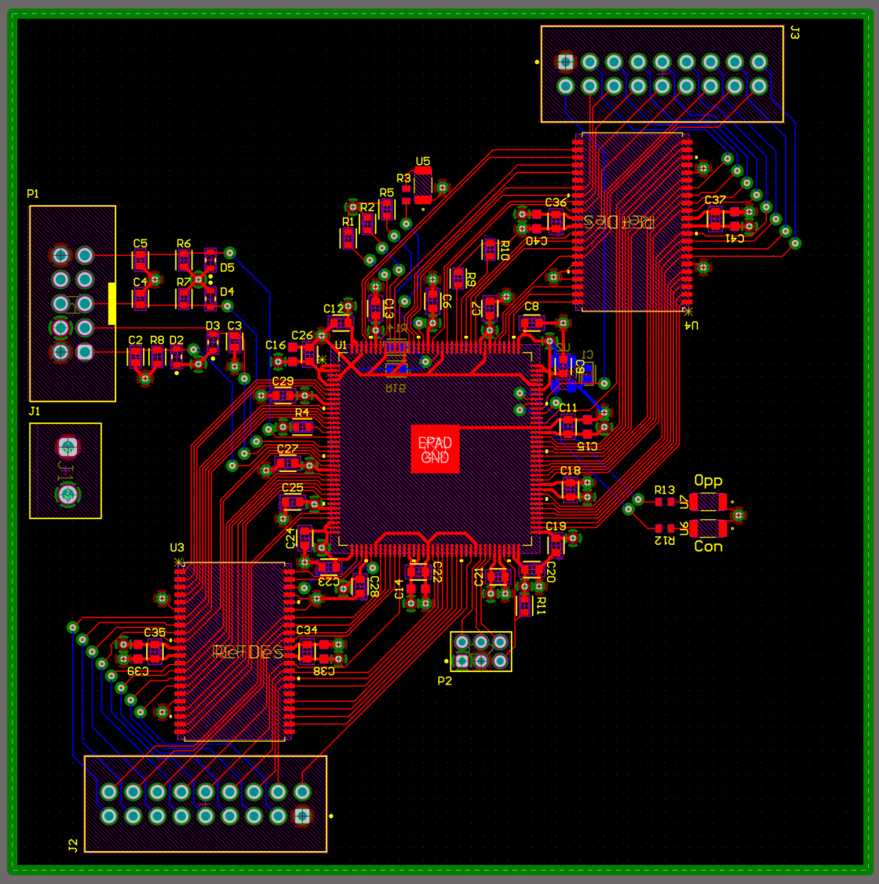

The PCB layout is shown above. This is a representation of the schematic with the actual connections between components. In this view, it is easy to see the 66 wires connecting each SRAM IC to the FPGA and output header.

***3.3. Subsystem Validation***

**Figure 4:** FPGA Validation Plan

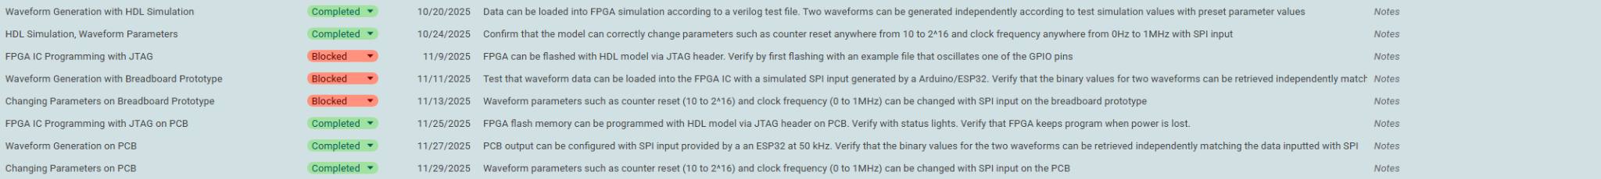

The validation plan for the FPGA subsystem is shown above. The tests can be split into three sections: simulation, prototyping, and final PCB. A breadboard prototype, where the FPGA would be tested with the SRAM by connecting them on a breadboard, was intended to be assembled before the designing of the PCB, but this had to be skipped because of time constraints.

**3.3.1. Simulation**

Testbenches were written for each module, then for the complete program. Iverilog and Icarus Verilog were used to simulate the Verilog HDL code with the testbench input. The waveforms for the input and output wires of the complete program is shown below:

**Figure 5:** Verilog Simulation Inputs and Outputs

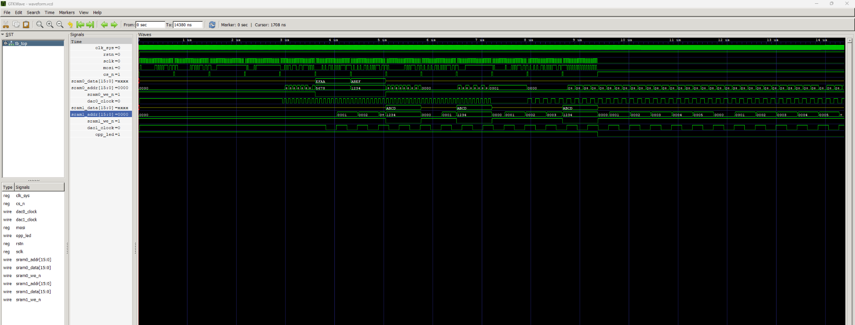

Gtkwave was used to view the input and output waveforms. The top line is the system clock, followed by the inputs: Reset, SCLK, MOSI, and CS. This is followed by the outputs for each channel, consisting of a 16 bit data bus, 16 bit address bus, SRAM read/write enable, and the clock output for the DAC.

This test shows that both channels of the FPGA can be configured through only the SPI input. The SPI input is shown only in the first part of the test. After all data is sent though SPI, the address and clock outputs are shown on the right side. After configuration, both waveforms are running at different frequencies and have different reset values. The test also shows that the SPI input can be used to change the frequency, reset, and memory values of the waveform during operation. For instance, sram0_addr starts out counting, but then is slowed down by a SPI input that changes the phase.

Since the SRAM could not be included in the simulation, the data wires during waveform generation only show the high impedance state of the FPGA pins. As such, we cannot confirm that the reading and writing of the waveform lookup table data to the SRAM is working as intended from these tests.

To test the maximum frequency that can be outputted by the subsystem, we input the conditions for a 50 MHz square wave by setting the phase increment to 7FFFFFFF. The NCO can only downstep the system clock up to 10 MHz without distortion, however the signal will also have no distortion if the frequency is a divisor of the system clock.

**Figure 6:** 50 MHz Square Wave Simulated Output

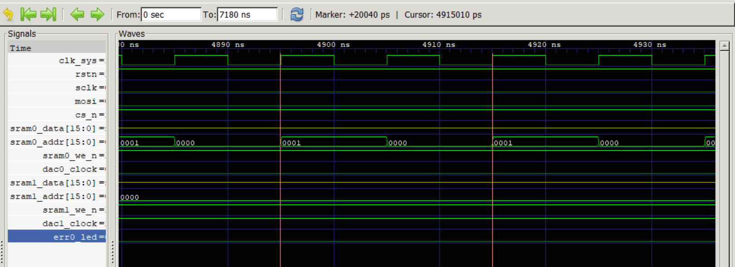

Here we can see that the subsystem can output a clean square wave with a period of 20040 ps, which equates to 49.9 MHz.

**3.3.2. PCB Testing**

As the breadboard prototype had to be skipped, the first test of programming the FPGA and writing to the SRAM was done after the assembly of the final PCB. This was risky, however, after assembly and changing the order of the JTAG wires the FPGA was able to be programmed without any issues. The FPGA’s internal flash memory was also able to be programmed without issue, allowing the FPGA to keep its program even after losing power.

After some alterations to the SPI decoder module, the subsystem was also able to be configured using the SPI input. An ESP32 Microcontroller was used to simulate the input from the MCU subsystem, and an Analog Discovery 2 (AD2) was used to supply power and monitor the output through the use of its digital logic analyzer mode. However, the AD2 was limited in the range of frequencies it could detect, and the number of data wires it had available. As such, the 50 MHz signal could not be confirmed to be able to be outputted by the system, and the output of both channels could not be monitored at the same time.

**Figure 7:** Simple Waveform A

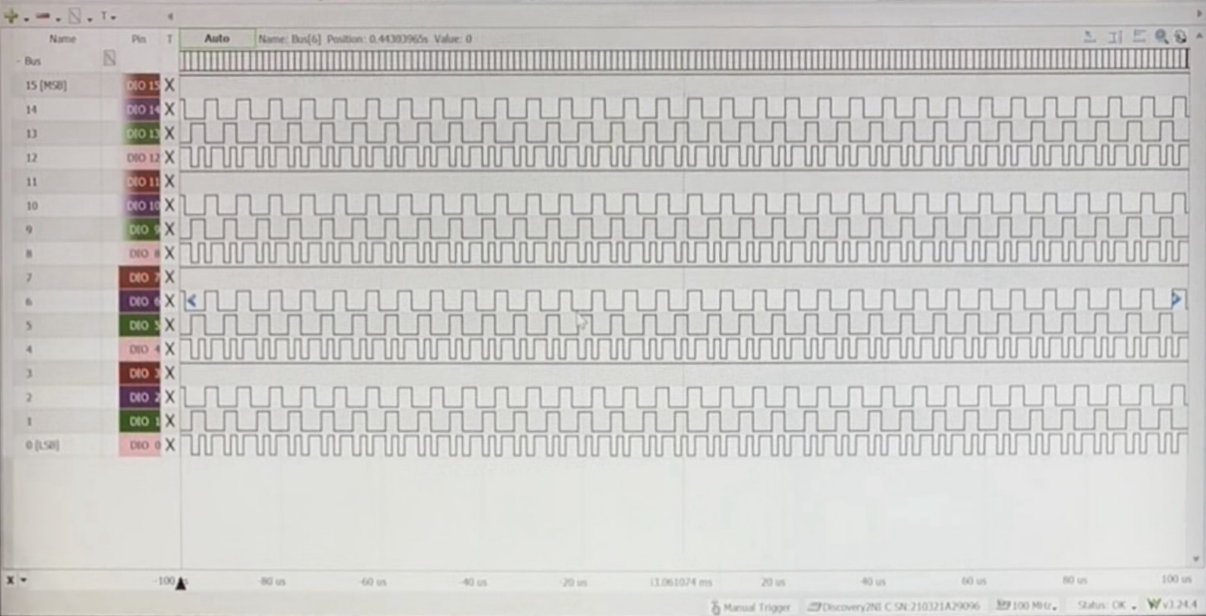

**Figure 8:** Simple Waveform B

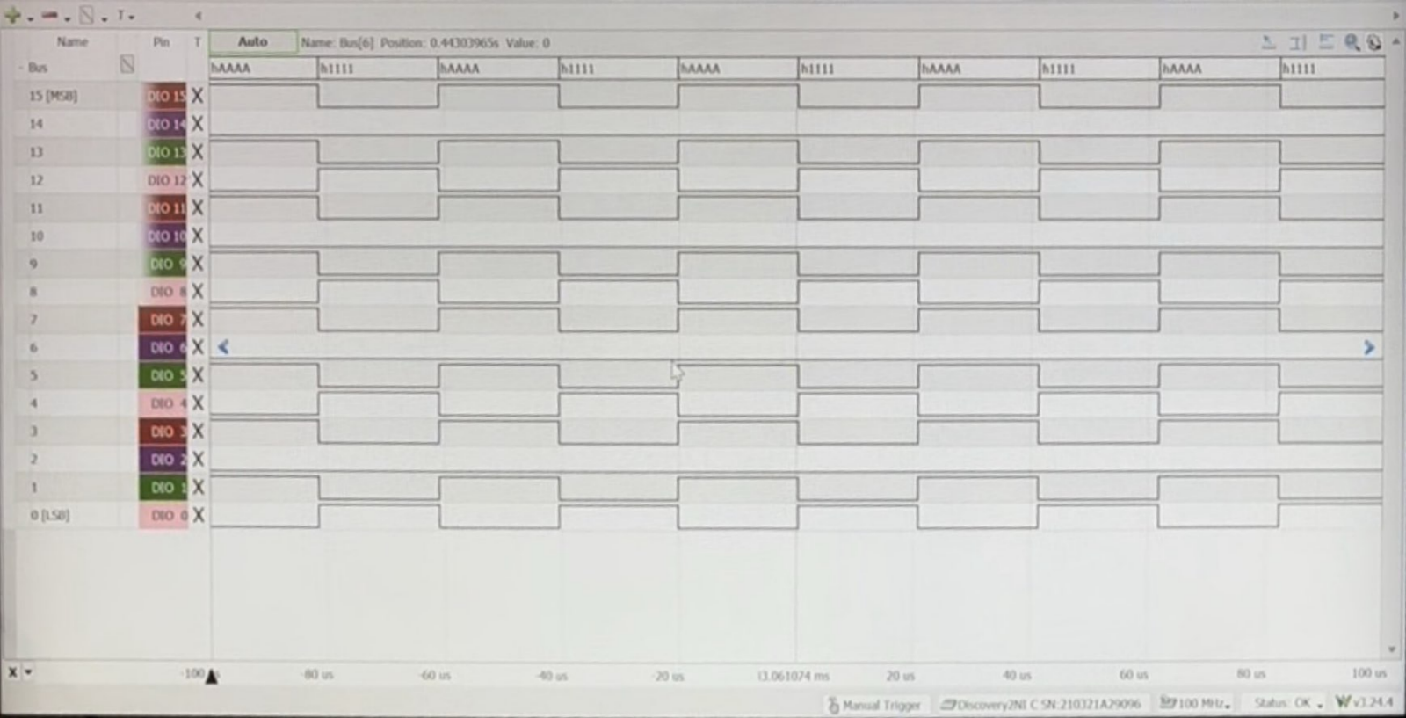

Above, two simple waveforms can be seen. A test script for the ESP32 was written to switch between these two waveforms every 5 seconds in order to test if the FPGA could be reconfigured during operation. The FPGA was able to quickly and consistently switch between these two waveforms with only a few inputted commands. The first waveform is made up of five values: 9999, AAAA, BBBB, CCCC, and DDDD. These are inputted into the SRAM for output channel 1 with the codes 100009999, 10001AAAA, 10002BBBB, 10003CCCC, and 10004DDDD. The frequency and reset were set with the codes 500FFFFFF and 30004FFFF respectively. The waveform was switched simply by changing the frequency, reset, and one value in memory with the codes 5007FFFFF, 30001FFFF, and 100001111.

**Figure 9:** Binary Sinusoidal Waveform

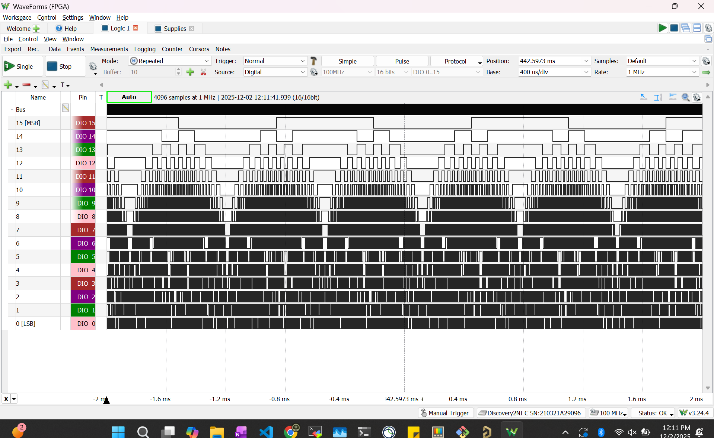

Above, the binary representation of a sinusoidal waveform can be seen. A function was added to the ESP32 test script to interpolate over one period of a sin function, calculate the amplitude values in hex, and send the data in SPI to the FPGA. This allowed large amounts of data to be easily loaded into SRAM. This test was intended to show that the subsystem can consistently output large, complicated waveforms.

Next, the FPGA subsystem was tested at very high frequencies. This was done by generating a square wave at increasing multiples of the system clock. First, a 6.25 MHz square wave was generated by inputting a phase of 0FFFFFFF.

**Figure 10:** 6.25 MHz Square Wave

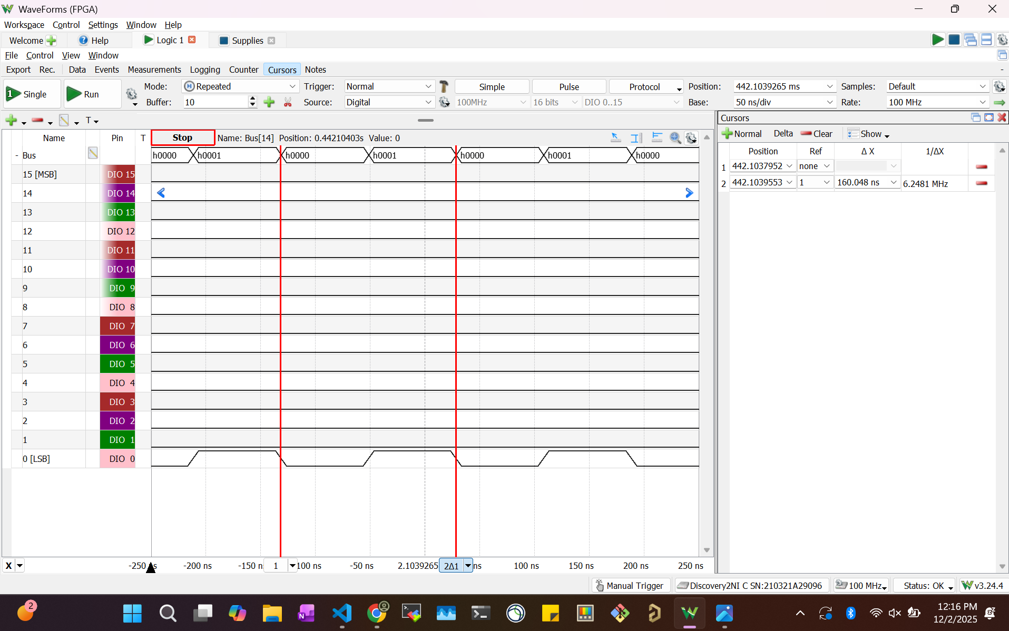

Above, we can see that the outputted signal has a frequency of 6.2481 MHz. This means that the outputted signal has an error of 4.03%. Next, a 12.5 MHz square wave was generated by increasing the phase to 1FFFFFFF.

**Figure 11:** 12.5 MHz Square Wave

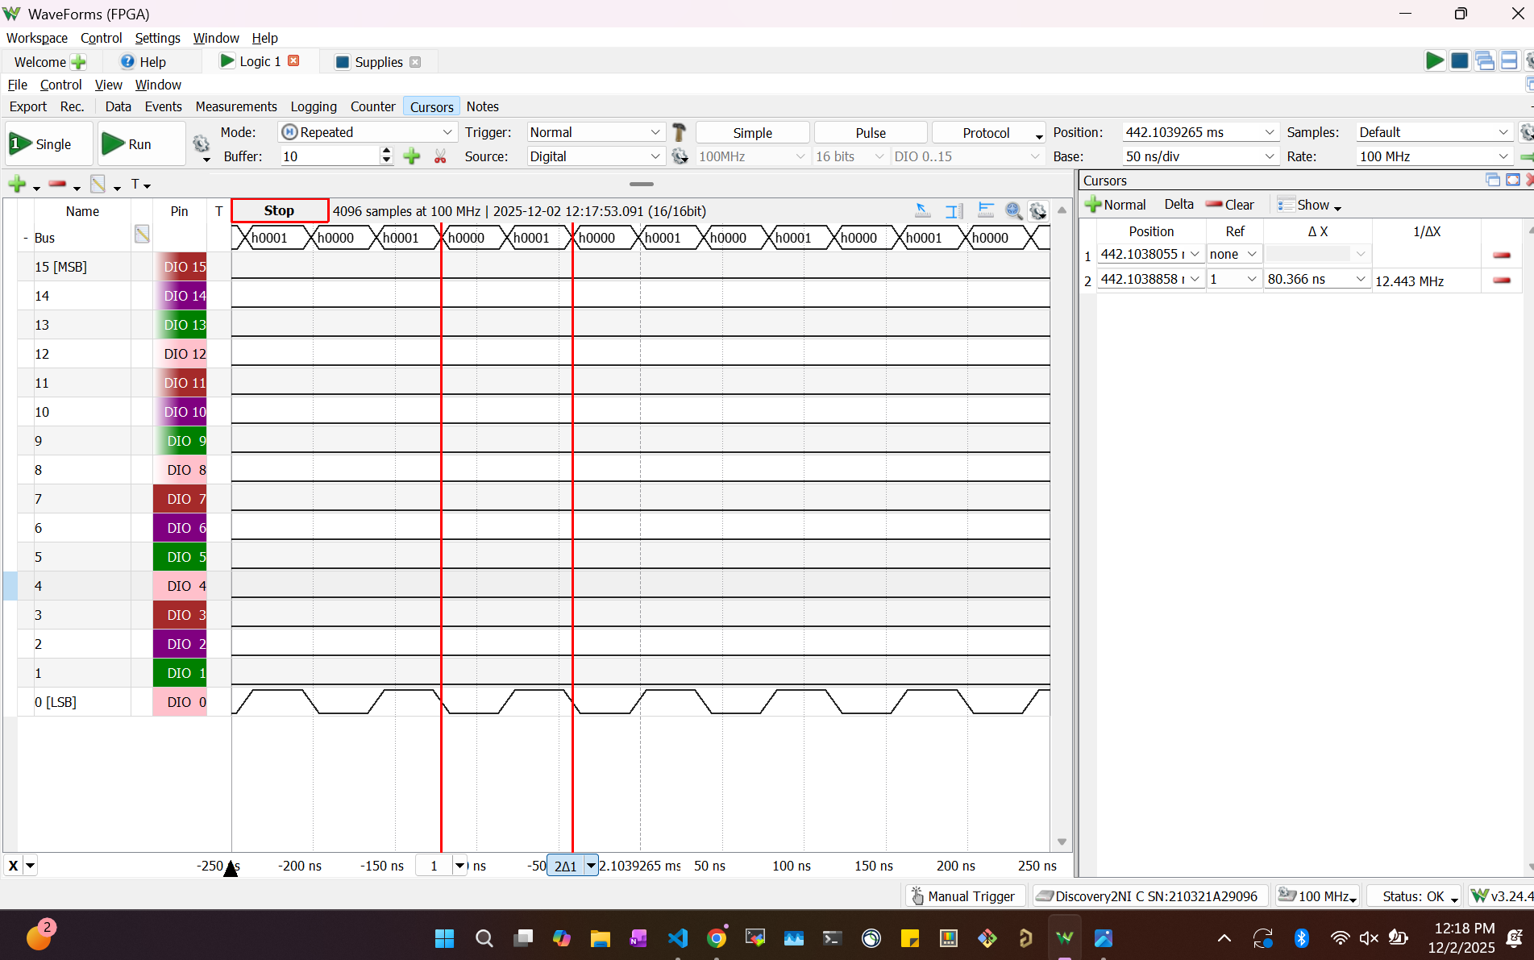

Above, we can see that the outputted signal has a frequency of 12.443 MHz. This gives the outputted signal an error of 0.458%. Next, a 25 MHz square wave was generated by increasing the phase to 3FFFFFFF.

**Figure 12:** 25 MHz Square Wave

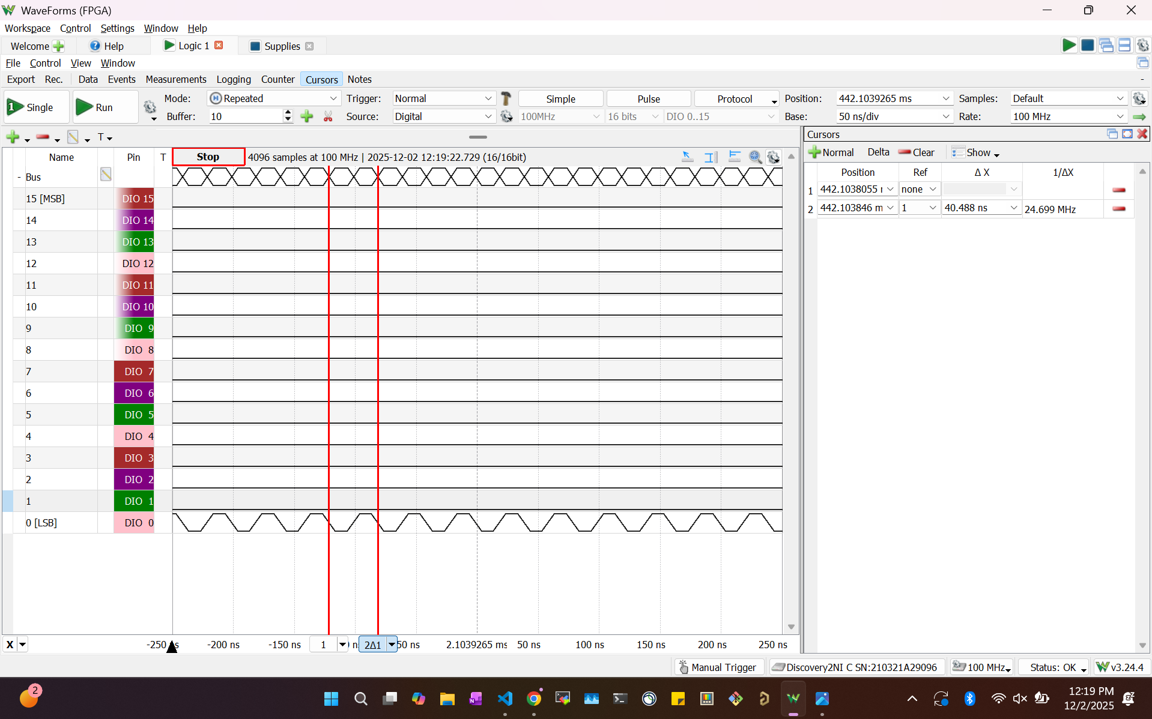

Above, we can see that the outputted signal has a frequency of 24.699 MHz. This means that the signal has an error of 1.22%. The phase was then increased to 7FFFFFFF in order to attempt to generate a 50 MHz square wave. However, due to constraints on the maximum frequency readable by the AD2, the signal could not be recognized.

***3.4. Subsystem Conclusion***

The FPGA subsystem was successfully designed and assembled. The subsystem met and exceeded the design specifications. It also passed all validation tests and was able to generate a recognizable square wave at a maximum frequency of 25 MHz. It did this by reading and writing data to the SRAM, taking input through only the serial SPI input, and being able to be programmed via JTAG. In the future, the subsystem will be integrated with the MCU and DAC to be able to both receive information from the app, and convert the binary output into a recognizable waveform.

## Two Channel Arbitrary Waveform Generator

Salina Teng

# Power Subsystem Validation Report

**4. Power Subsystem Report**

***4.1. Subsystem Introduction***

The power subsystem generates regulated voltage rails required by the Two-Channel Arbitrary Waveform Generator (AWG). From a +12 V input (derived from the +120 V wall outlet through an external AC-DC adapter), the system produces ±10 V for the analog output stage filters, +5 V for the DAC’s precision VREF, a filtered +3.3 V for the DAC’s VDD, and a main +3.3 V for the MCU and FPGA. Each rail must supply stable, low-noise power under its expected maximum load and maintain reliable performance across the full operation duration of the AWG.

***4.2. Subsystem Overview***

**4.2.1. Functional Description**

The power subsystem takes an input of +12 V from an external AC-DC adapter and distributes it through input protection. Three switching DC/DC buck converters generate the ±10 V, +5 V, and +3.3 V rails. A π-filter that was used after the main +3.3 V rail to produce a low-ripple, clean +3.3 V rail for the DAC’s VDD. A precision reference IC generates a clean +5 V VREF for the DAC. Each rail includes local decoupling by capacitors and load regulation to support the MCU, FPGA, DAC, and analog output stage.

Input protection circuitry is included at the +12 V input point, consisting of a rectifier diode for reverse polarity protection, a polyfuse for overcurrent protection, and a TVS diode for voltage spike protection.

**4.2.2. Requirements Summary**

The main +3.3 V rail must supply up to 0.76 A for the SRAMs, ESP32, and FPGA. An additional 0.5 A headroom was added to ensure reliable operation under worst-case loading. The filtered +3.3 V rail supplies only the DAC VDD and requires 0.01mA for both DACs.

The +5 V rail supports the two DAC VREF and is expected to deliver a maximum current output of 2 mA.

The ±10 V analog rails were designed to supply up to 214.1 mA each. This requirement comes from the analog output stage, which drives up to ±5V at 100kHz into a 50 Ω load. Given Ohm’s Law (I = V / R),each channel requires 100 mA, and with two channels plus op-amp quiescent currents, the total rail load becomes 214.1 mA. A headroom of ~386 mA was added, giving each rail a maximum expected load capability of 600 mA.

| **Power Rail** | **Description** | **Maximum Expected Current Output** | **Resistor for Full-Load Test** | **Resistor Power Rating** |
| --- | --- | --- | --- | --- |
| **+3.3V** | Main Digital Load (FPGA/MCU) | 1.26 A (0.5 A headroom) | 2.62 Ω | 4.16 W |
| **+3.3V_CLEAN** | DAC VDD | 0.01 mA | Included in main +3.3V test | Included in main +3.3V test |
| **+5V** | DAC VREF | 2 mA | 2.5 kΩ | 0.01 W |
| **+10V** | Analog Output Stage | 0.6 A (0.3 A headroom) | 16.7 Ω | 6.00 W |
| **-10V** | Analog Output Stage | 0.6 A (0.3 A headroom) | 16.7 Ω | 6.00 W |

***Figure 1: Power Rail Specification Table***

***4.3. Design Architecture***

**4.3.1. High-Level Architecture**

The power system follows a parallel architecture in which all regulated rails are derived from a single +12 V power input supplied by an external AC-DC adapter. The +3.3 V and +10 V rails are generated by stepping the +12 V rail down through dedicated buck converters. The -10 V rail is created from the +12 V rail using an inverting buck topology. Because the DAC VREF requires an extremely low-noise and high accuracy reference, a precision voltage IC is used to generate the +5 V rail. The DAC VDD is also noise sensitive, so a pi-filter following the main +3.3 V rail is used to create a clean, low-ripple +3.3 V supply for the DAC.

**4.3.2. Power/Signal Calculations**

***Figure 1*** displays the maximum load calculations for each rail. For the main +3.3 V rail, the maximum expected current draw is 1.26 A, corresponding to an equivalent worst case load resistance of 2.62 Ω rated at 4.16 W (R = V / I). The filtered +3.3 V rail (+3.3V_CLEAN) expects a maximum current draw of only 0.01 mA, so its worst case load is negligible and included with the main +3.3 V rail’s validation. The +5 V rail requires a maximum current draw of 2 mA, corresponding to the 2.5 kΩ load resistance rated at 0.01 W. The ±10 V analog rails will need to be able to operate stably given a load of 16.7 Ω rated at 6.00 W minimum given the fact that its maximum expected current draw is 0.6 A.

***4.4. Hardware Implementation***

**4.4.1. Schematic Design**

The power schematic design consists of five major sections: DC Power Jack with Input Protection, VREF to the DAC (+12V → +5V), Buck Converter for Digital Supply (+12V → +3.3V), Buck Converter for Analog Supply (+12V → +10V), and Inverting Buck Converter for Analog Supply (+12V → -10V). As per ***Figure 2***, all of the sections are displayed, where each buck converter, precision voltage IC, and input protection design, layout, and wiring are shown. Each block follows the recommended typical application circuits from its respective datasheet. The specific IC used for the +3.3 V (both main and filtered), +5 V, +10 V, and -10 V rails are as follows: LM2596S-3.3/NOPB, LT6654BHS6-5#TRMPBF, LMR14020SDDAR, LM43601PWPR. An indicator LED is included in the design to confirm proper +12 V connection to the board.

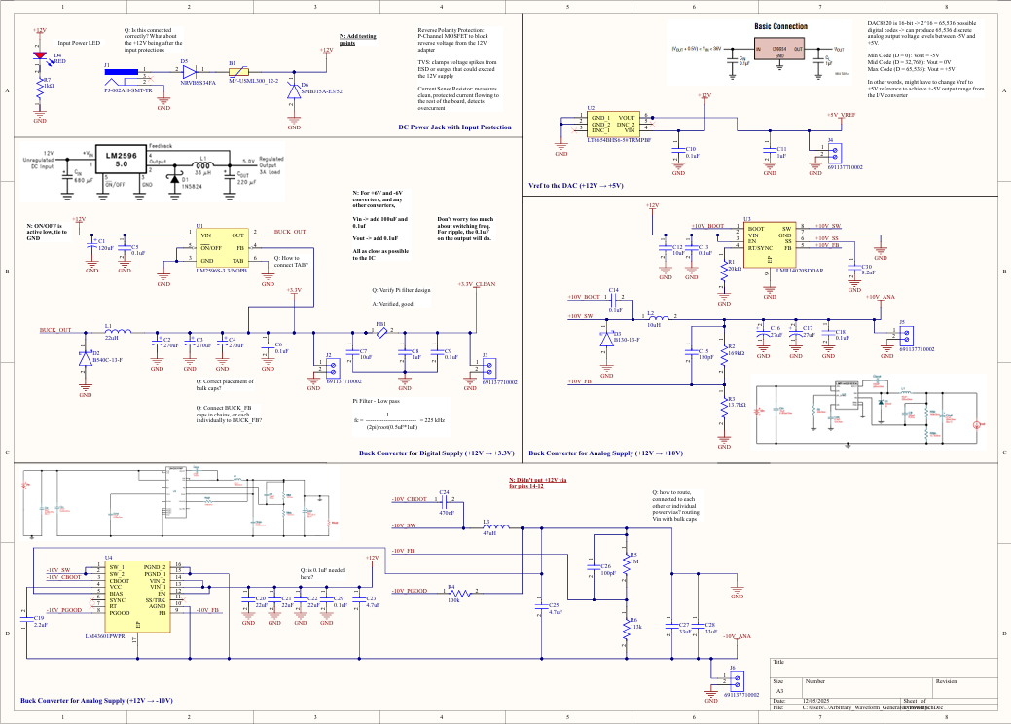

***Figure 2: Power Subsystem Schematic***

**4.4.2. PCB Layout Considerations**

***Figure* 3** displays the power PCB layout. The components for each rail (+3.3 V, +5 V, +10 V, -10 V) are grouped together to allow for a compact design that prioritizes short trace length for low noise and design readability. The +12 V input enters through J1, and each regulated rail outputs through its own terminal block: +3.3 V on J2, filtered +3.3 V on J3, +5 V on J4, +10 V on J5, and -10 V on J6. The trace widths were determined by each rail’s current draw requirements. The +5 V rail traces have a 0.5 mm width, the main and filtered +3.3 V rail traces have a 1 mm width, the -10 V rail traces have a 0.5 mm width, and the +10 V rail traces have a 0.5 mm width. The +12 V input rail traces have a 1.5 mm width.The decoupling capacitors were placed close to the main IC for each rail design.

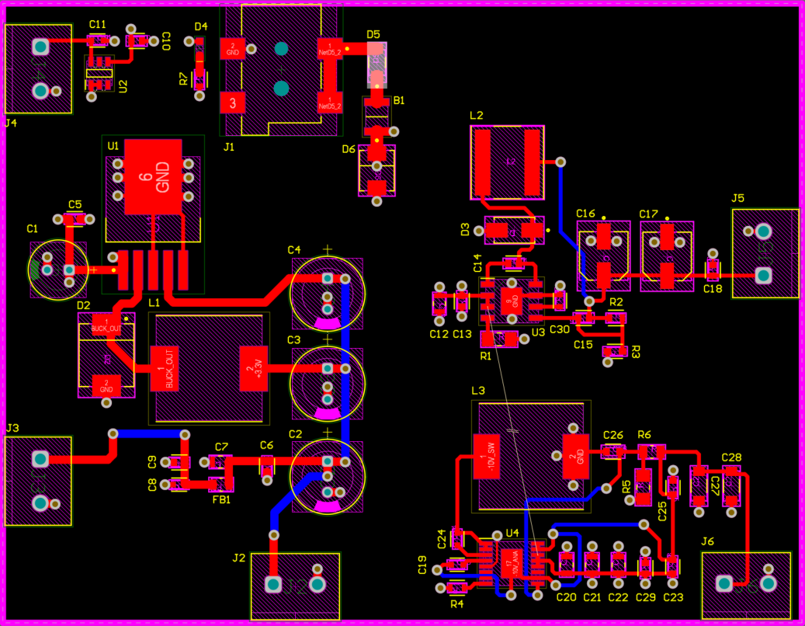

***Figure 3: Power Subsystem PCB Layout***

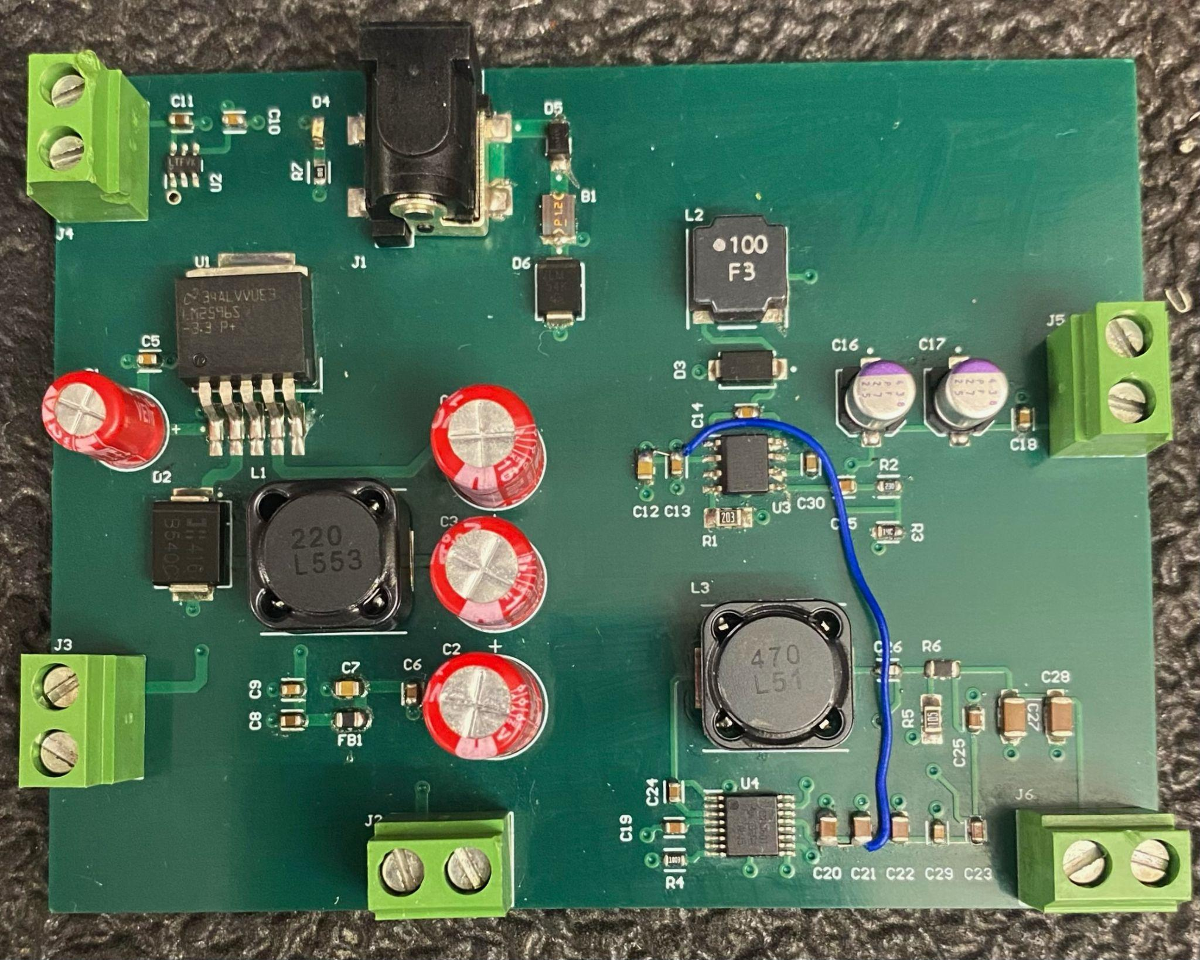

***Figure 4: Assembled Power Subsystem PCB***

***4.5. Integration With System***

**4.5.1. Electrical Interfaces**

Each rail connects from its terminal block to the terminal block(s) of its corresponding subsystem(s). The +5 V rail powers the DAC VREF. The main +3.3 V rail powers the MCU, FPGA, and SRAMs. The filtered +3.3 V rail powers the DAC VDD. The +10 V and -10 V rail routes to the analog output stage PCB, providing supply voltage to the op-amps.

***4.6. Testing & Validation***

**4.6.1. Validation Plan**

The validation plan consists of two sections: simulation and benchtop testing. Prior to PCB layout design, LTspice and WEBENCH simulations were performed to verify transient behavior, steady-state output, startup response, and performance across the full ±10% input voltage range and various load conditions. After PCB assembly, benchtop testings were performed. Each rail was tested under no-load and maximum-load conditions for over 15 minutes to verify load capability, stability, and regulation.

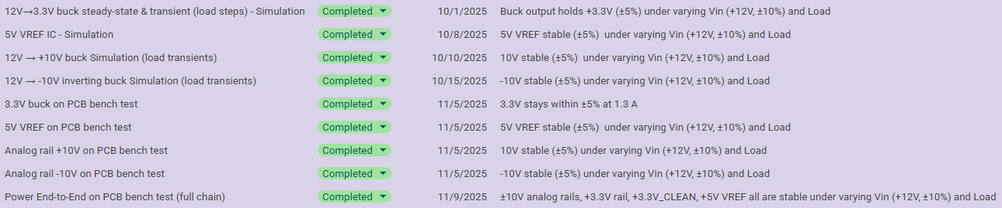

***Figure 5: Power Subsystem Validation Plan***

**4.6.2. Simulations**

For each power rail, its performance across the full ±10% input voltage range and various load conditions was validated. Below are the simulation results for Vout vs Vin and Load vs Vin. These results verified that every rail maintained stable and accurate output across the full input voltage range and at maximum load.

The +3.3 V rail was tested across the full ±10% input voltage range (+10.8 V through +13.2 V, nominal Vin = +12 V), and the Vout remains stable at around +3.3 V. ***Figure 6*** shows the Vout of the +3.3 V rail given a nominal voltage input of +12 V. The +3.3 V rail displayed excellent load capabilities in ***Figure 7***, showing how it is able to maintain an accurate voltage output of +3.3 V even with a 4 A load.

Similarly, the +5 V rail was tested across the full ±10% input voltage range (+10.8 V through +13.2 V, nominal Vin = +12 V), and the output voltage remains stable at around +5 V as shown in ***Figure 8***. Given various load conditions of 0 A to 10 mA, the +5 V rail remains accurate and stable as shown in ***Figure 9***.

The +10 V rail was simulated in WEBENCH. Given the input transient plot as shown in ***Figure 10***, the rail remains stable, dropping to only +9.996 V given a sudden input voltage spike. Given the load transient plot as shown in ***Figure 11***, the rail still remains stable, dropping to only +9.9 V given a sudden current draw spike.

Lastly, the -10 V rail was tested across the full ±10% input voltage range (+10.8 V through +13.2 V, nominal Vin = +12 V), and the Vout remains stable at around -10 V. ***Figure 12*** shows the Vout of the -10 V rail given a nominal voltage input of +12 V. The -10 V rail displayed great load capabilities in ***Figure 13***, showing how it is able to maintain an accurate voltage output of -10 V at a maximum expected load of 0.6 A.

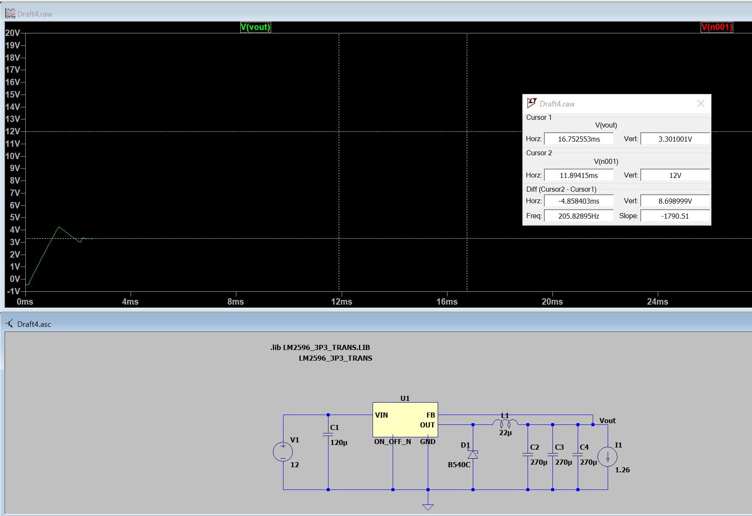

***Figure 6: +3.3 V rail, Vout Response when Vin = +12 V***

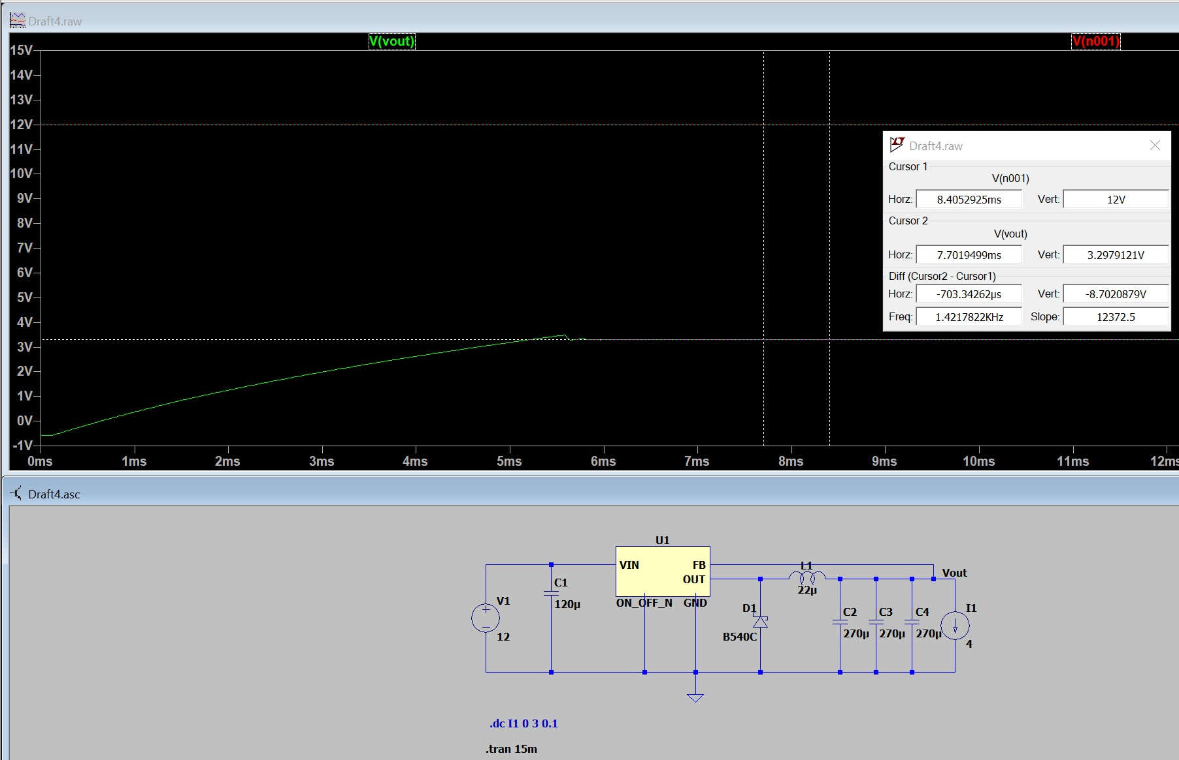

***Figure 7: +3.3 V rail, Vout Response when Load = 4 A***

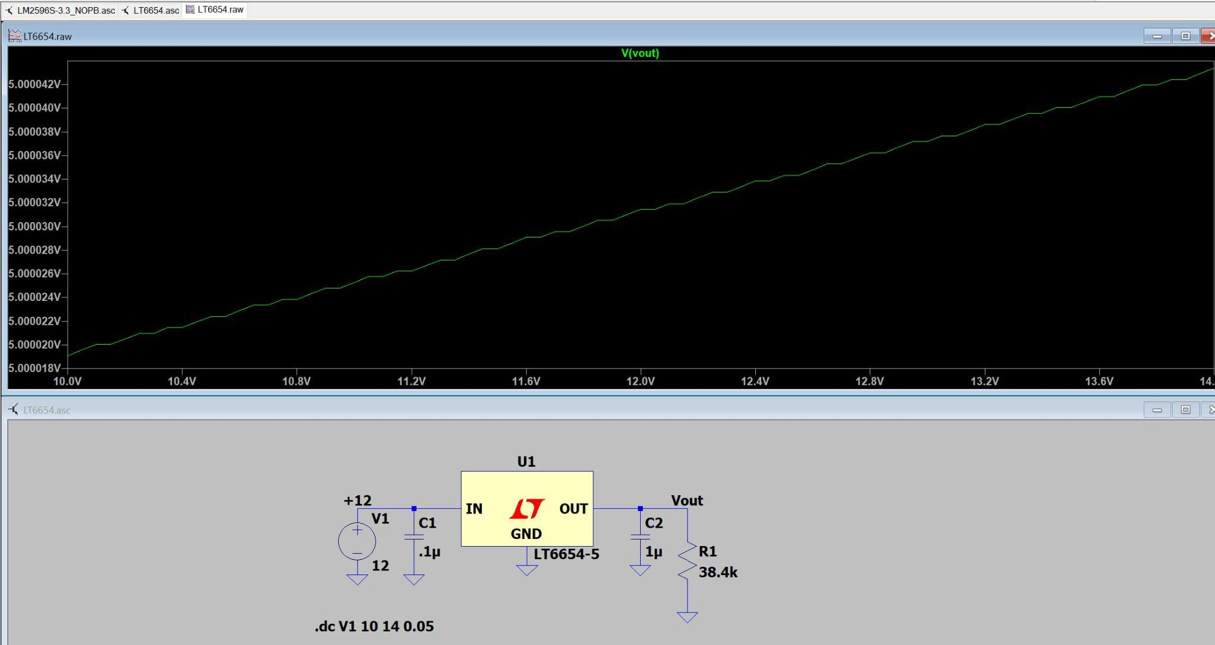

***Figure 8: +5 V rail, DC Sweep Plot, Vin = 10 V - 14 V***

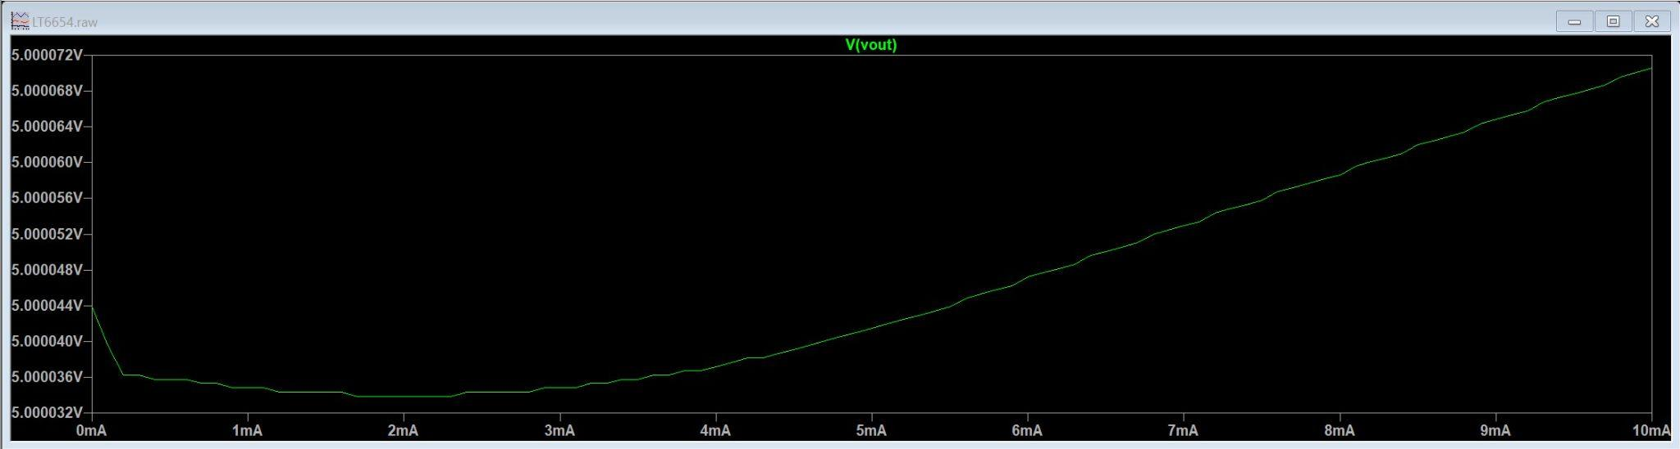

***Figure 9: +5 V rail, DC Sweep Plot, Load = 0 A - 10 mA***

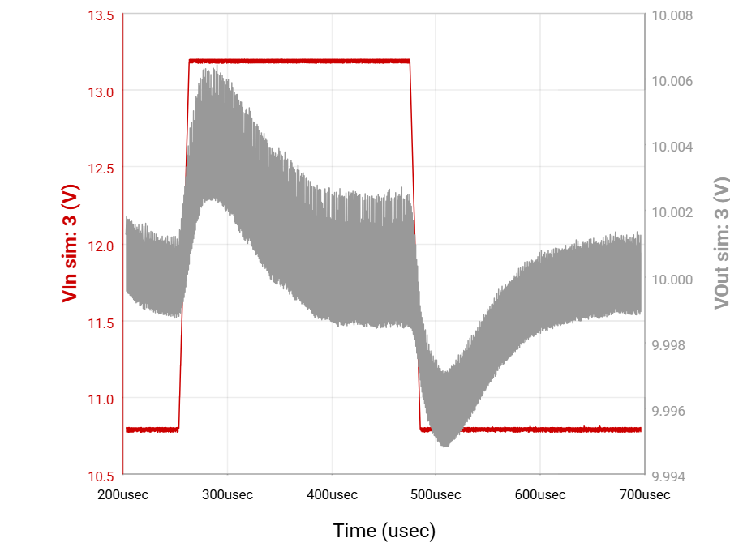

***Figure 10: +10 V rail, Input Transient Plot***

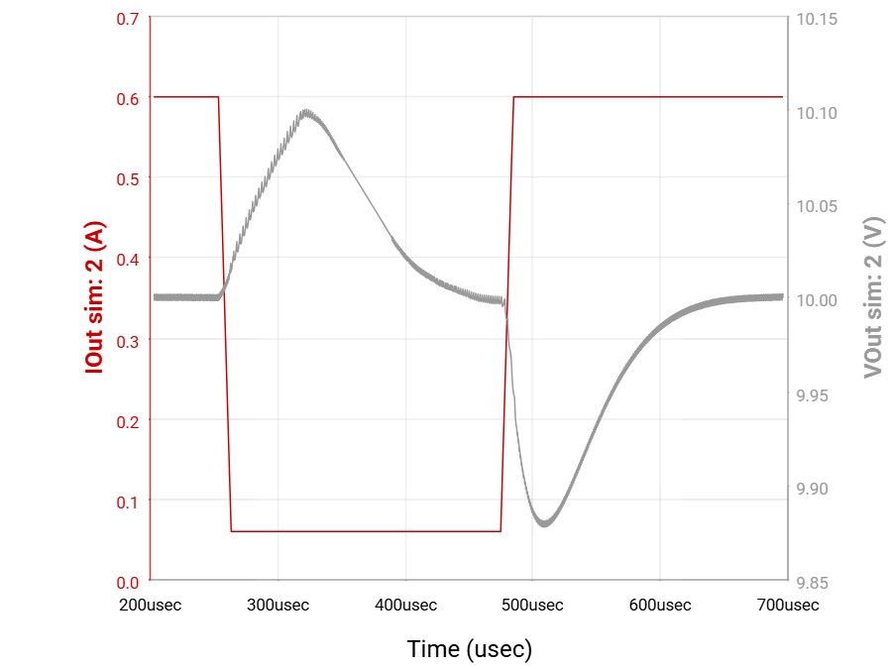

***Figure 11: +10 V rail, Load Transient Plot***

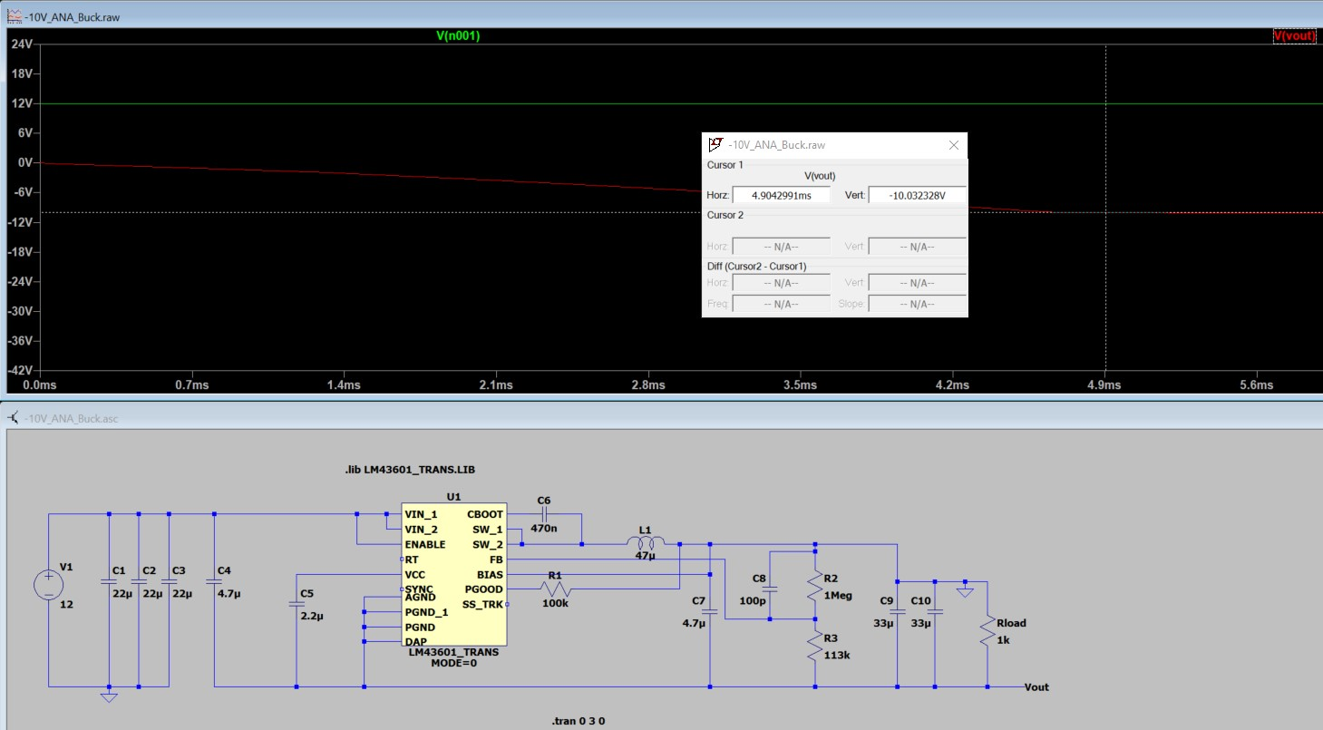

***Figure 12: -10 V rail, Vout Response when Vin = +12 V***

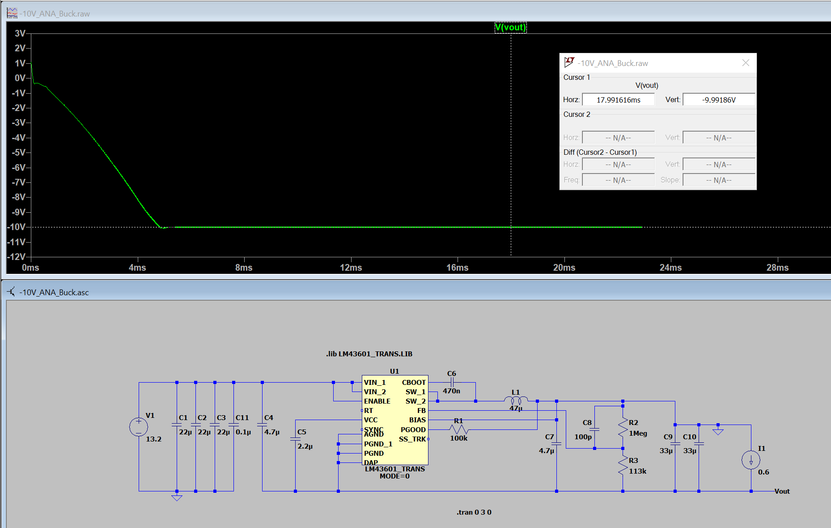

***Figure 13: -10 V rail, Vout Response when Load = 0.6 A***

**4.6.3. Benchtop Results**

Below displays the benchtop testing results for each power rail at no-load. The Time vs. Voltage plots were collected using the oscilloscope, which slightly lowered the displayed DC accuracy due to the oscilloscope’s input impedance. Re-measuring with a digital multimeter confirmed that all rails measured within the ±2% tolerance.

The main and filtered +3.3 V rail (***Figure 14*** and ***Figure 16***) outputs around +3.27 V. The +5 V rail (***Figure 18***) outputs around +4.99 V. The +10 V rail (***Figure 20***) outputs around +10.00 V. The -10 V rail (***Figure 22***) outputs around -10.20 V. All of these resulting voltage values are within the ±2% tolerance expected from each rail.

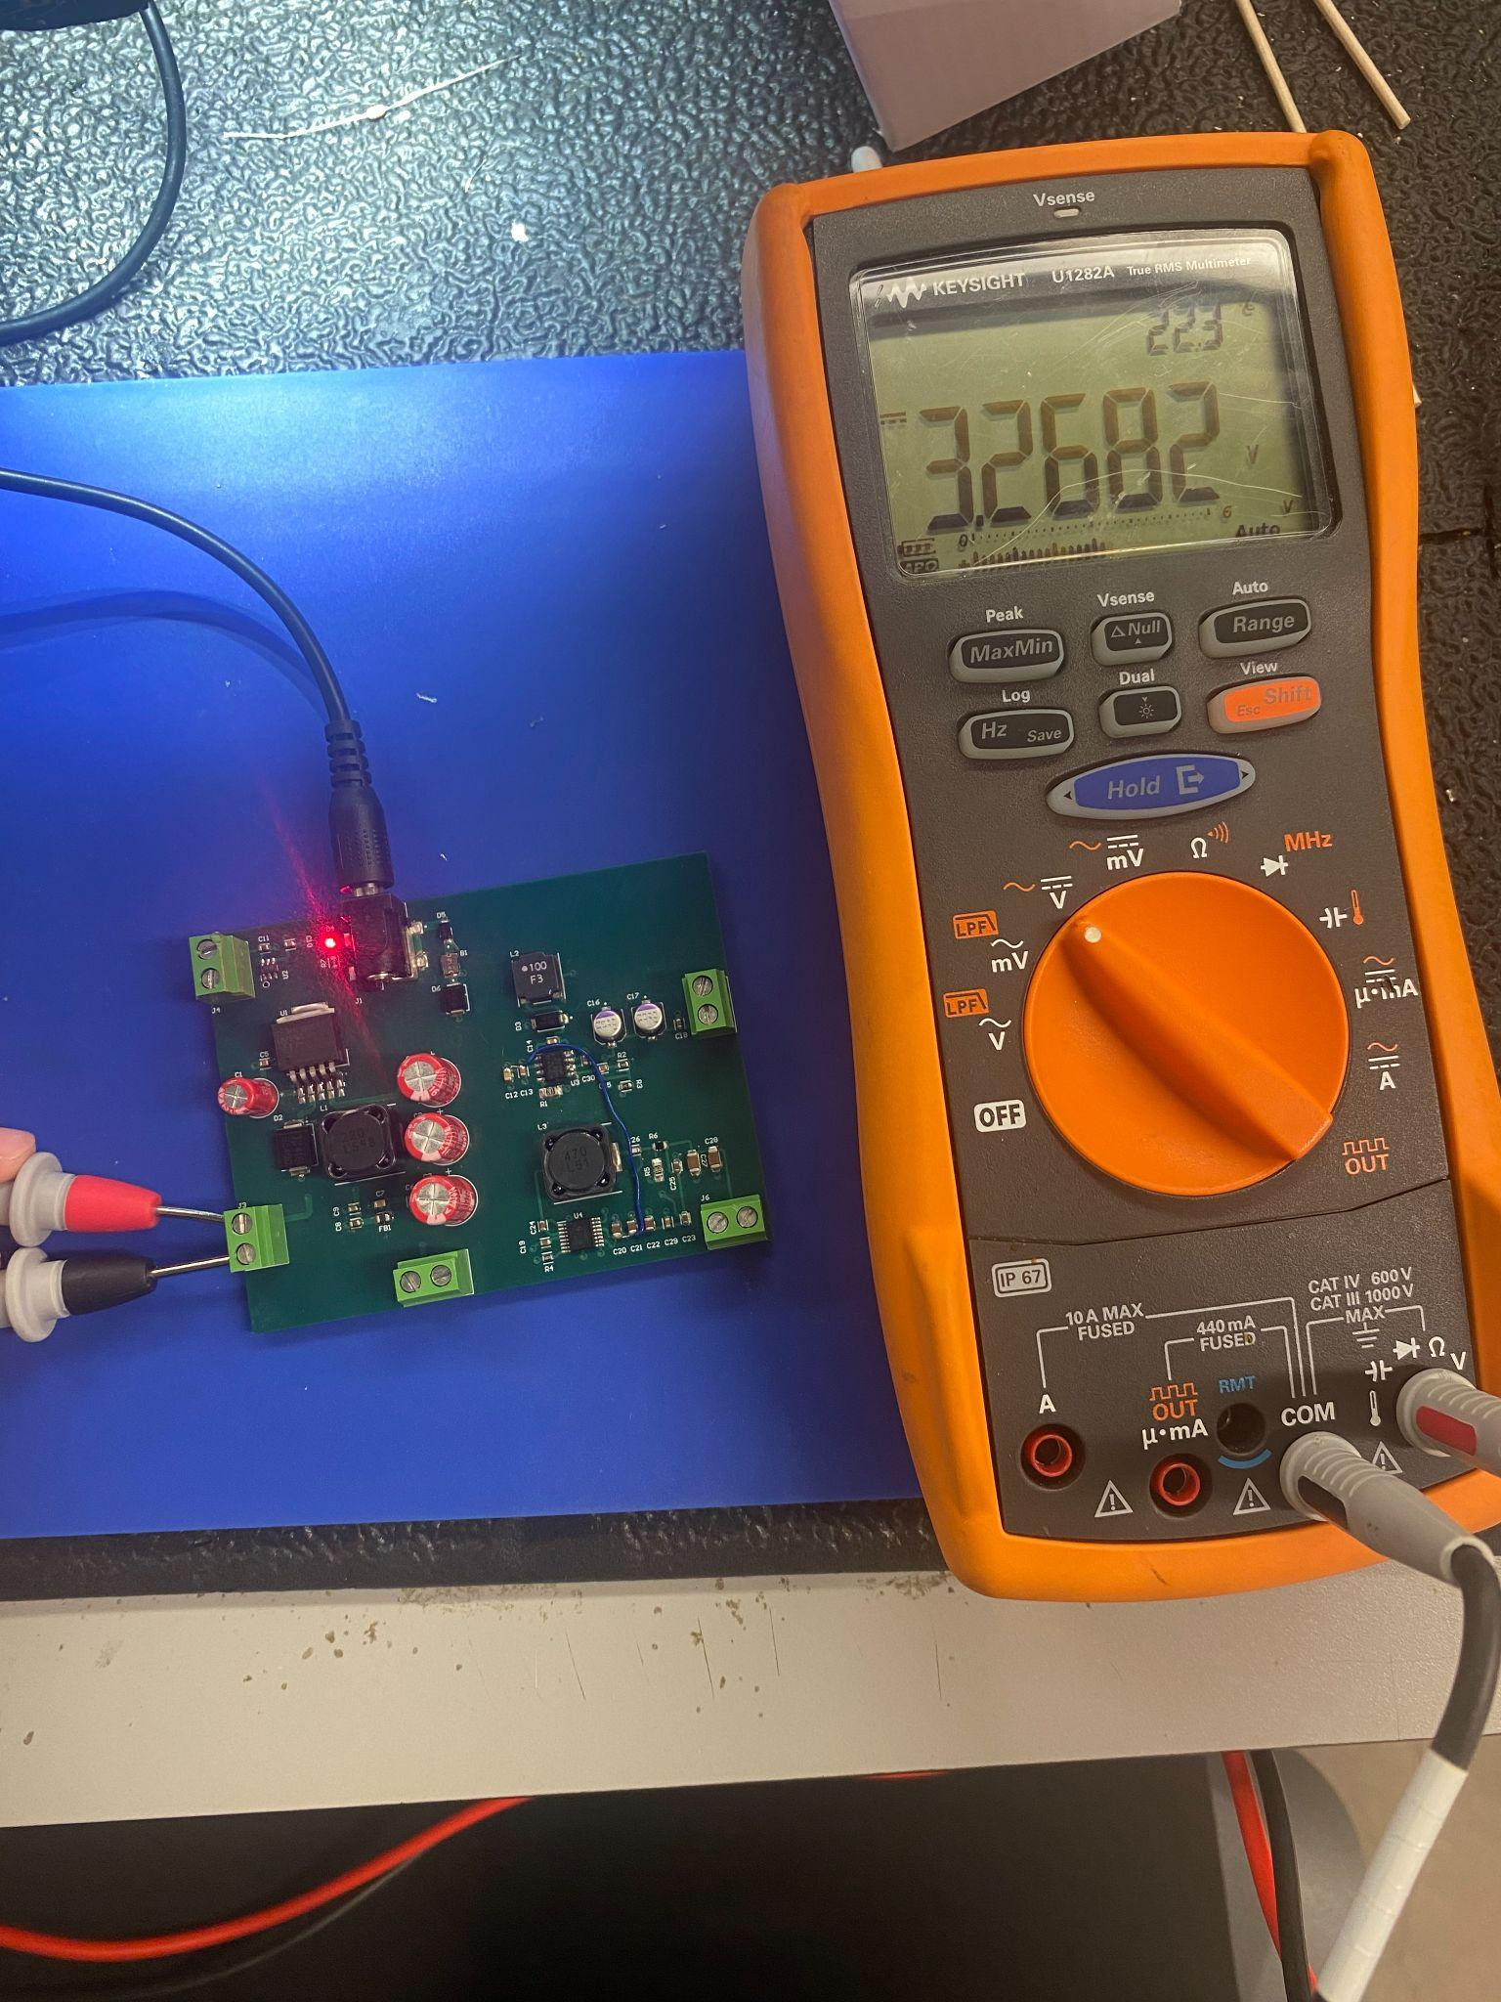

***Figure 14: Main +3.3 V rail, Vout Given No Load***

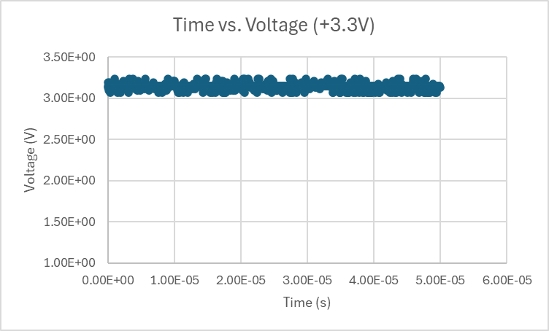

***Figure 15: Main +3.3 V rail, Time vs. Voltage Plot***

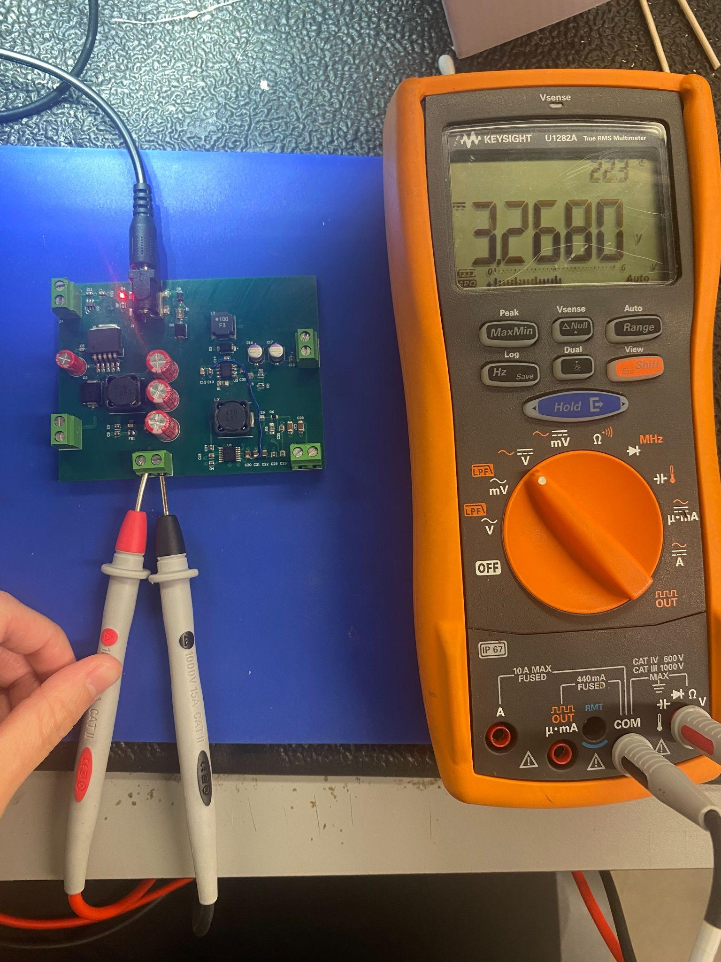

***Figure 16: Filtered +3.3 V rail, Vout Given No Load***

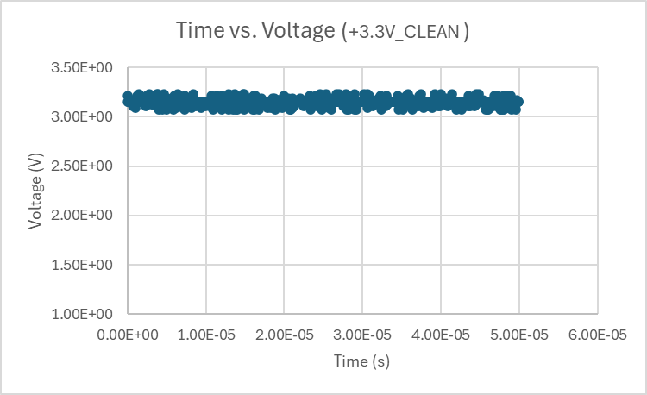

***Figure 17: Filtered +3.3 V rail, Time vs. Voltage Plot***

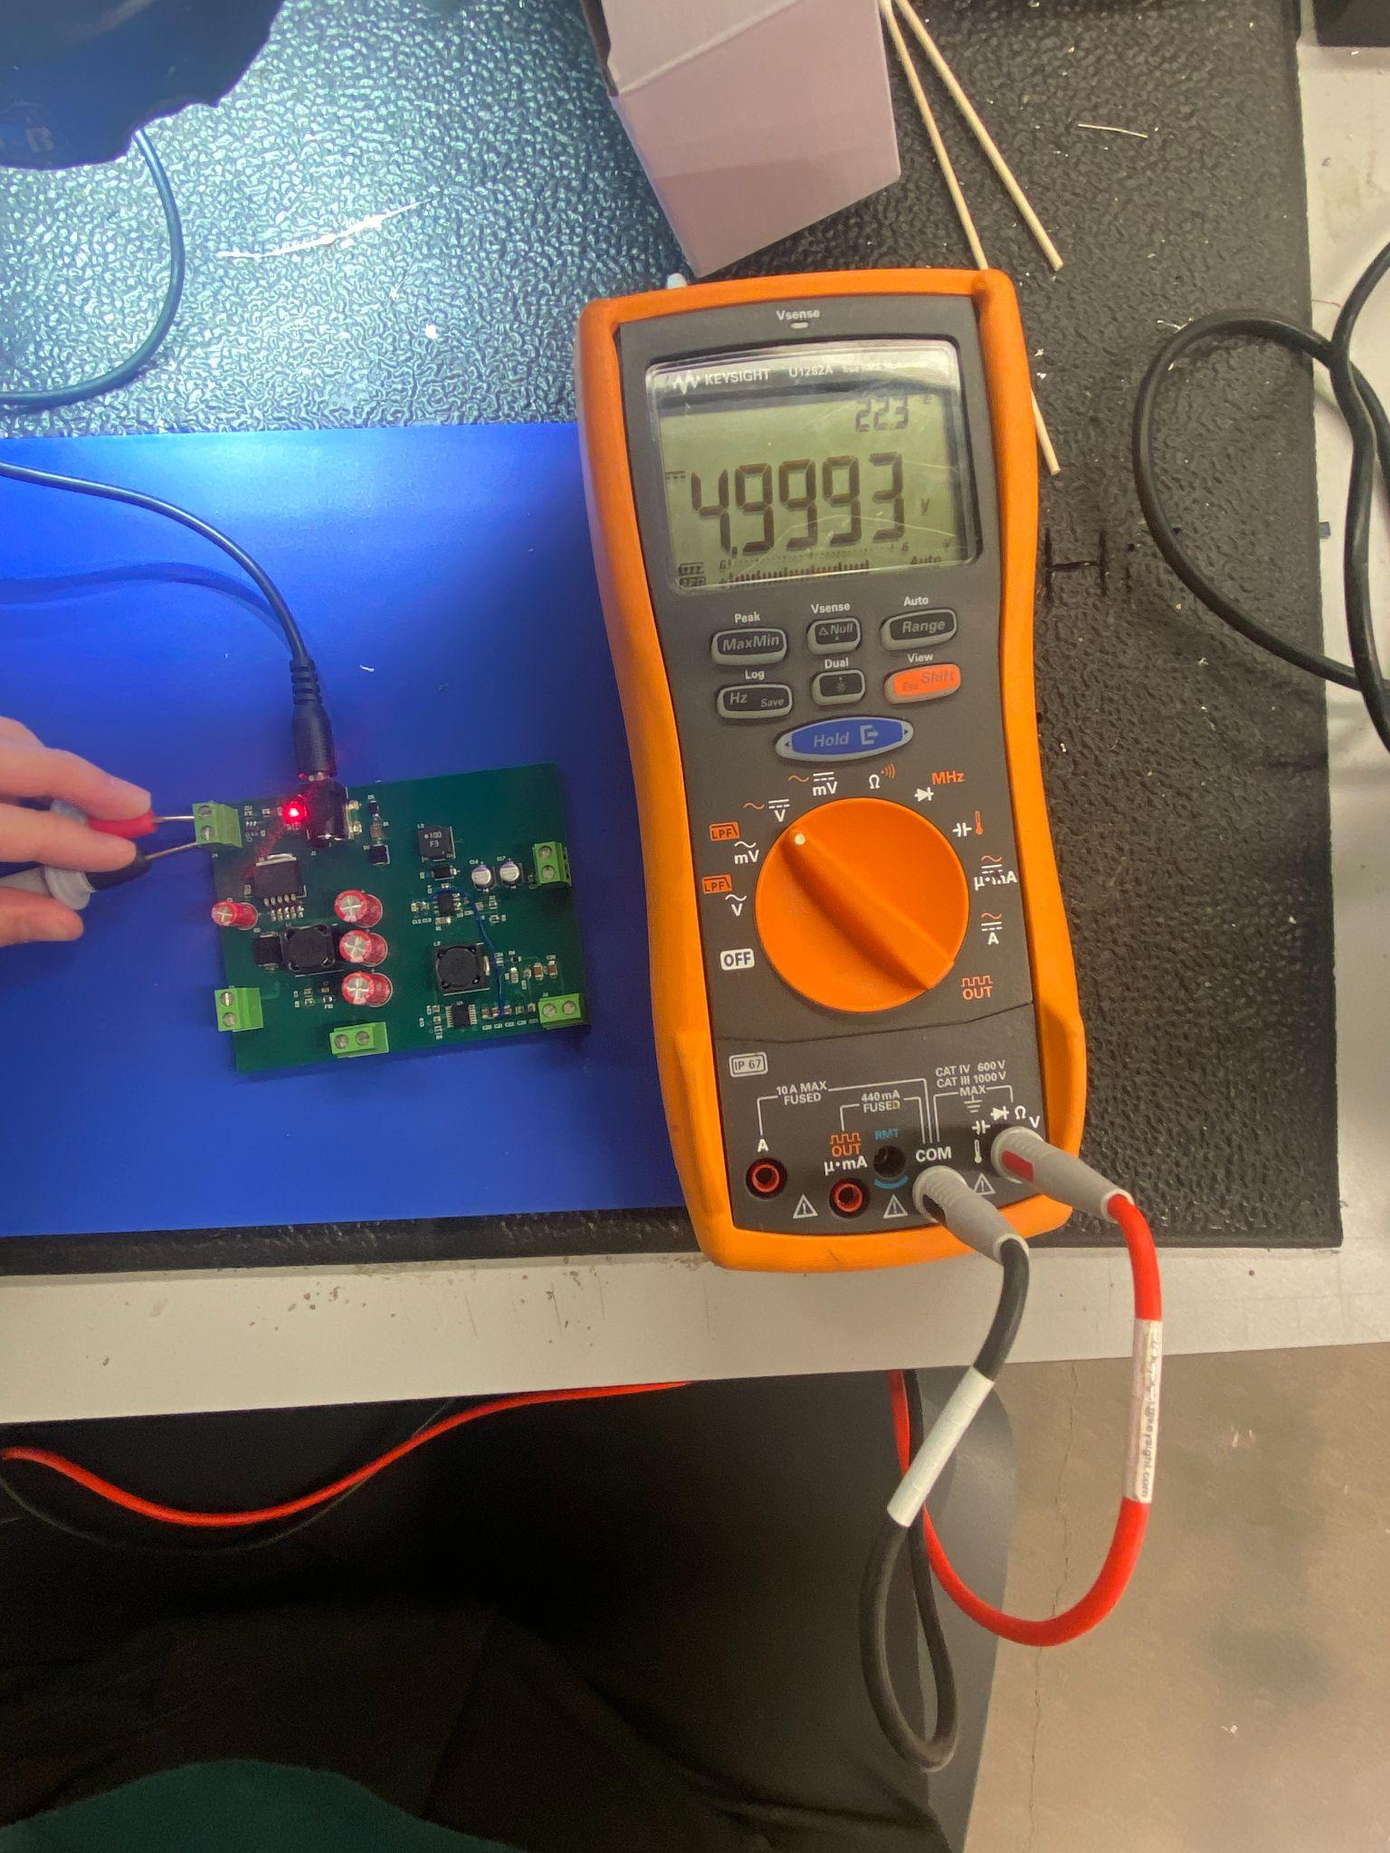

***Figure 18: +5 V rail, Vout Given No Load***

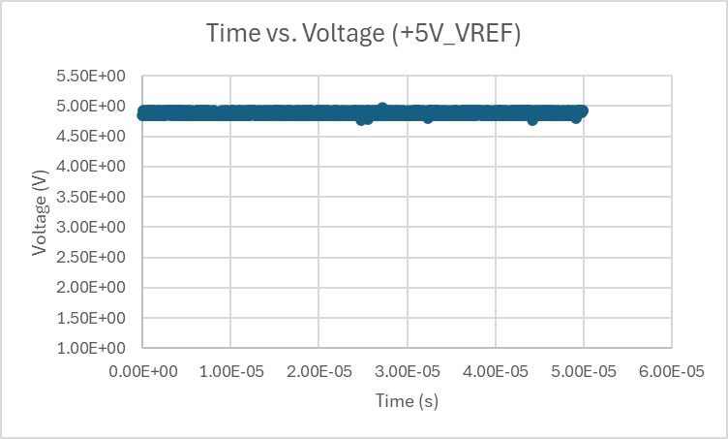

***Figure 19: +5 V rail, Time vs. Voltage Plot***

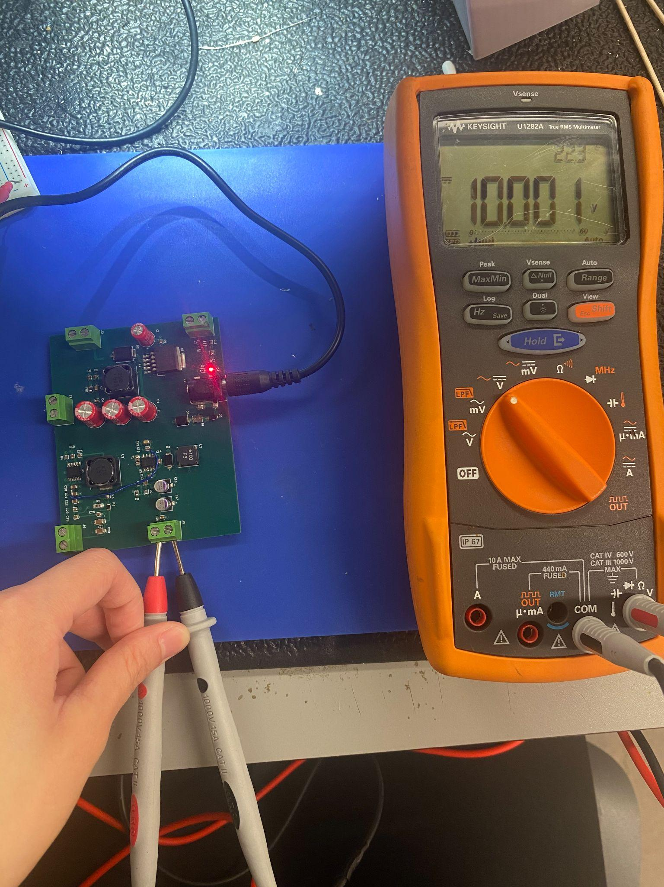

***Figure 20: +10 V rail, Vout Given No Load***

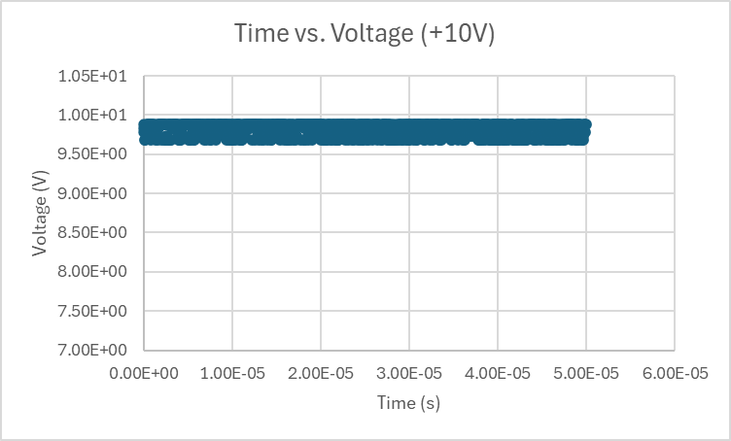

***Figure 21: +10 V rail, Time vs. Voltage Plot***

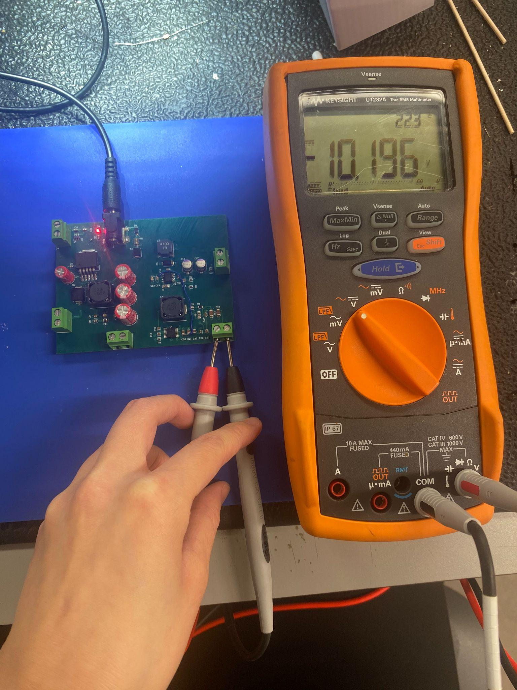

***Figure 22: -10 V rail, Vout Given No Load***

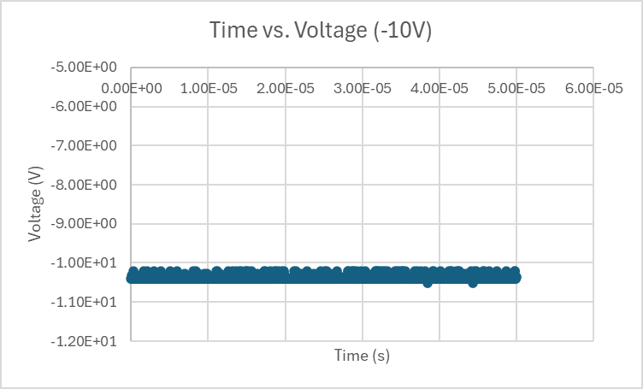

***Figure 23: -10 V rail, Time vs. Voltage Plot***

Under maximum load, the results were as follows: the +5 V rail produced +4.99 V, the +3.3 V rail produced +3.1 V, and the +10 V rail produced +9.8 V. This result indicates that the rails can operate stably at maximum load within ±6% tolerance.

***4.7. Subsystem Conclusion***

The power subsystem was successfully designed and assembled. All validation tests were passed, and the power design was able to produce accurate, stable +3.3 V, +5 V, +10 V, and -10 V rails to power all other subsystems within the AWG. In ECEN 404, the power subsystem will be integrated with the MCU, FPGA & Memory, and analog output stage subsystems to deliver clean, accurate power for stable operation of the AWG.

## Two Channel Arbitrary Waveform Generator

Salina Teng

# Analog Output Subsystem Validation Report

**5. Analog Output Subsystem Report**

***5.1. Subsystem Introduction***

The analog output subsystem generates two independent ±5 V arbitrary signals capable of driving a 50 Ω load at 100 kHz. This subsystem interfaces with the FPGA, taking in streams of 16-bit digital codes that are relayed to the DAC, in which the DAC’s outputs are then filtered and amplified to produce signals delivered with low distortion and sufficient current drive. The analog output stage operates from the regulated ±10 V power supply rails.

***5.2. Subsystem Overview***

**5.2.1. Functional Description**

The analog output subsystem accepts the DAC’s current outputs as inputs. The current values are then translated through the I/V converter to the corresponding voltage values. Further signal conditioning involves low-pass filtering and high-current output buffering stages. The filter and amplification design ensures:

* Ability to drive 50 Ω load at ±5 V, 100 kHz
* Clean analog output with low noise and ripples
* Stable performance across the full signal amplitude and frequency range

Each of the two channels operate independently, producing different signals according to user specifications.

**5.2.2. Requirements Summary**

The analog output subsystem follows a three stage process: I/V conversion to convert current to bipolar voltage (±5V), 150 kHz Sallen-Key low-pass filtering to remove noise and smooth the DAC’s stepped output, and an output buffer to drive the 50 Ω load.

This system’s key objectives involve hitting the full ±5V swing and guaranteeing the 100 mA minimum current drive needed for both channels simultaneously.

| **Category** | **Objective/Constraint** | **Goal** |
| --- | --- | --- |
| *Amplitude* | ±5V output swing | VREF set to +5V |
| *Bandwidth* | Pass max 100 kHz signal | MFB filter fc = ~150 kHz |
| *Drive Current* | Supply high current per channel | ≥ 100 mA peak per channel |

***Figure 1: Filter Subsystem Key Objectives Table***

***5.3. Design Architecture***

The analog output filtering and amplification chain is as follows: DAC → I/V converter → low-pass filter → unity-gain buffer chain.

**5.3.1. Domain Conversion**

The FPGA sends in the stream of 16-bit digital codes into the DAC, in which the DAC will then process and translate these digital code values into current values according to the DAC’s VREF. The stream of current values then passes through the bipolar I/V converter to be translated into their corresponding voltage values. This current to voltage conversion is highly necessary in order to facilitate further processing and filtering in later stages within the analog output chain.

**5.3.2. Input Low-Pass Filtering**

The stream of voltage values pass through a Sallen-Key low-pass filter that has a cutoff frequency of 150 kHz ($f_{c}=150 kHz$). The 150 kHz cutoff frequency value was strategically selected to ensure that signals with frequencies at or close to the maximum 100 kHz don’t get attenuated. This low-pass network ensures that signals with frequencies over 150 kHz get attenuated, allowing only the desired signal bandwidth (≤ 100 kHz) reaches the amplification stage.

This low-pass filter is the main driving force in smoothing out the DAC’s stepped output, creating the analog waveform.

**5.3.3. High-Current Output Buffering**

In order to meet the analog output’s requirement of driving a 50 Ω load at ±5 V with a frequency of 100 kHz, each channel must supply a minimum 100 mA (I = V / R). A high-output current precision operational amplifier powered by ±10 V rails is used for the final buffer stage.

***5.4. Hardware Implementation***

**5.4.1. Schematic Design**

The analog output stage schematic design consists of two filtering and amplification systems, each for one of the two required channels. The filtering and amplification systems are identical between the two channels, and are as follows: I/V converter → low-pass filter → unity-gain buffer chain. The DACs are also included in the schematic since they will be housed on the analog output PCB. As per ***Figure 2***, the specific op-amps used for the I/V converter, Sallen-Key low-pass, and unity gain buffer are as follows: OPA2277, OPA211, and OPA593. Terminal blocks were labeled to serve as power inputs and inputs for the 16-bit digital codes from the FPGA. The final analog signal is outputted through the BNC jack, as seen in the schematic.

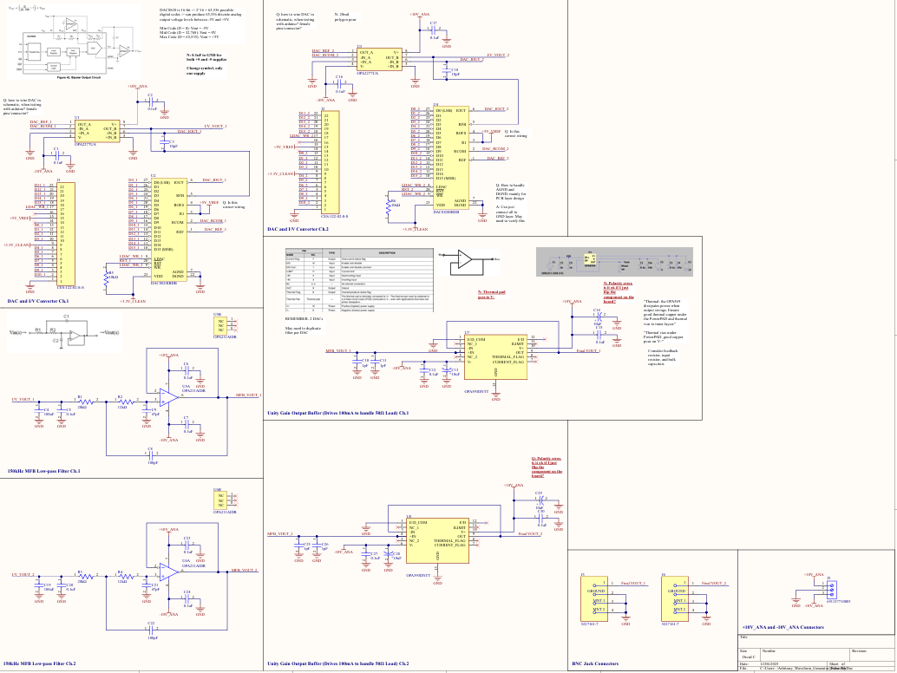

***Figure 2: Filter Subsystem Schematic***

**5.4.2. PCB Layout Considerations**

***Figure 3*** displays the analog output stage PCB layout. The PCB is divided into two equal sections: Channel 1 and Channel 2. The 3-pin terminal on the PCB’s right side takes in the ±10 V rails and distributes them to each op-amp’s supply input through geometrically spaced copper pours. The analog output PCB also houses the two DAC’s that are represented by U2 and U4. As can be observed at the very top of the PCB’s, the 22-pin connectors are used to take in the 16-bit digital codes, as well as the +3.3 V rail for the DAC’s VDD and the +5 V for the DAC’s VREF. From there, the signal goes through conversion, filtering, and amplification as it passes through the I/V converter, low-pass filter, and unity gain buffer. The final signal that gets outputted through the BNC jacks that are represented by J3 and J4. Decoupling capacitors are placed near each op-amp’s power supply for local decoupling purposes. The traces throughout the board are 0.5 mm in width, abiding by the maximum 0.6 A current draw expectation.

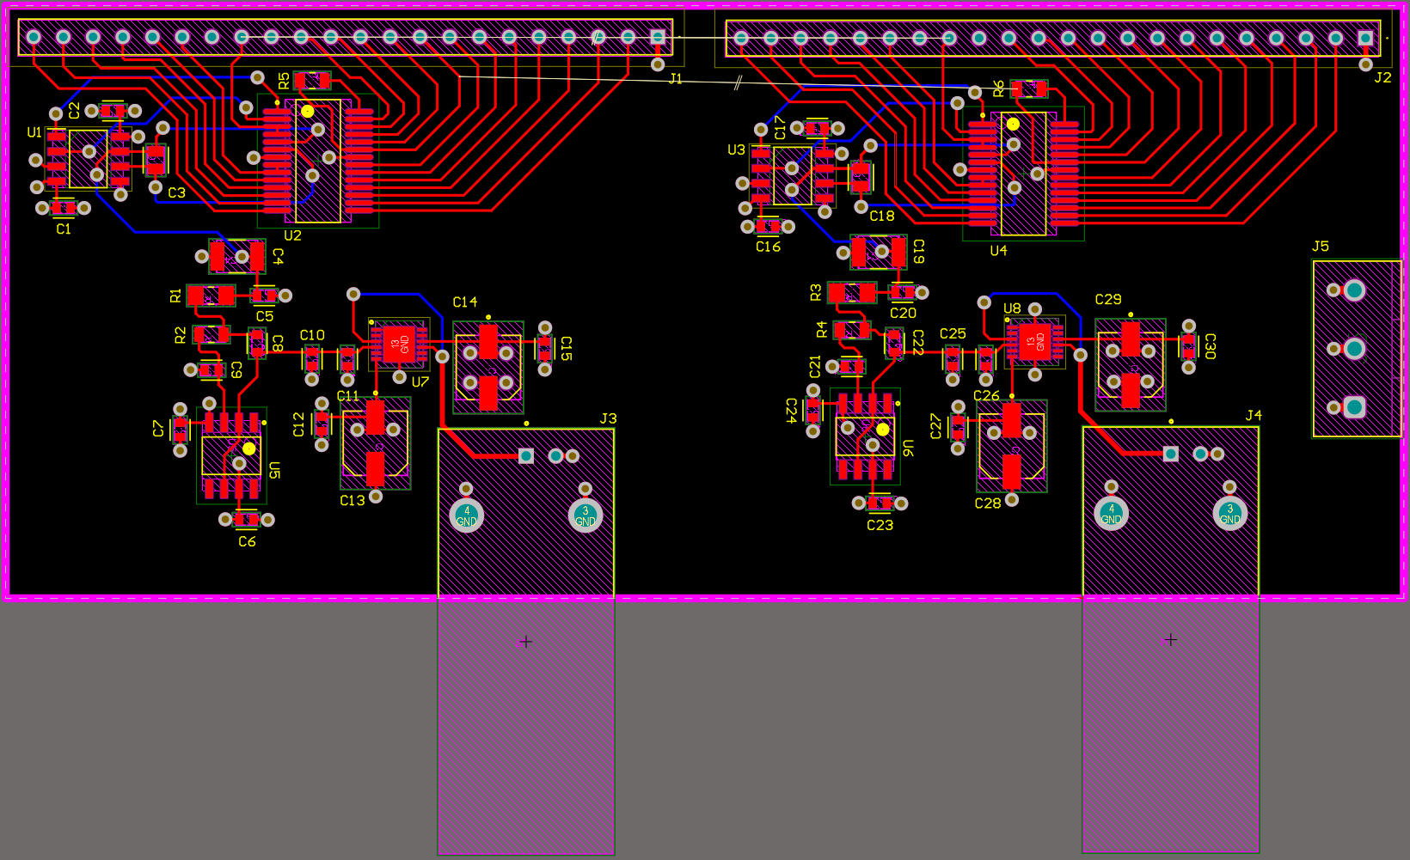

***Figure 3: Filter Subsystem PCB Layout***

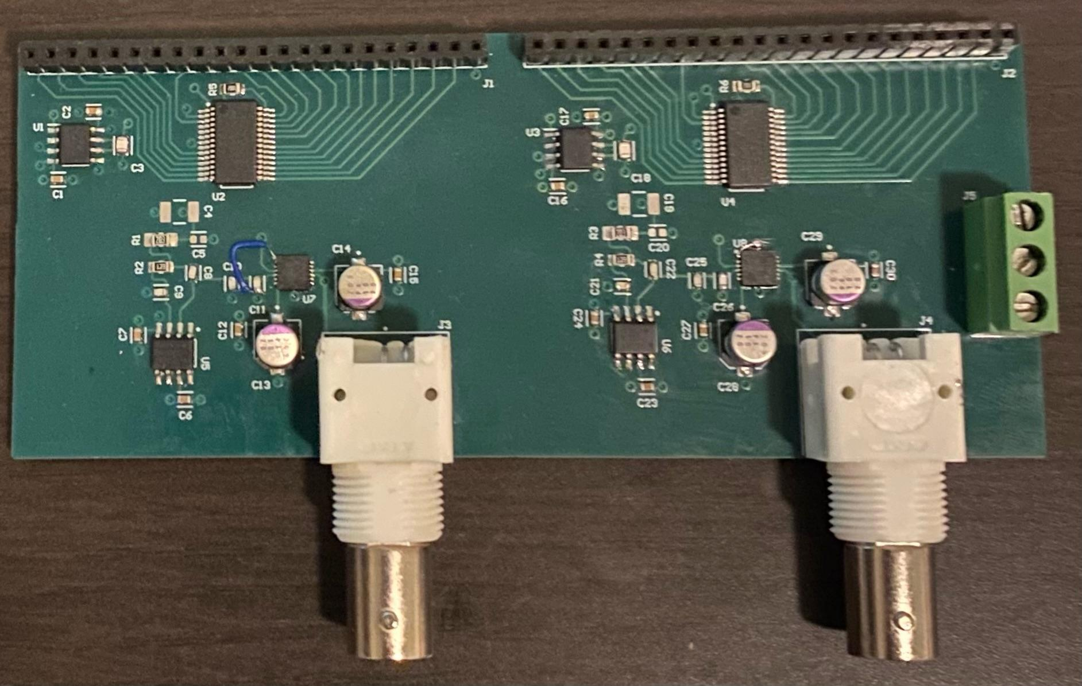

***Figure 4: Assembled Filter Subsystem PCB***

***5.5. Integration With System***

**5.5.1. Electrical Interfaces**

The analog output system interfaces with the FPGA and DAC subsystem, in which the FPGA will send the stream of 16-bit digital codes and the DAC converts the 16-bit digital codes into current values. The power system delivers the ±10 V rails needed to power the analog output stage. The BNC jacks deliver the final signal out of the AWG.

***5.6. Testing & Validation***

**5.6.1. Validation Plan**

The validation plan consists of two sections: simulation and benchtop testing. Prior to PCB layout design, LTspice simulations were performed to test the I/V accuracy, filter response, and output swing under the 50 Ω load. After PCB assembly, benchtop testings were performed. Because subsystem integrations are not performed until in ECEN 404, the ESP32 and Arduino were used to send the stream of 16-bit digital codes. A series of signals (sine, sinc, DC pulsing) waves were tested at maximum amplitude and a frequency of 1 kHz to verify proper operation of the analog output PCB.

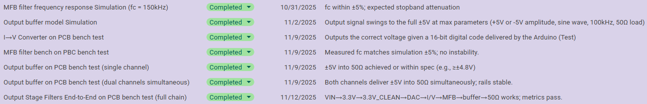

***Figure 5: Filter Subsystem Validation Plan***

**5.6.2. Simulations**

The LTspice simulations involved simulating the low-pass filter and unity gain buffer stages. Because the DAC is unable to be simulated accurately in LTspice, the DAC → I/V converter chain was tested only on benchtop.

***Figure 6*** and ***Figure 7*** displays the low-pass filter simulation results. Because the filter is designed to have a cutoff frequency of 150 kHz, frequencies above 150 kHz get attenuated, and frequencies below 150 kHz pass through the filter. ***Figure 6*** shows the result of the signal at 50 kHz when passing through the 150 kHz low-pass filter. The magnitude of the signal remains at -100.452 mdB, indicating that the signal is not attenuated at a frequency of 50 kHz. ***Figure 7*** shows the result of the signal at 200 kHz when passing through the 150 kHz low-pass filter. The magnitude of the signal remains at -6.680 dB, indicating that the signal is heavily attenuated at a frequency of 200 kHz.

***Figure 8*** displays the unity gain buffer simulation results. A ±5 V Sine Wave at 100 kHz was passed through the unity gain buffer. At 50 Ω load, the output signal remains identical to the input signal, a ±5 V Sine Wave at 100 kHz with no clipping and minimal ripple and noise. This result indicates that the buffer successfully delivered the minimum 100 mA current that is needed to drive a ±5 V signal at 100 kHz into a 50 Ω load.

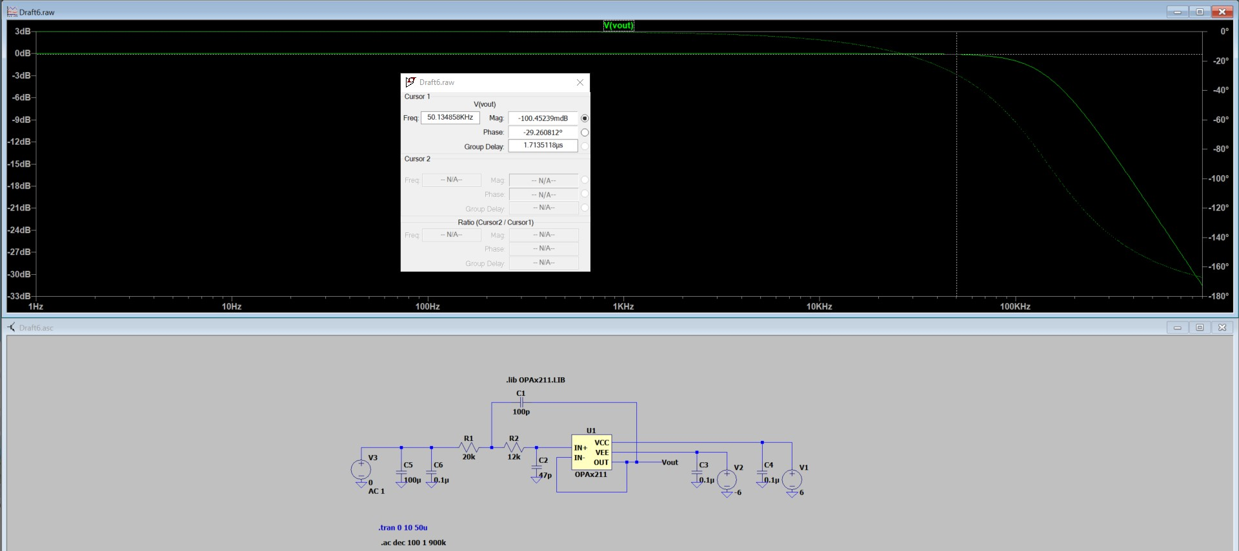

***Figure 6: 150 kHz Low-Pass Simulation, frequency = 50 kHz***

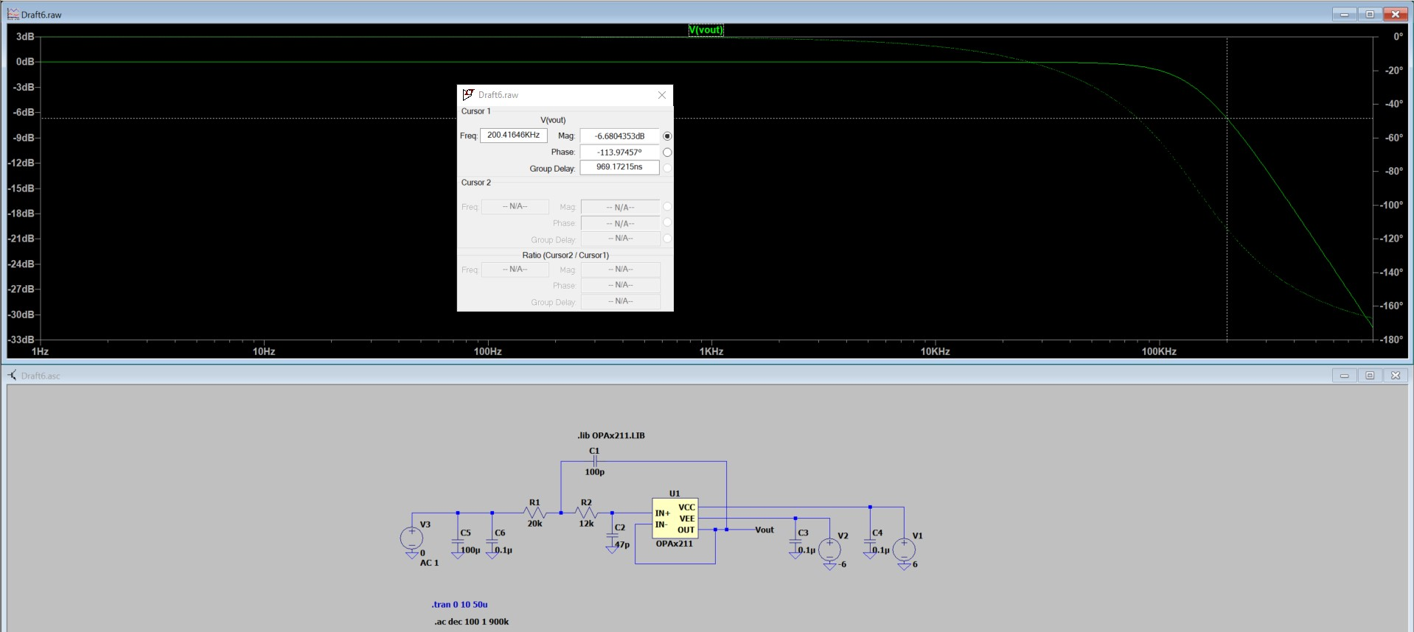

***Figure 7: 150 kHz Low-Pass Simulation, frequency = 200 kHz***

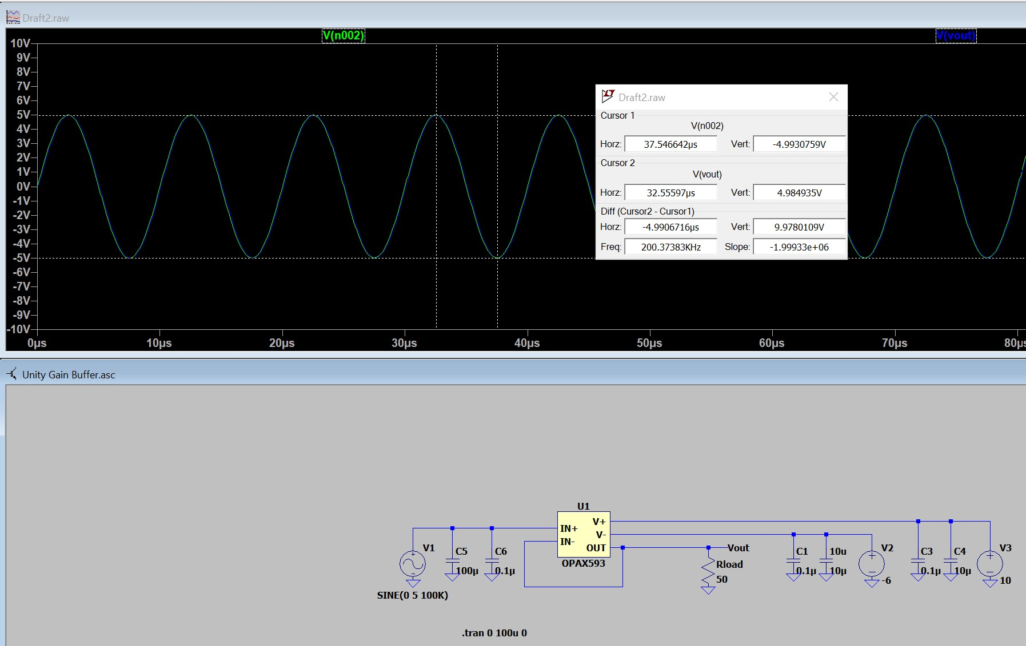

***Figure 8: Unity Gain Buffer Simulation, ±5V Sine Wave at 100 kHz, 50* Ω Load**

**6.4.3. Benchtop Results**

***Figure 9***, ***Figure 10***, and ***Figure 11*** displays the analog output subsystem’s benchtop result. The analog output PCB successfully produced a variety of waveforms, such as a ±5V sine wave at 1 kHz, ±5V sinc wave at 1 kHz, and ±5V DC Pulsing Wave at 0.5 kHz, all into a 50 Ω load. As shown through these waveform outputs, the resulting signals are clean with minimal noise and distortions. These results indicate that the subsystem’s key objectives were met.

It should be noted that the ESP32 and Arduino, which were used to deliver the stream of 16-bit digital codes to each channel’s filter systems in place of the FPGA, both have low sampling rates. This is unlike the FPGA, which has an exceptionally high sampling rate. This low sampling rate can cause signals at high amplitudes and/or frequencies to be stepped or distorted. Due to this limitation, along with the fact that the FPGA can’t be integrated with the analog output stage until ECEN 404, signals at only 1 kHz maximum were used to validate this subsystem. The sponsor verified that this limitation is only due to the ESP32 and Arduino usage and is not a subsystem design issue. ***Figure 8*** confirms that the system is able to drive ±5 V signals at 100 kHz into a 50 Ω load.

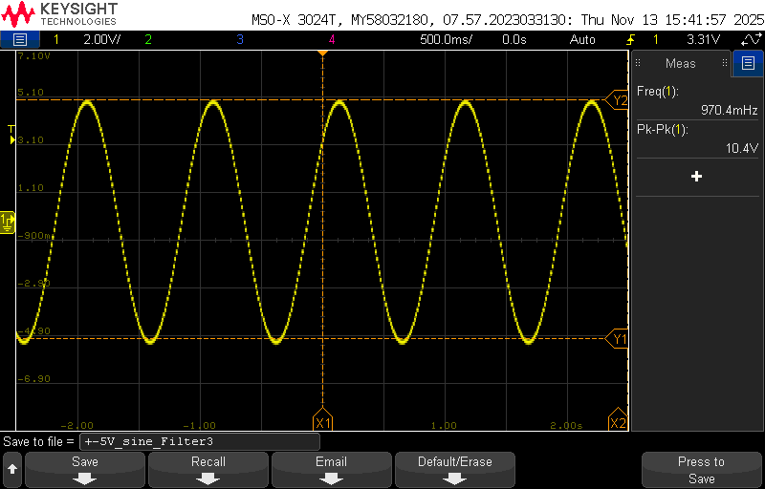

***Figure 9: ±5V Sine Wave at 1 kHz into 50 Ω Load***

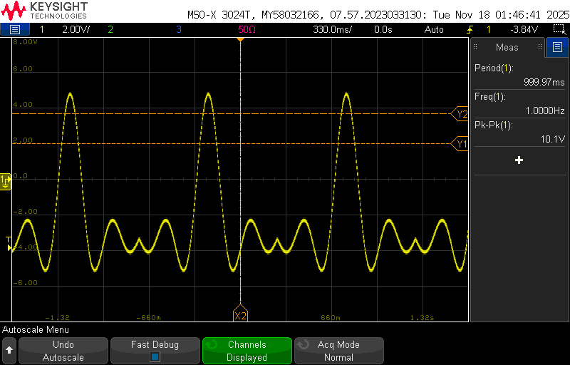

***Figure 10: ±5V Sinc Wave at 1 kHz into 50 Ω Load***

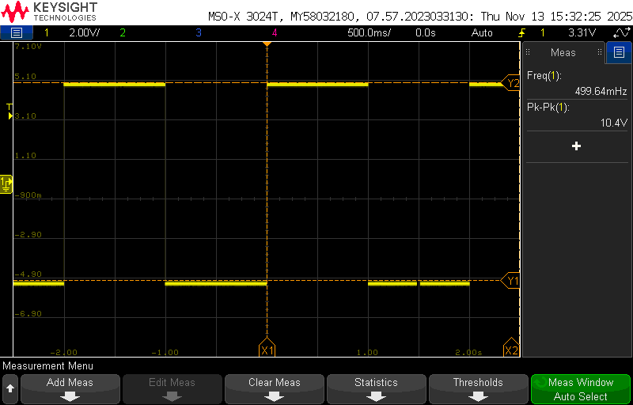

***Figure 11: ±5V DC Pulsing Wave at 0.5 kHz into 50 Ω Load***

***5.7. Subsystem Conclusion***

The analog output stage subsystem was successfully designed and assembled. All validation tests passed, and the analog output stage design was able to drive ±5 V signals at 100 kHz into a 50 Ω load. As shown in the above benchtop results, the output signals were clean, containing minimal noise and distortions. In ECEN 404, the analog output subsystem will be integrated with the FPGA, in which the FPGA will be used to deliver the streams of 16-bit digital codes to both filter systems.